TRIPLE TOP FINISH FOR GARGOYLES

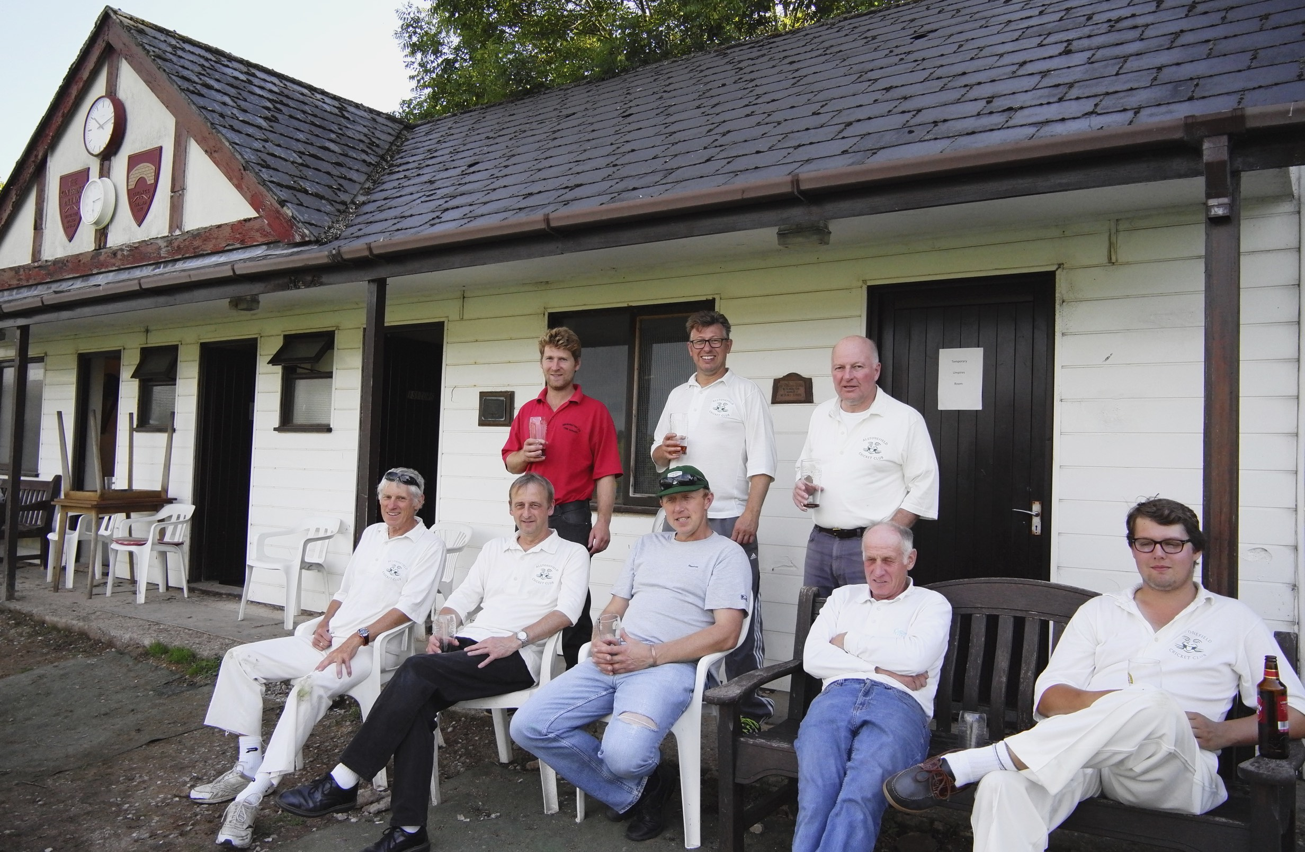
Alstonefield cricketers relax after winning final away match of 2016 season at Clifton

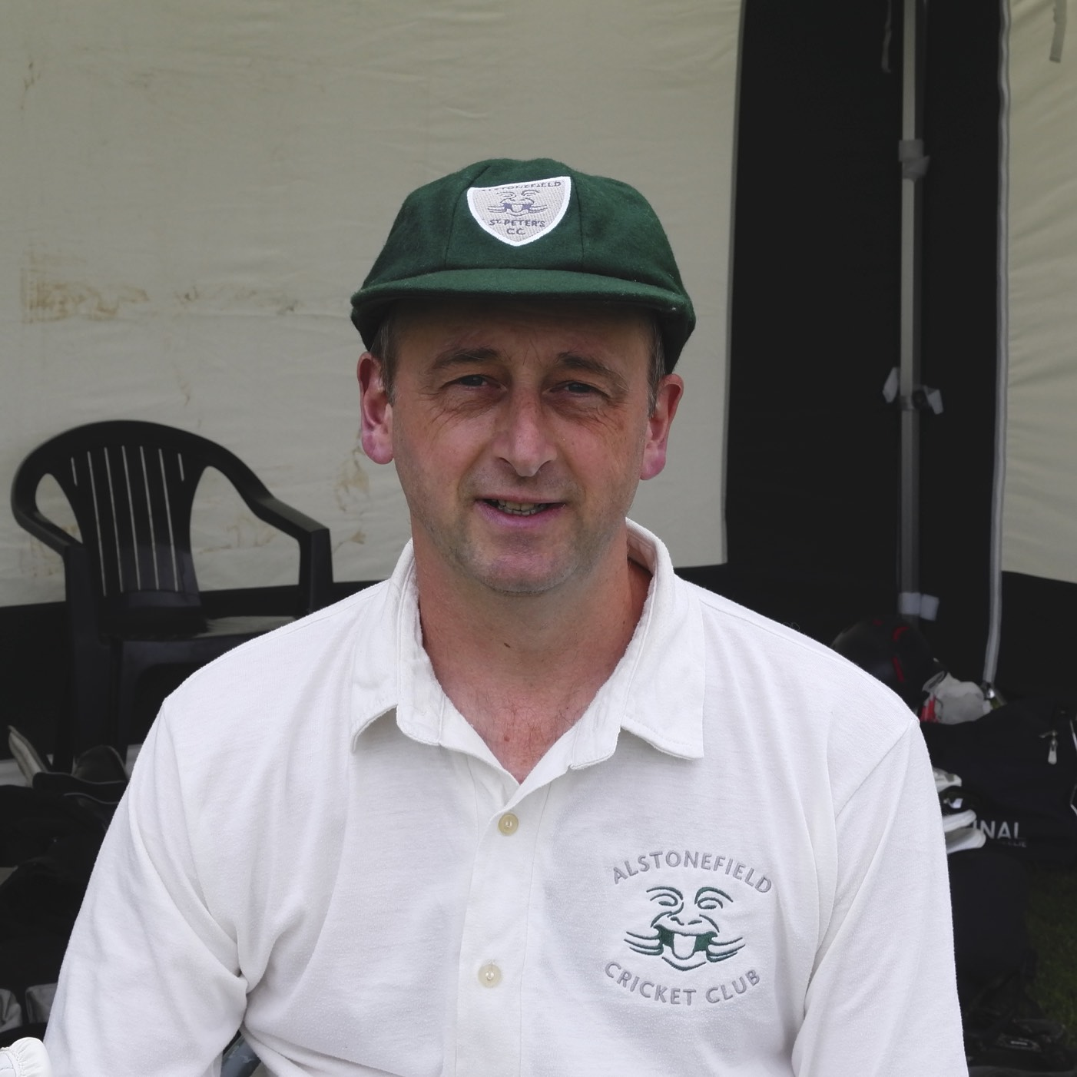
Played 14, won 8, drawn 1 and lost 5. In one of the most weather-disrupted summers in memory, Alstonefield Cricket Club somehow managed fourteen fixtures in 2016 and achieved their best ever win ratio. To do so, while giving every player the opportunity to shine with bat and ball in every match, is a tribute to the cricketing brain and thoughtful leadership of Andy Bray in his first season as club captain.
Captain Bray

In many ways, the final three matches typified the season, with different players making match winning batting contributions each week.

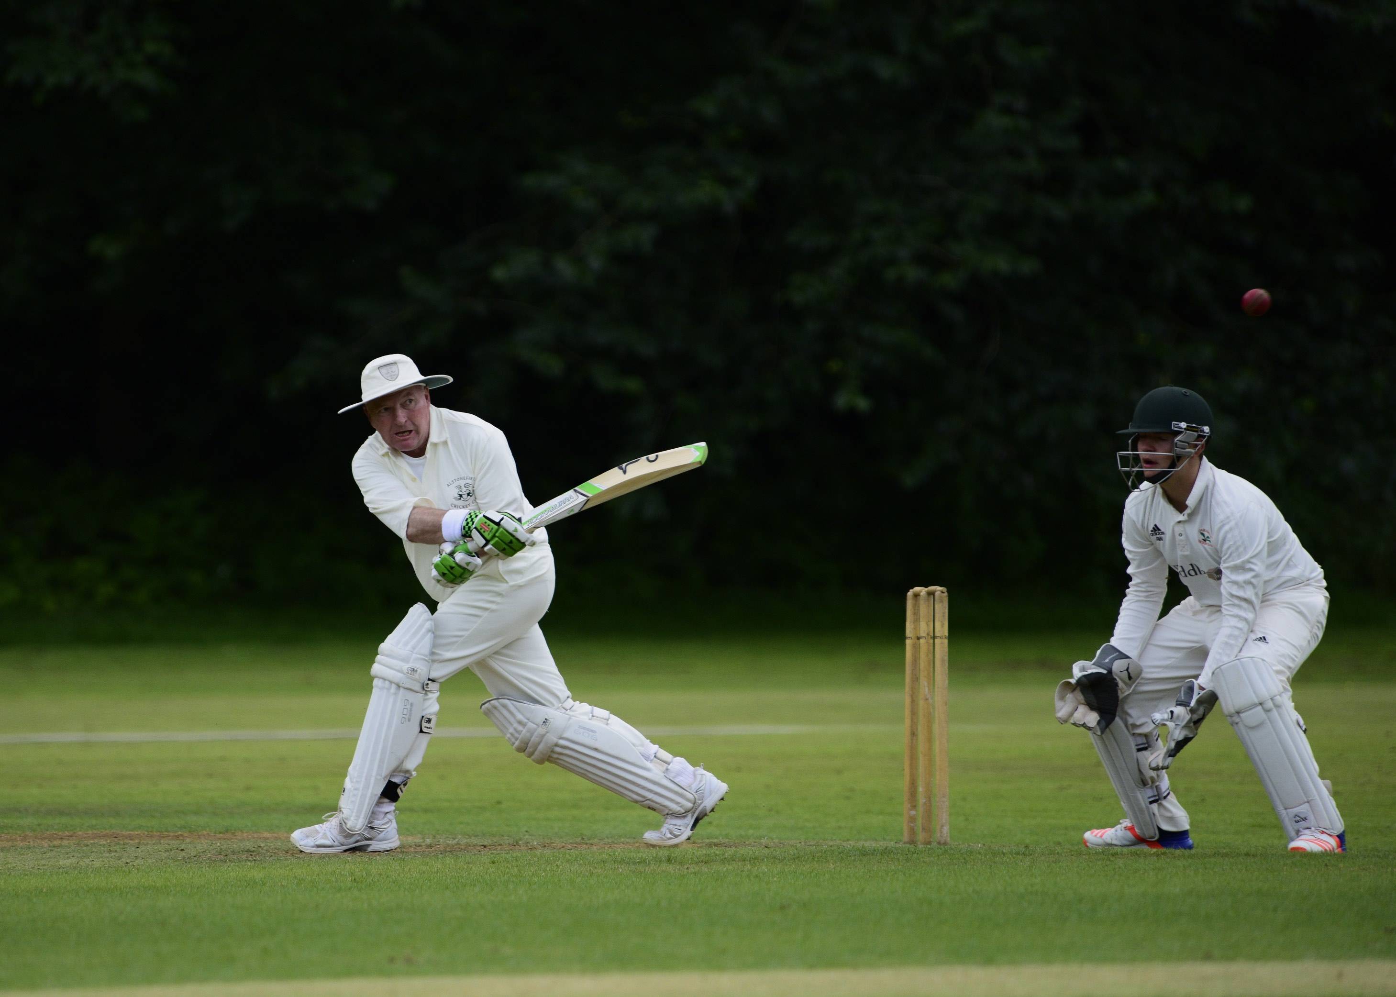
Ian McKay demonstrates his usual fluency

Against Wootton, Andy Bray and Ian McKay put on 71 in 8 overs to set up an 8 run victory.
Against Clifton, Harry Jones and Ben King put on 82 between them to allow Shahid Ali to blast 43 and put the game beyond the hosts.

Ben King in full dress uniform

In the dramatic finale against Sunseekers, what had seemed an eminently gettable target suddenly looked distant, until Andy Farmer and Will Siddons calmly lofted 33 runs in just over two overs, to win the match with 4 balls to spare!

Will Siddons taking on fuel before the final onslaught

This democratic approach to excellence applied to the bowlers and fielders too. It was not a case of one bowler having a field day and running through the order. Rather, all the bowlers took wickets and built pressure. Rounding off the whole team ethos, of the 26 wickets taken in these three matches, 15 were catches by 9 different catchers, none easy and there were 3 stumpings for good measure.
Fittingly, there was another standout performance in the last match. Andy Bray took 4 wickets for 9 runs and top scored with 30.
Some are just more equal than others…

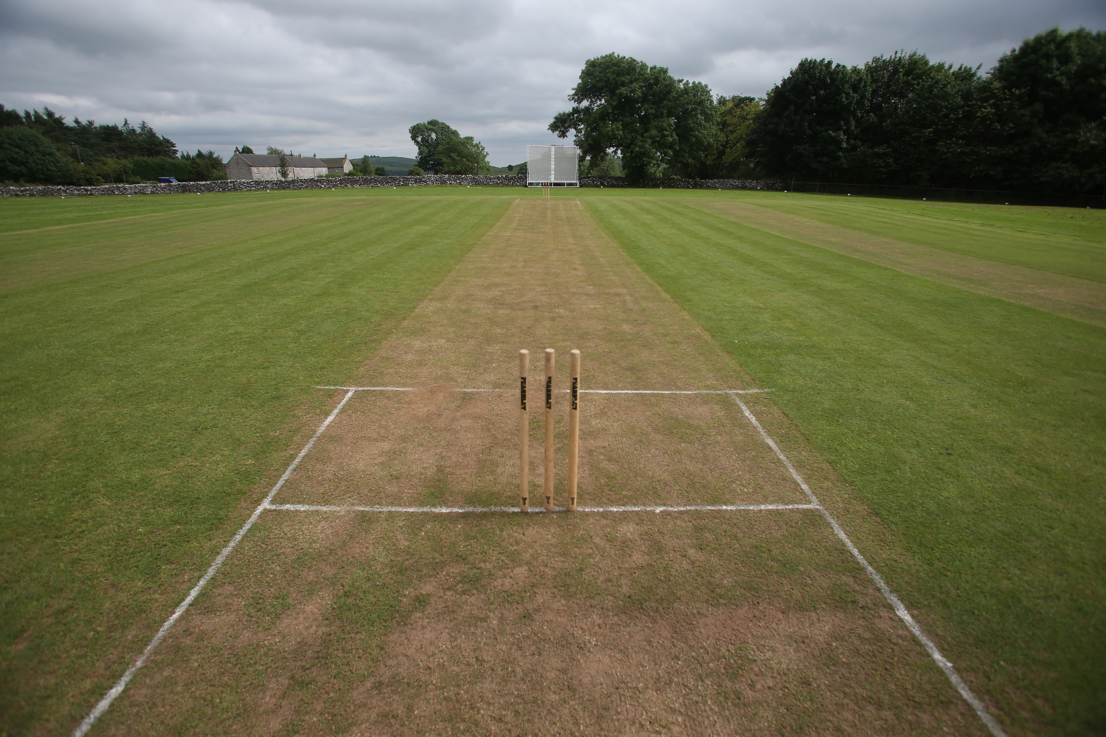

ALSTONEFIELD CC 169 FOR 5, BEAT WOOTTON CC, 161 FOR 8, BY 8 RUNS

ALSTONEFIELD CC 175 FOR 3, BEAT CLIFTON CC, 128 ALL OUT, BY 47 RUNS

ALSTONEFIELD CC 137 FOR 7, BEAT SUNSEEKERS CC, 131 FOR 9, BY 3 WICKETS.

2016 SEASON.

PLAYED 14 – WON 8 – DRAWN 1 – LOST 5

