PERFECT FINALE AS GARGOYLES CHASE GAME HUNTERS AWAY

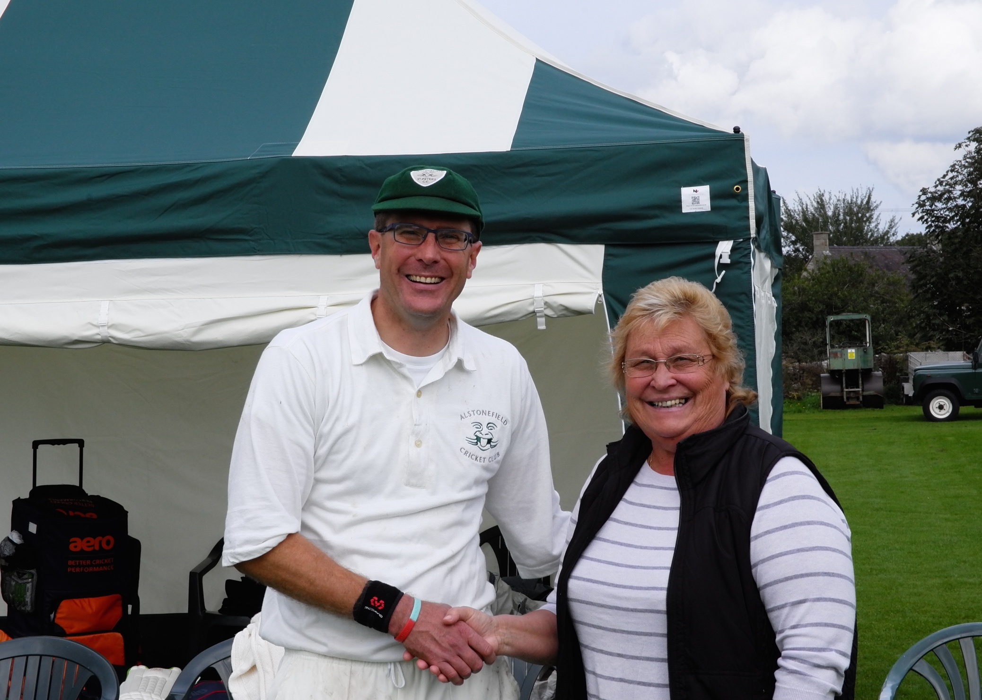
Simon Smith with Cllr Gill Heath

It's a big responsibility hosting a touring side whose expressed desire is
simply to play cricket in the most beautiful settings imaginable, especially
when they play in the stately surroundings of Chatsworth the day before.
What transpired on the most glorious Sunday afternoon of the summer, was the complete embodiment of village cricket and a timely reminder to all involved of why the game is played. In the last match of what has been one of their most successful seasons, this encounter also demonstrated just how far Alstonefield Cricket Club has developed, in both cricketing ability and ground facilities. The club was honoured to have Councillor Gill Heath in attendance to formally open the new marquee changing rooms, generously supported by the Staffordshire County Council Local Community Fund. To defeat the Hampshire based White Hunters and their eccentricities, in particular their ‘Not Out First Ball’ rule, while making them feel most welcome and wanting more, is of course the balancing trick for all hosts.

This time, the Gargoyles were pitch perfect …

There was no doubting the White Hunters' intent or skill, as they opened
their innings briskly, with Cooper elegantly driving on both sides of the
wicket. Andy Bray and Liam Duffy, both mastering the ideal flight and
length, made early breakthroughs and when captain Simon Smith held on to a superb catch to dismiss Cooper for 19, the Gargoyles were marginally ahead at 49 for 3 from 12 overs. Dixon and Baker soon put paid to any
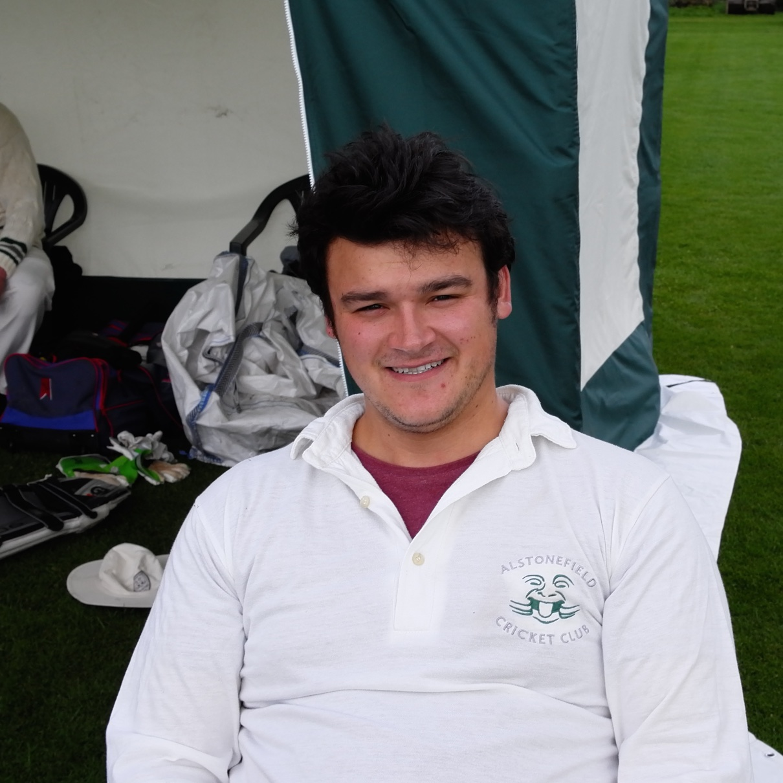
complacency as they put on 40 runs in 5 overs, before the acrobatic Wilkins caught Dixon off his own bowling. Baker was still enjoying the on-side and had made 37 when Smith introduced himself and immediately found the top edge with a snorter, Ian McKay taking the catch. 118 for 6 off 22 overs. The score then rattled along to 169 off 30 overs, as young Whitcombe produced a superb knock of 33 at more than a run a ball, to make a score in excess of 200 a real possibility. Enter Bond - Henry Bond - the Gargoyles' latest secret weapon. Needing his first over to adjust to the altitude, Bond then produced a genuine spell of medium fast seam bowling too good for the White Hunters' tail. The runs were stemmed, alert fielding and smart glovework by Neil Shotton delivered a run out, and a typical catch in the deep by Alan Hayes saw the end of Whitcombe, leaving last man Allison to be snaffled at slip by McKay off the deserving Bond. 184 all out was still one of the highest ever 35-over scores on the Alstonefield ground, providing a challenging total on the lush outfield.
Impressive debut by Henry Bond

But what did the Hunters have in their bowling armoury?

Openers Andy Bray and Neil Shotton were soon to find out. A mix of athletic energy from the younger bowlers and wily flight from the more experienced, soon had their rewards. Shotton played the wrong line and edged to the keeper, while Bray mistimed a pull and was gone for 10.
34 for 2 off 9 overs was well behind the rate.
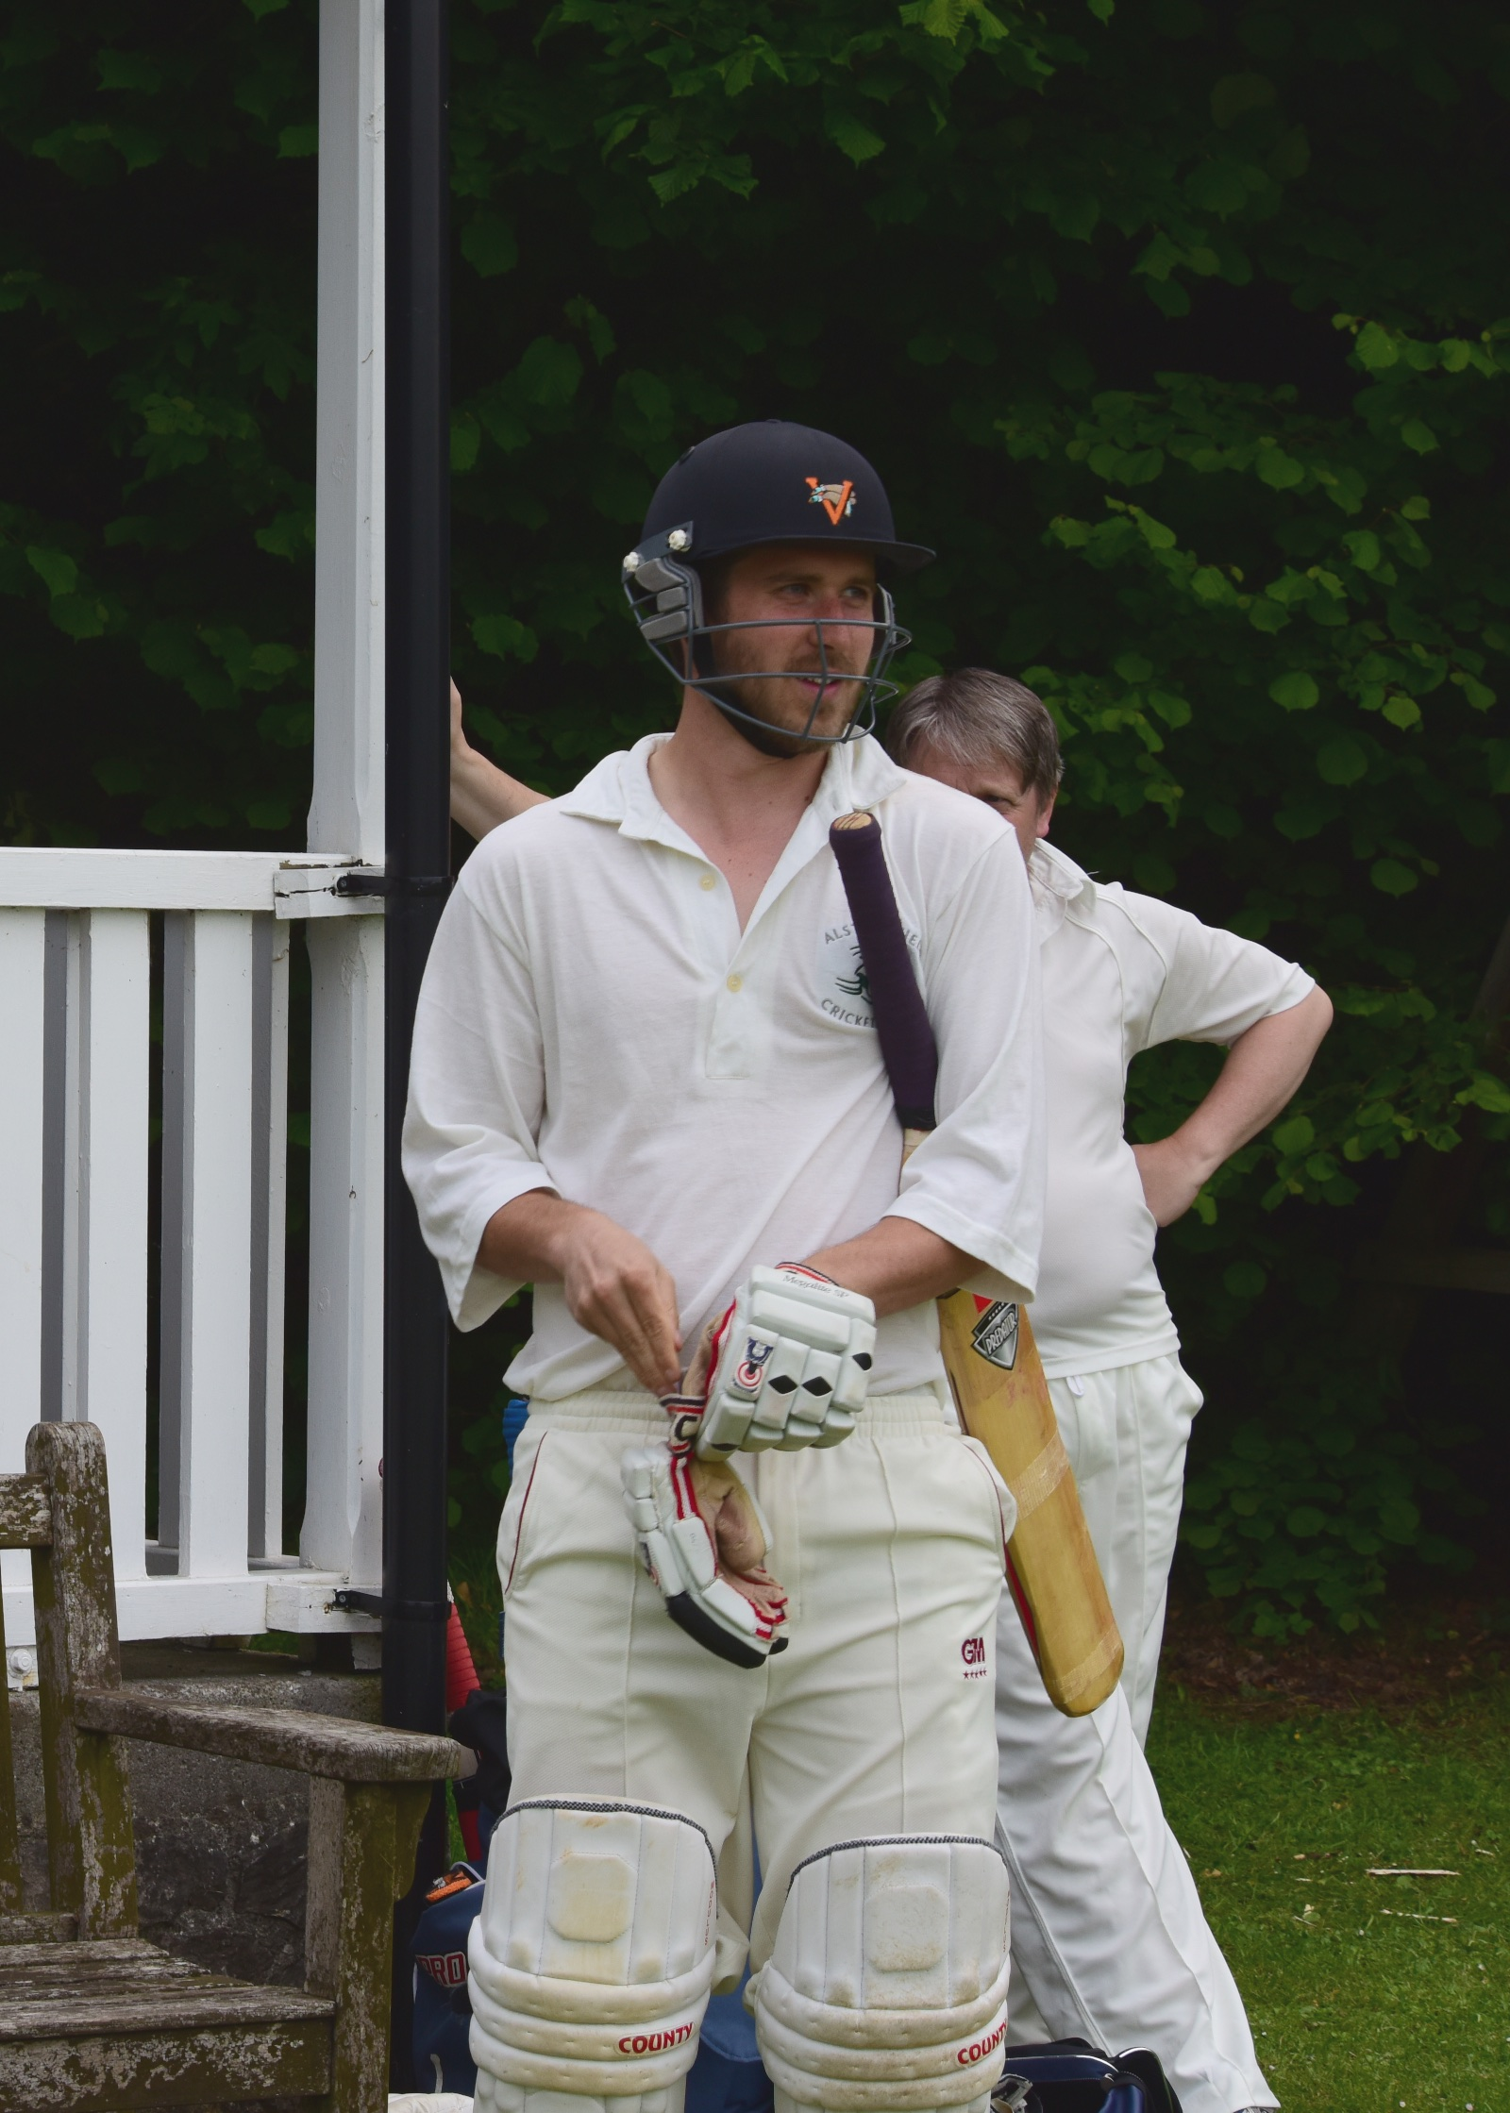
Chris Wilkins has played some sparkling innings this season, but this proved to be his zenith and there was absolutely nothing the Hunters could do to quell the thoroughbred bombardment that followed. In the fastest half century of the season, Wilkins hit 44 of his 53 not out in boundaries, all of which drew applause from his opponents. With cultured support from Liam Duffy, who made 20, Wilkins retired with the Gargoyles on 141 for 3 after 21 overs. A little flurry of wickets followed, in which Dave Singleton became the first batsman ever to be out first ball twice in the same innings, giving Allison a theoretical hat trick.
Wilkins at his sparkling best!

Ian McKay was joined in the middle by Will Siddons and these two made the 42 runs required without fuss in just over 6 overs.

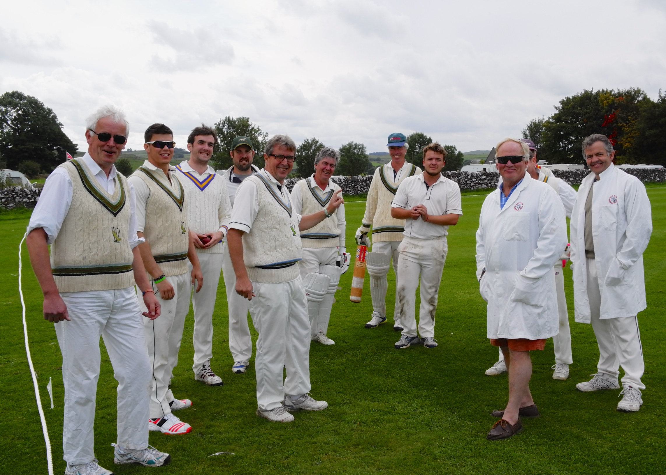
A Blast of Hunters

185 for 5 in 27 overs, at almost 7 runs per over, was the highest and
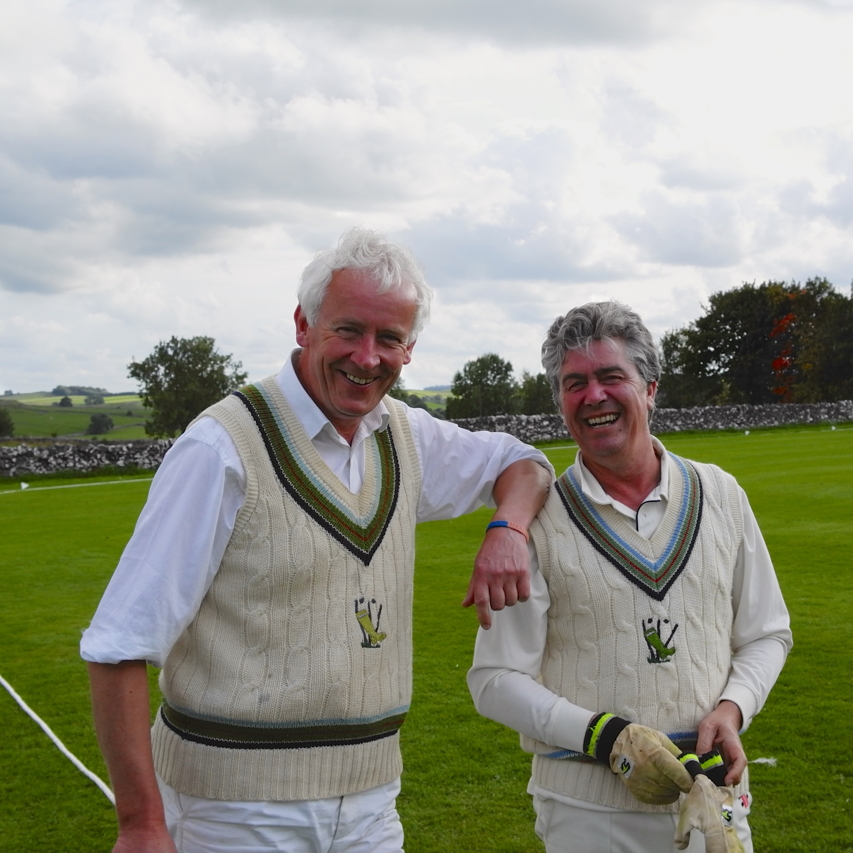
fastest run chase in Gargoyles history. There followed the moving occasion of the White Hunters' team thanking their hosts for a splendid and memorable day in the hills and two of their founders, Richard Perkins and Roger Morgan-Grenville (their club is in its 29th year) presenting captain Simon Smith with their acclaimed publication "Not Out - First Ball."
Happy Founders

The adjournment to The George rounded off the perfect day's cricket in good company and optimism for the future.

A season can't end any better than that.

ALSTONEFIELD CC 185 FOR 5 BEAT WHITE HUNTERS CC, 184 ALL OUT, BY 5 WICKETS

