NOMADS JUST TOO STRONG FOR GARGOYLES

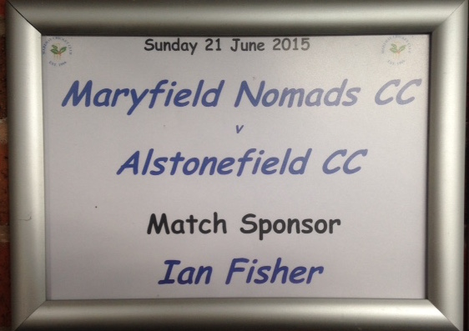

Another last over thriller, saw Alstonefield CC come second in a perfectly balanced match, but make no mistake, this was a big day in the development of the club. Guests for the first time of Marehay CC at their wonderful ground, the Gargoyles were treated to life in the upper echelons of Derbyshire League cricket. Immaculate changing rooms, a clubhouse of village hall proportions and a pitch that rewarded batsmen with over 430 runs in the afternoon. On the field, the Gargoyles were not overawed and encouragingly for the future of the club, there were impressive contributions from the newcomers, including a Man of the Match performance
from Andy Farmer…….

Andy Farmer

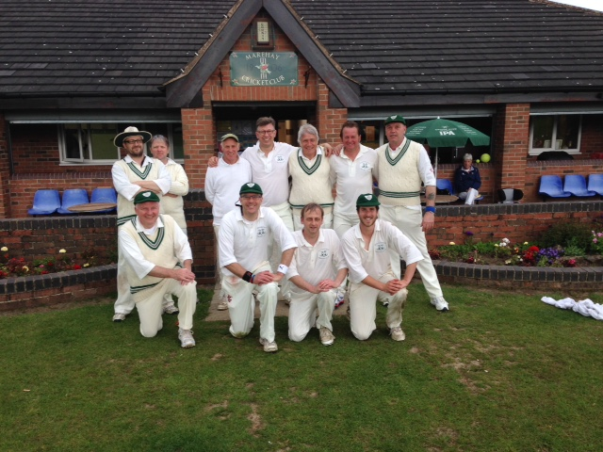

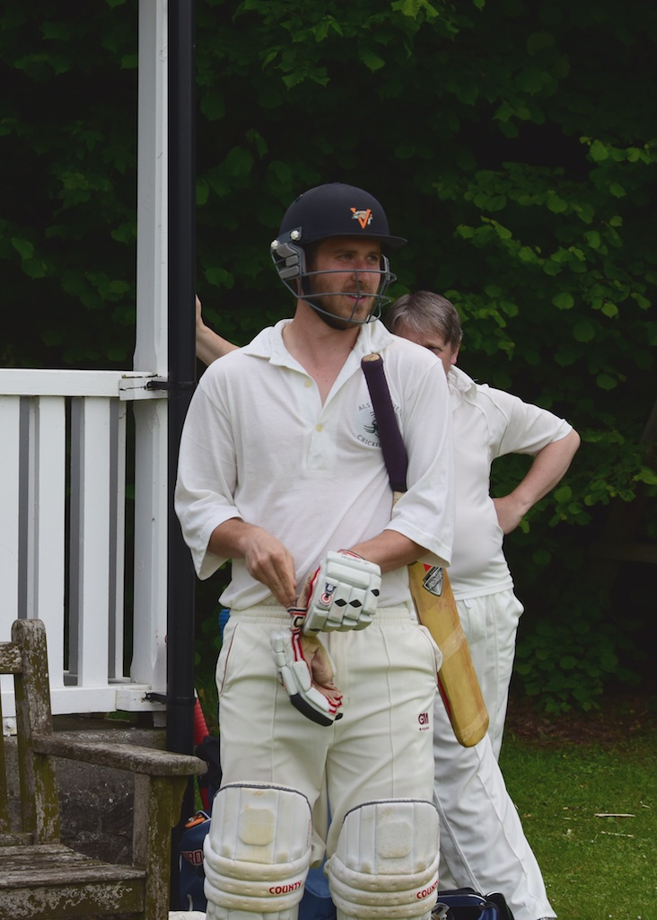
Put into bat on what looked like a good batting surface, Harry Jones and Andy Bray made a steady start, before Jones chopped on for 12. Chris Wilkins was instantly into his stride, with his first 4 scoring shots rattling up 18. He and Bray took the score to 83, before Bray mistimed a drive and was caught. Ian McKay joined the increasingly fluent Wilkins and the score continued to move along nicely, reaching 120 at 5 per over, when McKay edged a wide one behind. Wilkins retired on a majestic 51 not out.
Chris Wilkins - fluent batting
Gargoyles’ captain Simon Smith had started to show his true class at Chatsworth and now had the perfect opportunity to hold the second half of the innings together and construct a big score. All the Gargoyles’ batsmen got in. Neil Shotton with 11 and Dave Singleton with 9, put on valuable runs with their captain, who by now was timing his strokes to perfection and scoring freely. Smith had reached 42 when he picked the wrong line and was bowled. This meant the middle was occupied by Andy and Mark Farmer. Recently returned from their intensive coaching course these two produced one of the stands of the season, as Mark Farmer nonchalantly picked the gaps and scored his first runs for the club, while Andy Farmer, fresh from his riff plucking success, played some exquisite strokes, including an effortless 6 into the crowd at mid-wicket, in his unbeaten 20. These two had added 31 runs in 5 overs,to give the Gargoyles a competitive total of 216 for 7 at 5.4 runs per over.

The Nomads just looked like a side who know how to bat and captain Smith asked Chris Wilkins and Ian McKay to continue their new ball pairing and keep the runs to a minimum. After 10 overs the Nomads were well behind the asking rate at 36 for 1, with Wilkins taking 1 for 17 from his first 5 over spell. Opener Wilby was accumulating steadily, Andy Bray clean bowled Daley and Caulton made a brisk 24 before failing to pick Andy Farmer’s drifter. So, at the half way stage, the Nomads were 92 for 3 after 20 overs. Steve King in his longest spell for the club, was impressively accurate, returning 0 for 21 off his 5 overs. Meanwhile, Northage was starting to penetrate the field and although Simon Smith had Fisher smartly stumped by Harry Jones with a perfect leg break, there was a sense of the Nomads going through the gears and upping the rate. Northage moved effortlessly to his 50, while Pykett took a more brutal approach to run scoring. Coming in at 151 for 4, with only 8 overs remaining, he bludgeoned anything short or pitched up for maximum scores. In a remarkable innings of 42 not out, there were no 4s, just 6s and singles. Captain Smith brought his opening bowlers back for the last four overs, with the Nomads still needing 32 to win. Pykett just kept hammering McKay into the trees and the match was over in the last over.

Another close defeat, but so many encouraging signs for the Gargoyles, not least the emergence of some real cricketing talent in the King and the Farmers.

ALSTONEFIELD CC, 216 FOR 7 LOST TO MARYFIELD NOMADS, 217 FOR 4, BY 6 WICKETS

