Happy New Planting
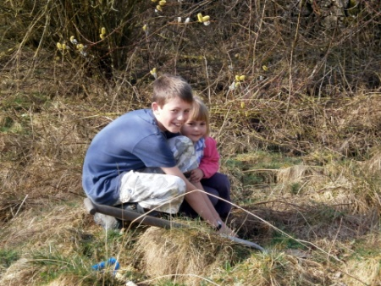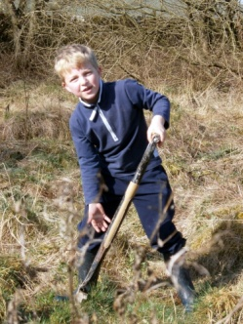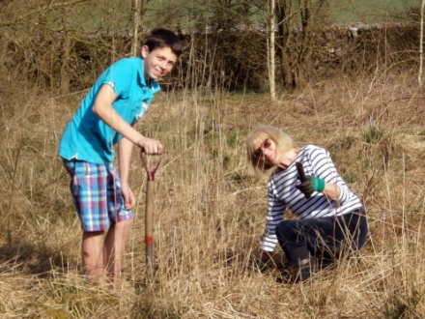
We hope you enjoyed planting your pack of free trees from the Woodland Trust. Within just a few years these saplings will create welcome shade and shelter for local people and wildlife alike to enjoy.
Your trees were provided as part of the Woodland Trust's Jubilee Woods Project, which has a vision of planting 6 million trees in celebration of Queen Elizabeth II's Diamond Jubilee. The big picture would not be possible without your help and, to say thank you, your contribution will be recognised in a new official record of Jubilee trees.
Forgotten treasure
Inspired by the discovery of the Royal Record of King George VI's Coronation, which details millions of celebration trees planted by schools, community groups, organisations and individuals, we are creating a new Record of trees planted today for the Diamond Jubilee. The 1937 Royal Record can be viewed online here
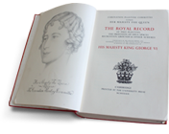
Mark your place in history
We have a created a simple entry in our Record acknowledging your contribution.
A special, bound copy featuring your contribution will be presented both to the Queen and the British Library, for generations to come to admire.

