GARGOYLES SHOW GREAT WILL TO WIN

The Sunseekers fixture is always a competitive, if not a feisty, one. Before the first ball was bowled, the tone was set by the Sunseekers’ captain, who, having won the toss, fatefully dismissed the notion of batsmen retiring at 50 and chose to bat. In other words, he fancied his batting line up had some heavy scorers, who would take the game away from their opponents.
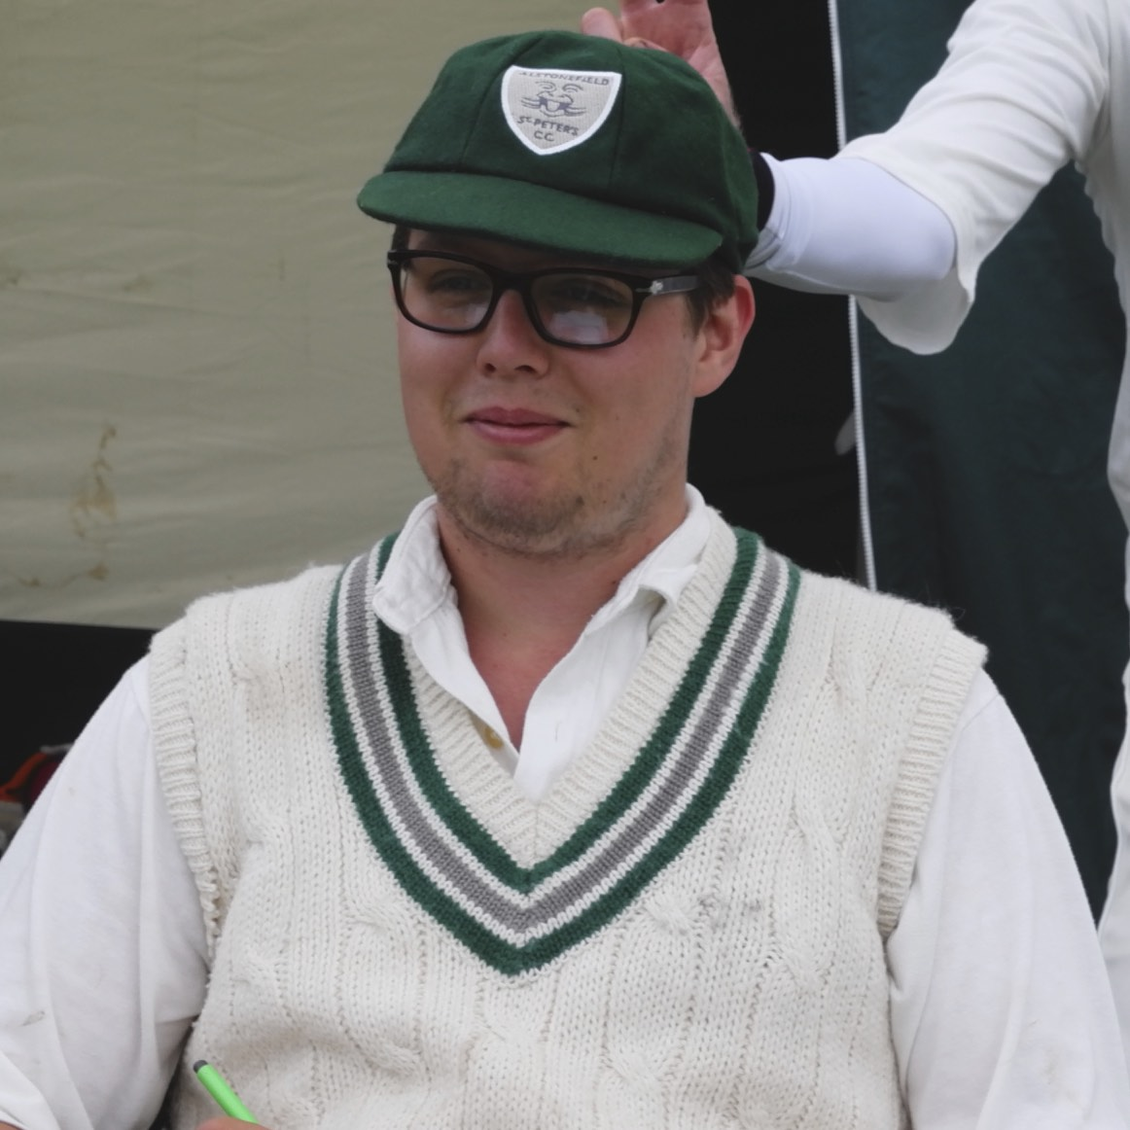
Will Siddons – almost a legend
Sunseekers duly started confidently. Openers Kent and Nicholls clearly had different roles. Kent was aggressive from the off and Nicholls set his stall out for a long stay. Ben King and Will Siddons kept the run rate below four an over in their opening spells, with
Will Siddons – almost a legend
Siddons yorking Kent for 25 in his fifth over. Shahid Ali bowled superbly in his first spell, conceding only 11 runs in 5 overs. Steve King continued his return to action with a long spell and the wicket of Downes, caught behind by Harry Jones. At 20 overs, Sunseekers were 68 for 2 and unable to force the pace.

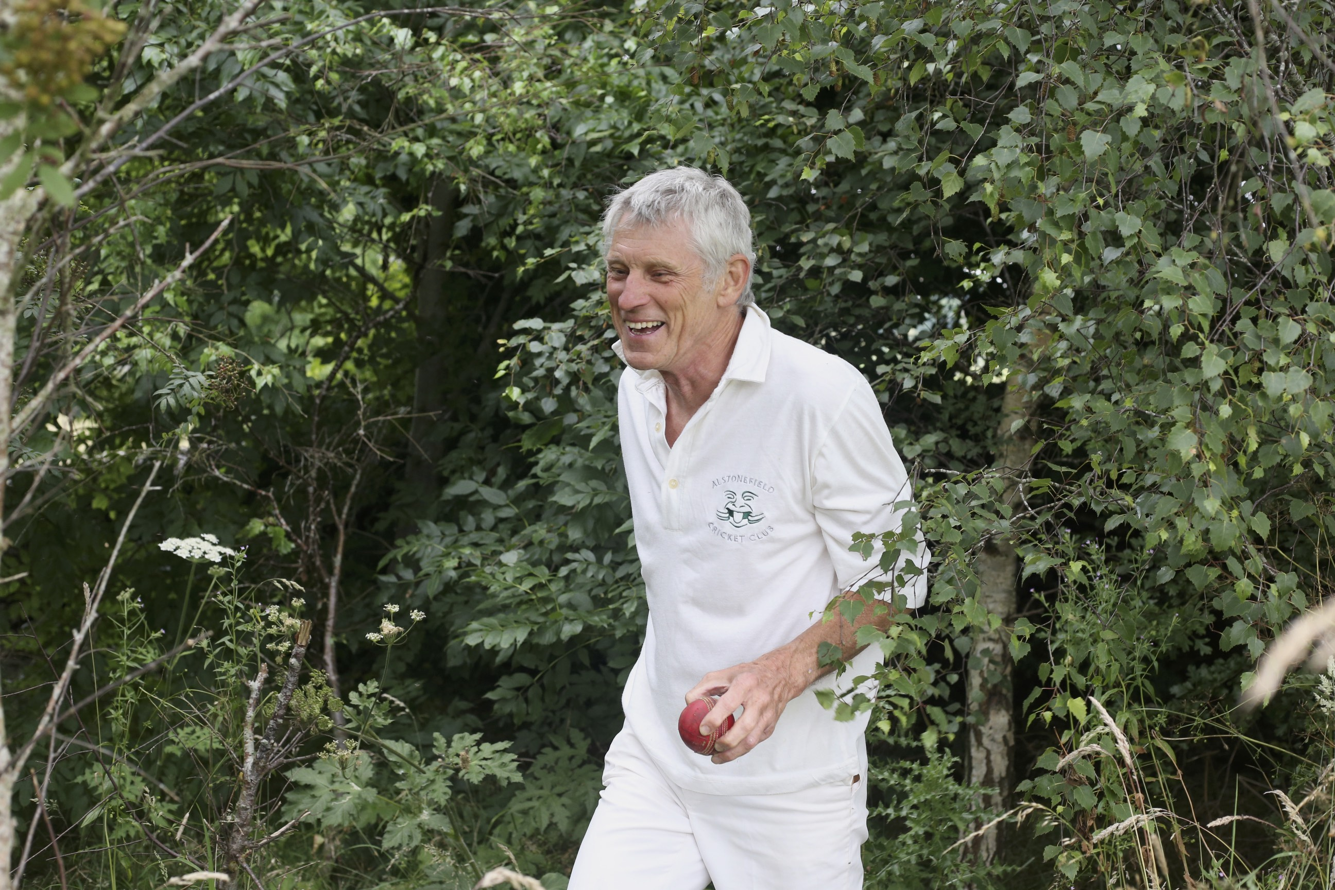
Captain Andy Bray brought himself on and struck in his second over with a beautifully flighted delivery and crucially, did exactly the same two overs later, bowling Longdon, who had scored a century in the corresponding fixture last season and was deliberately kept back in the order to launch an onslaught in the final 15 overs. Meanwhile Nicholls had reached an excellent 50
Age-defying feats from Rob Handscombe

and was now playing his shots. At 30 overs, 124 for 5 was probably below par from a Sunseekers perspective, but put the Gargoyles in a strong position. The fielding throughout was keen and effective, with David Joyce, Andy Farmer and Rob Handscombe earning plaudits from the opposing batsmen for a number of age defying and run saving feats. Some catches went begging and there was an early contender for the Lame Duck Award, but there was no doubting the Gargoyles’ determination to keep the score under 200. Shahid Ali returned and immediately accounted for the excellent Nicholls for 62 and then had Thorley caught behind by the athletic Jones for 1, to finish with the exceptional figures of 2 for 16 off 8 overs. There was some last wicket aggression from Goven and Coxon, adding 31 in the final 6 overs, but at 187 for 9 off 40 overs, it was job half done for the Gargoyles.
Regular openers Harry Jones and Will Siddons looked comfortable, if not expansive, in moving the score to 32 before Jones edged one behind for 15 in the 10th over.
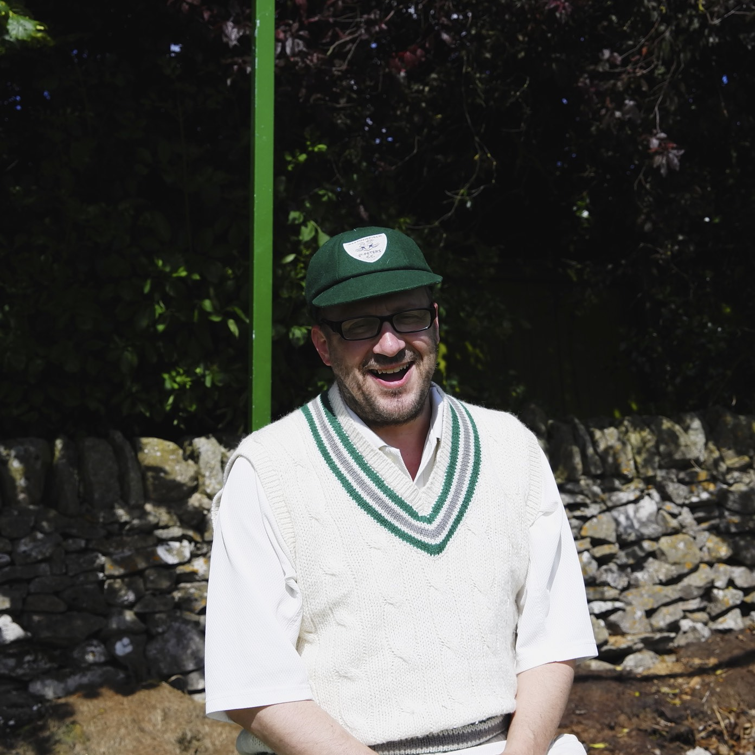
Master Tactician Neil Shotton

Neil Shotton joined Siddons with the score at 58 for 2 in the 19th over and brought all his vast experience to bear. He read the match situation perfectly and though struggling to find his most fluent form, he coached and cajoled Siddons into turning 1s into 2s and 2s into 3s. Time in the middle made all the difference and he accompanied Siddons in finding the rope with regularity.
When Shotton lofted one into the deep and was caught for 34 with the score at 152 in the 33rd over, these two had transformed the run rate from 3 runs per over at the half way stage, to nearly 5 per over. With 7 overs remaining, the Gargoyles needed 36 to win and Siddons was still there on 81. The sheer quality of his strokeplay and the resolution of his defence made this an innings of rare distinction. He had calmly moved to 98 when a tired looking square cut cruelly sent the ball into the stumps, agonisingly close to becoming the club’s first centurion. Ben King and Shahid Ali expertly knocked off the remaining 17 runs with two overs to spare.

Back in the changing room, inundated with accolades from both teams and having produced as clear a game changing performance as can be imagined, Siddons drew on Nietzsche for his characteristically philosophical view about the difference between 98 and 100, stating “there are no facts, only interpretations.”

ALSTONEFIELD CC 188 FOR 4 BEAT SUNSEEKERS CC 187 FOR 9, BY 6 WICKETS.

