GARGOYLES WINNING HABIT IS CATCHING

New opponents, big changes in the batting order and the weather, could not deter Alstonefield CC from recording their sixth consecutive win of the season.
Duffield CC were the first time visitors to the hills, fielding a team of well coached youth led by some seasoned league veterans. Given the difference in average ages of the two teams, they would have been as amazed as the hosts themselves by the sheer audacity of the Gargoyles’ catching. In this record breaking start to the season, the one facet of their game yet to reach the heights had been the ability to hold on to catches at crucial moments. On Sunday, 7 of the 9 Duffield wickets to fall were catches and some were far from regulation……….

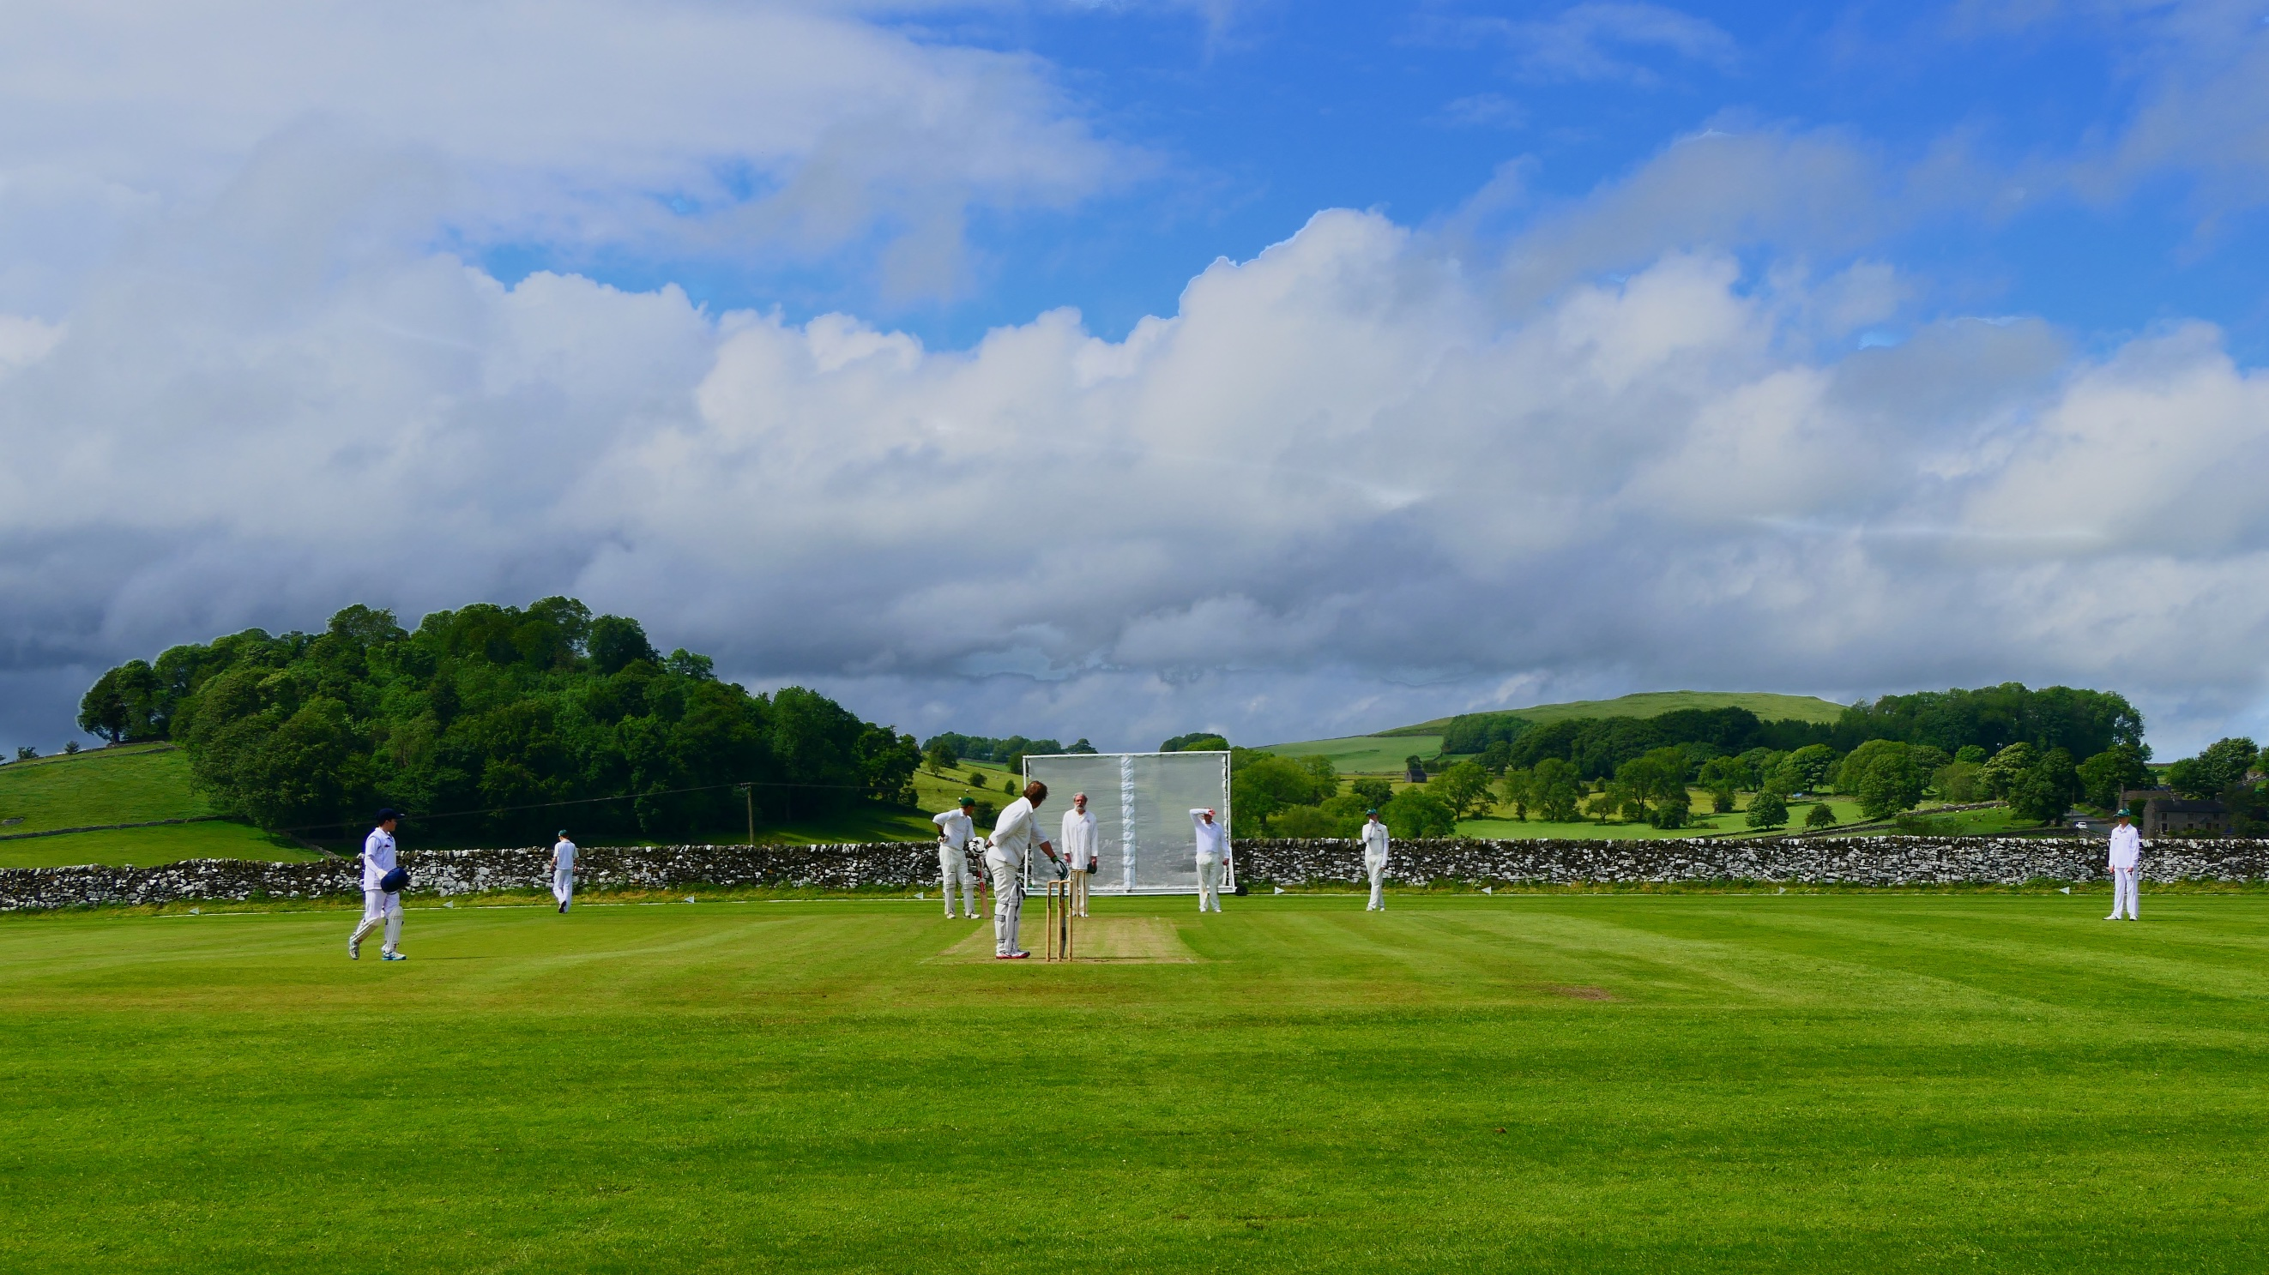

Wonderful setting at Alstonefield for the first ever game against Duffield. A lot of hard work during the week paid dividends, with the ground looking stunning…

The wicket had been protected from the rain, but under cover for three days, was not exactly lively. The outfield was damp. Runs would need to be earned. The locals thought 160 would be an above par score. Jon Lane opened the batting with captain Andy Bray, displaying the patience and resolution necessary to gauge the pace of the wicket and help lay the platform for the innings.
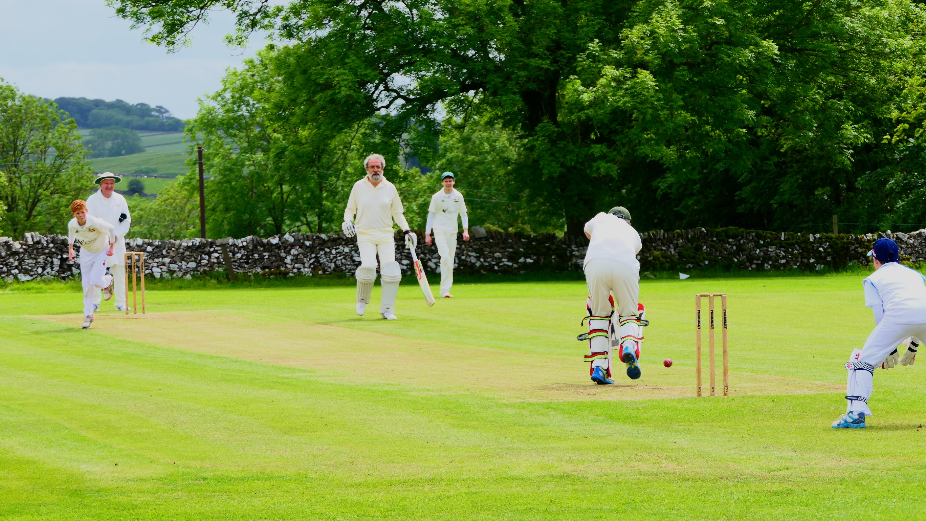
Captain Andy Bray and Jon Lane opened the batting

After 10 overs the score had just reached 30, against a skilful Duffield attack. Bray moved from watchful to punishing anything short and these two had reached 55 in the 15th over when Lane was stumped for 8, making an early season claim for the ‘Clarkey’ award. Bray had made 40 when he holed out with the score on 63 in the 18th over. Simon Smith and Ben King set about accelerating proceedings, with quick singles rotating the strike and putting pressure on Duffield for the first time in the match. King had made 23 when he was caught off a mistimed drive. That stand of 38 in 7 overs had seen the Gargoyles move to 100 for 4 after 25 overs and with batsmen to come, that 160 was still on. An optimistic call for a single from Ian McKay accounted for Smith, for a fluent 18, in his first innings of the season. There was then an extraordinary conclusion to that same over from Duffield captain Jones. First the prolific Alsonefield’s Harry Jones was bowled first ball and then Tony Guest suffered the same fate. Jones had taken 3 wickets and overseen a run out in one over. 100 for 4 was now 101 for 8 with 9 overs remaining.
160 was a long way off now. John Curry joined McKay in the middle. Calm was restored, Jones was paid due respect, but these two got the scoreboard moving at its fastest rate of the innings. When McKay was adjudged lbw for 17, the stand was worth 41 in just under 7 overs. Curry, establishing himself as more than capable batsman, finished not out with 23 invaluable runs to his name when the innings closed on 147.

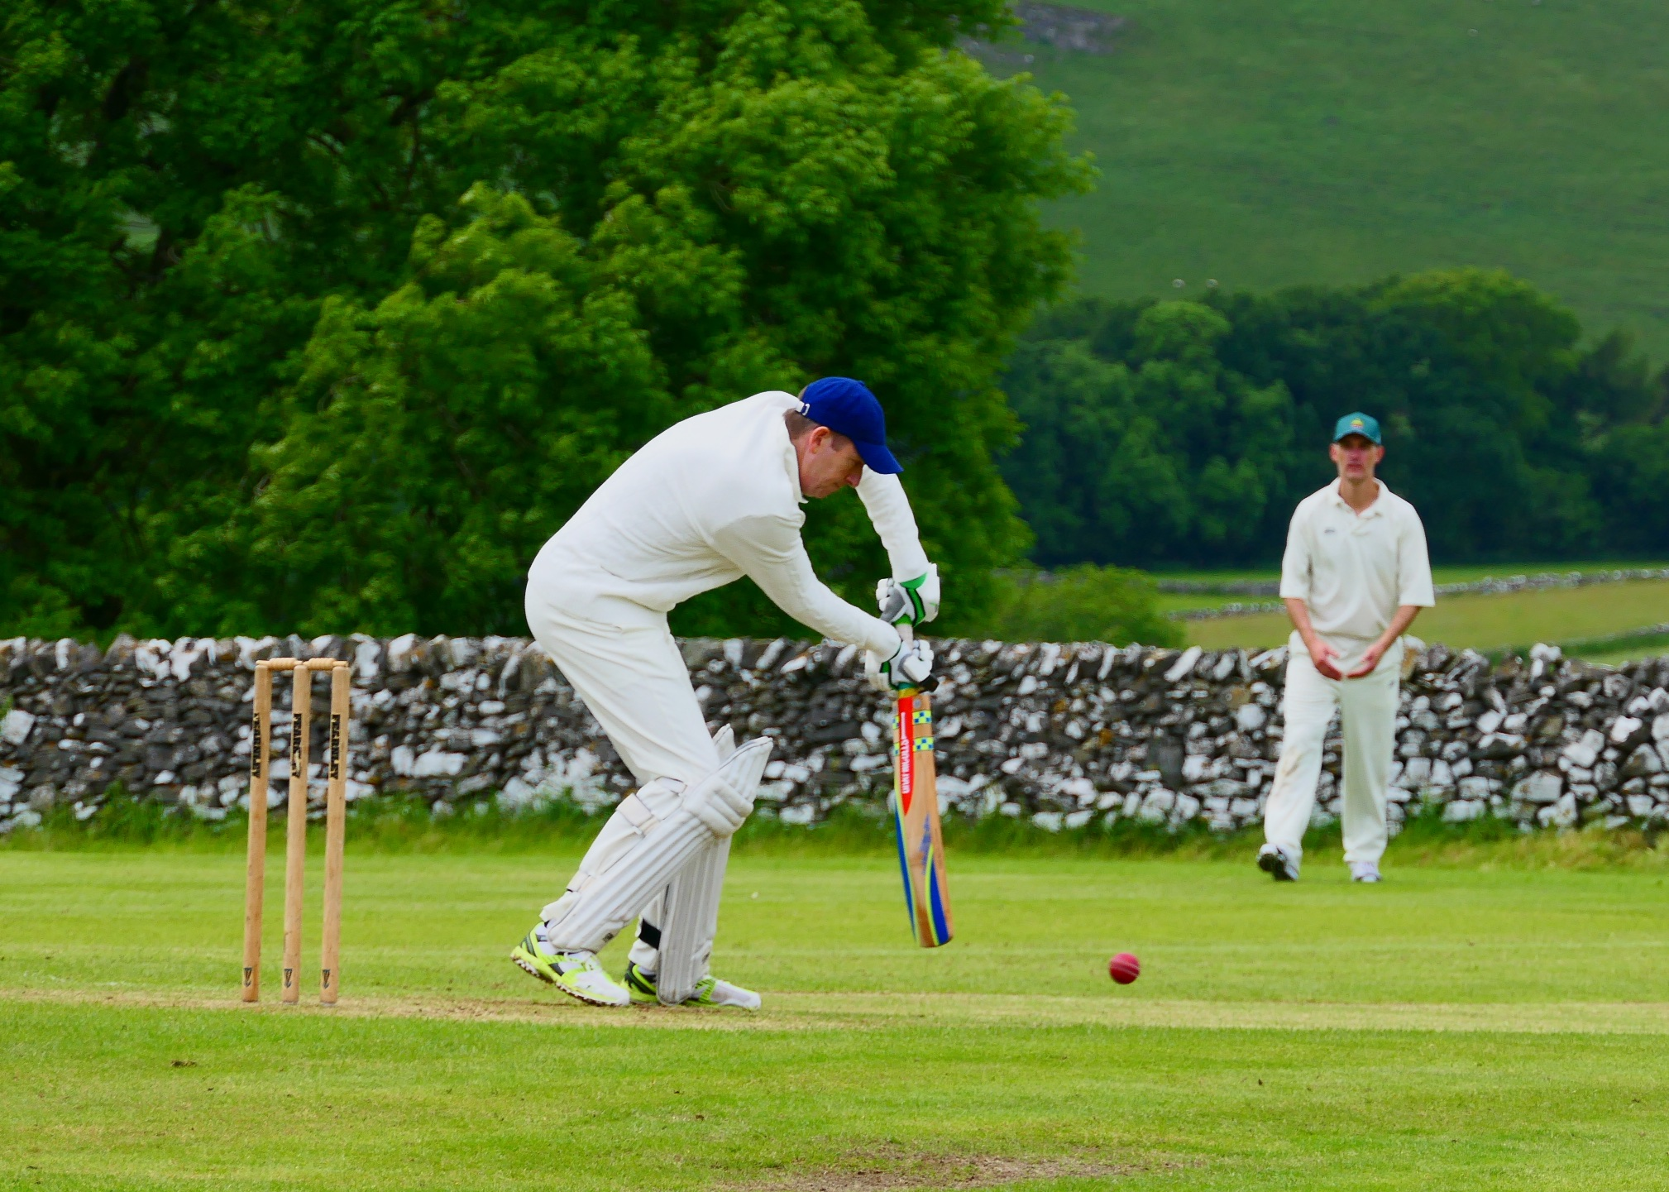
John Curry - more than capable

Not quite 160, but as tea was taken while the rain came down again, there was a quiet confidence in the Gargoyles ranks.
Ben King’s wicket maiden first over was just the start. A confident drive by opener Blenkinsop, but hard and straight into the hands of Steve King.

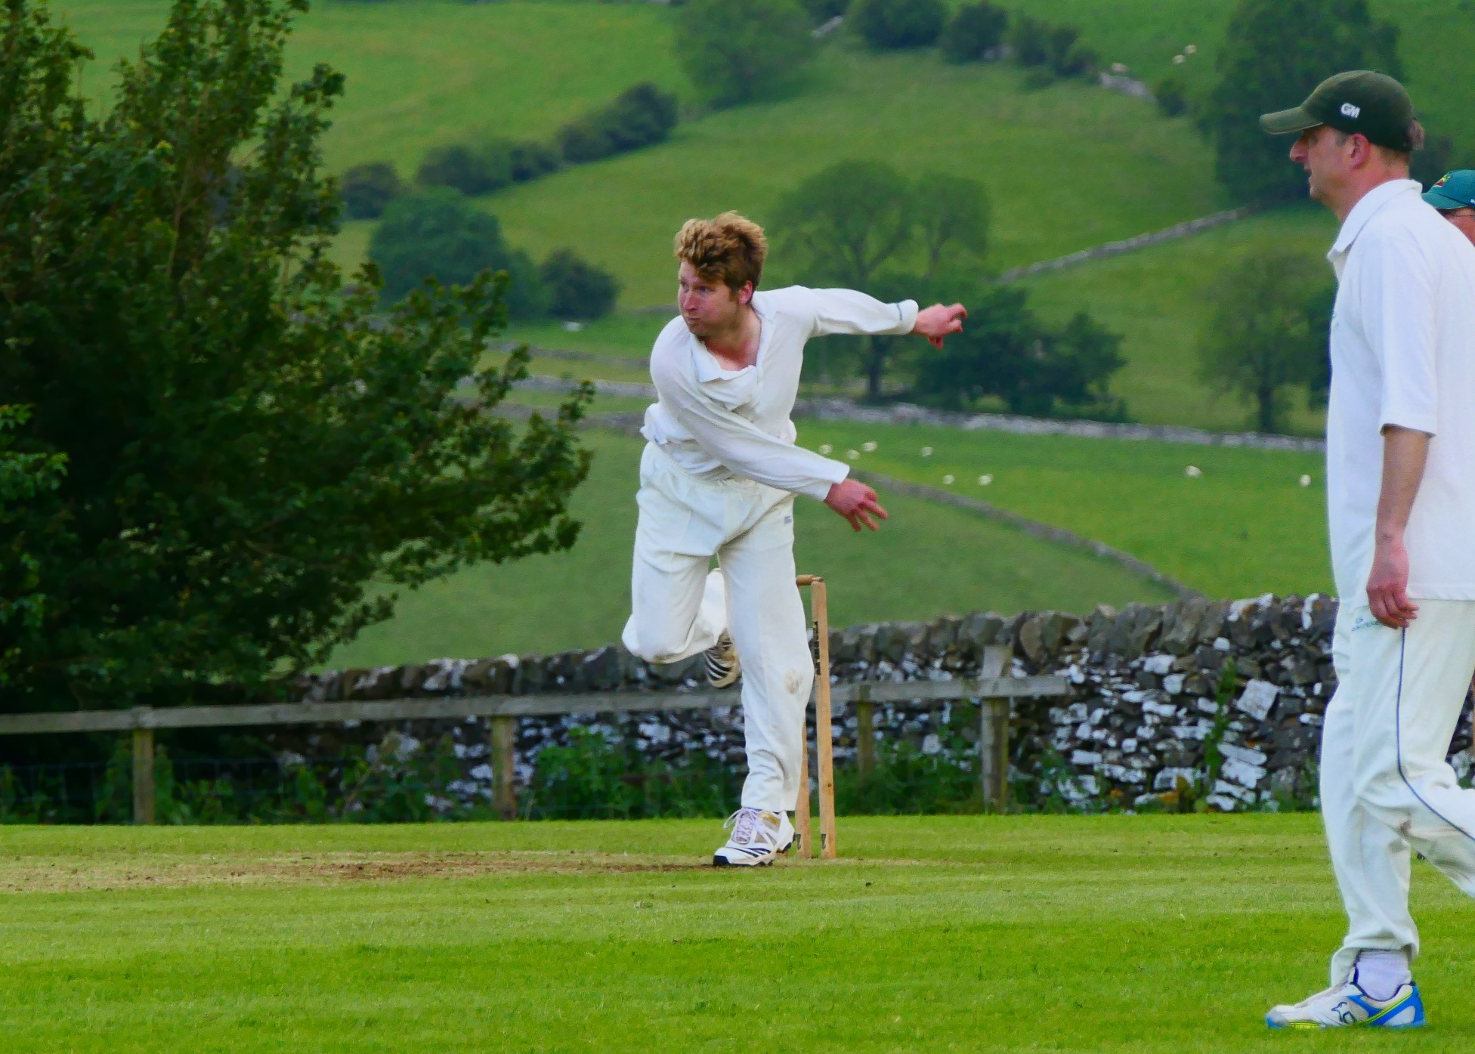
Ben King - a wicket maiden to start his spell
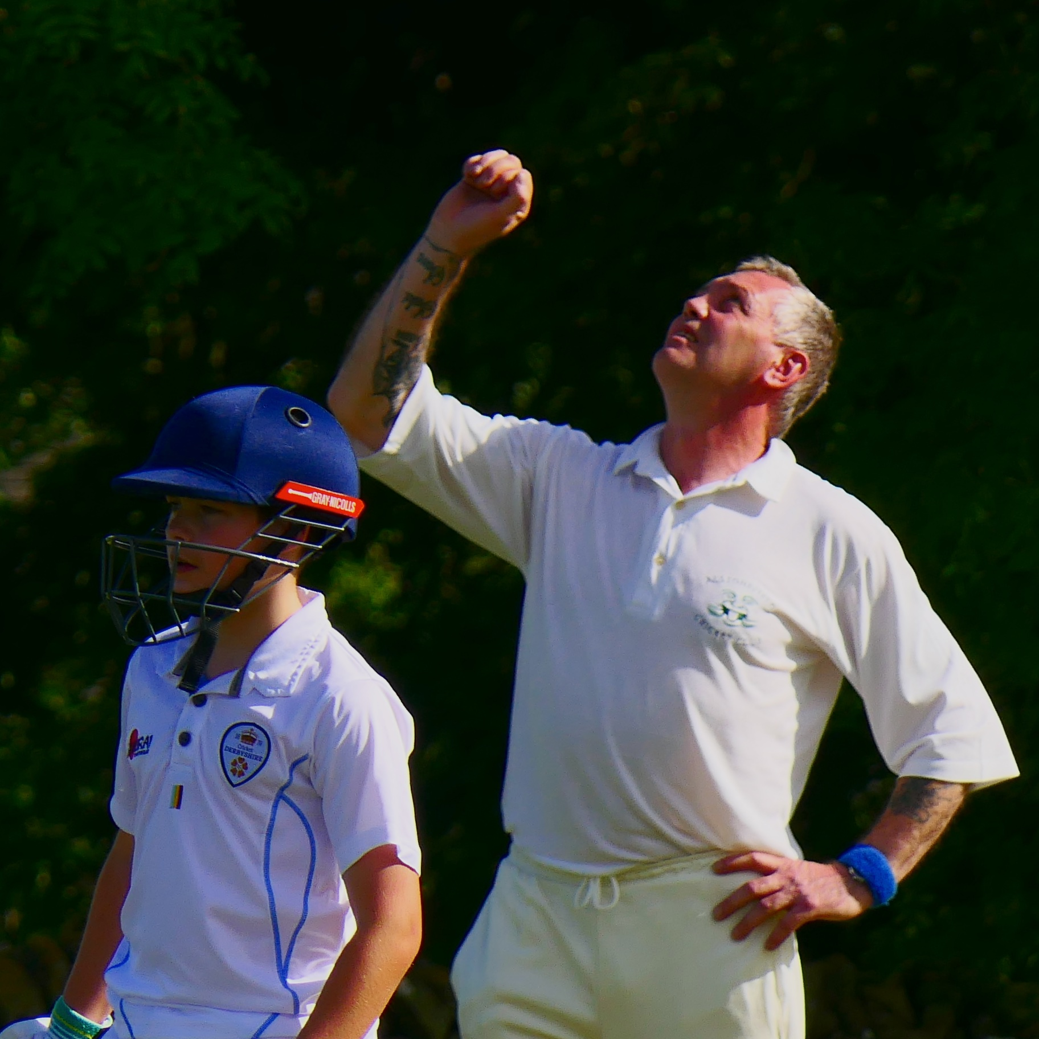
Steve King – another fine catch
Tony Guest shared the new ball and was immediately into his rhythm. The Duffield batsmen were struggling to get off the square. Pressure builds in a batsman’s mind, risky shots come out of nowhere and suddenly it is 15 for 5 after 10 overs.
Harry Jones, having his best season with the gloves, made two low leg side edges look simple and Andy Farmer joined the catching party, holding on to a return chance off his own bowling. This brought Duffield captain Jones to the middle and he announced himself with an emphatic pull for four and gave notice he was probably as destructive with the bat as he had been devastating with the ball. For the second time this season, Jon Lane changed the game. A full blooded on-drive off Guest, no more than two feet off the ground was being guided to Lane’s knee caps. Some would have avoided the impact by jumping aside Lane calmly bent forwards and pouched the leather. The batsman, and if truth be told, his team mates, fell silent in awe. The fly past by the Red Arrows was perfectly timed.
Perfectly timed appearance from the Red Arrows

From 15 for 5 there was then the best partnership of the match between the elegantly correct Bond and Watson, who manfully took the score to 69.
Ben King and Ian McKay were brought on to mop up the tail and Guest finished the contest, courtesy of a well-judged pounce by Simon Smith.
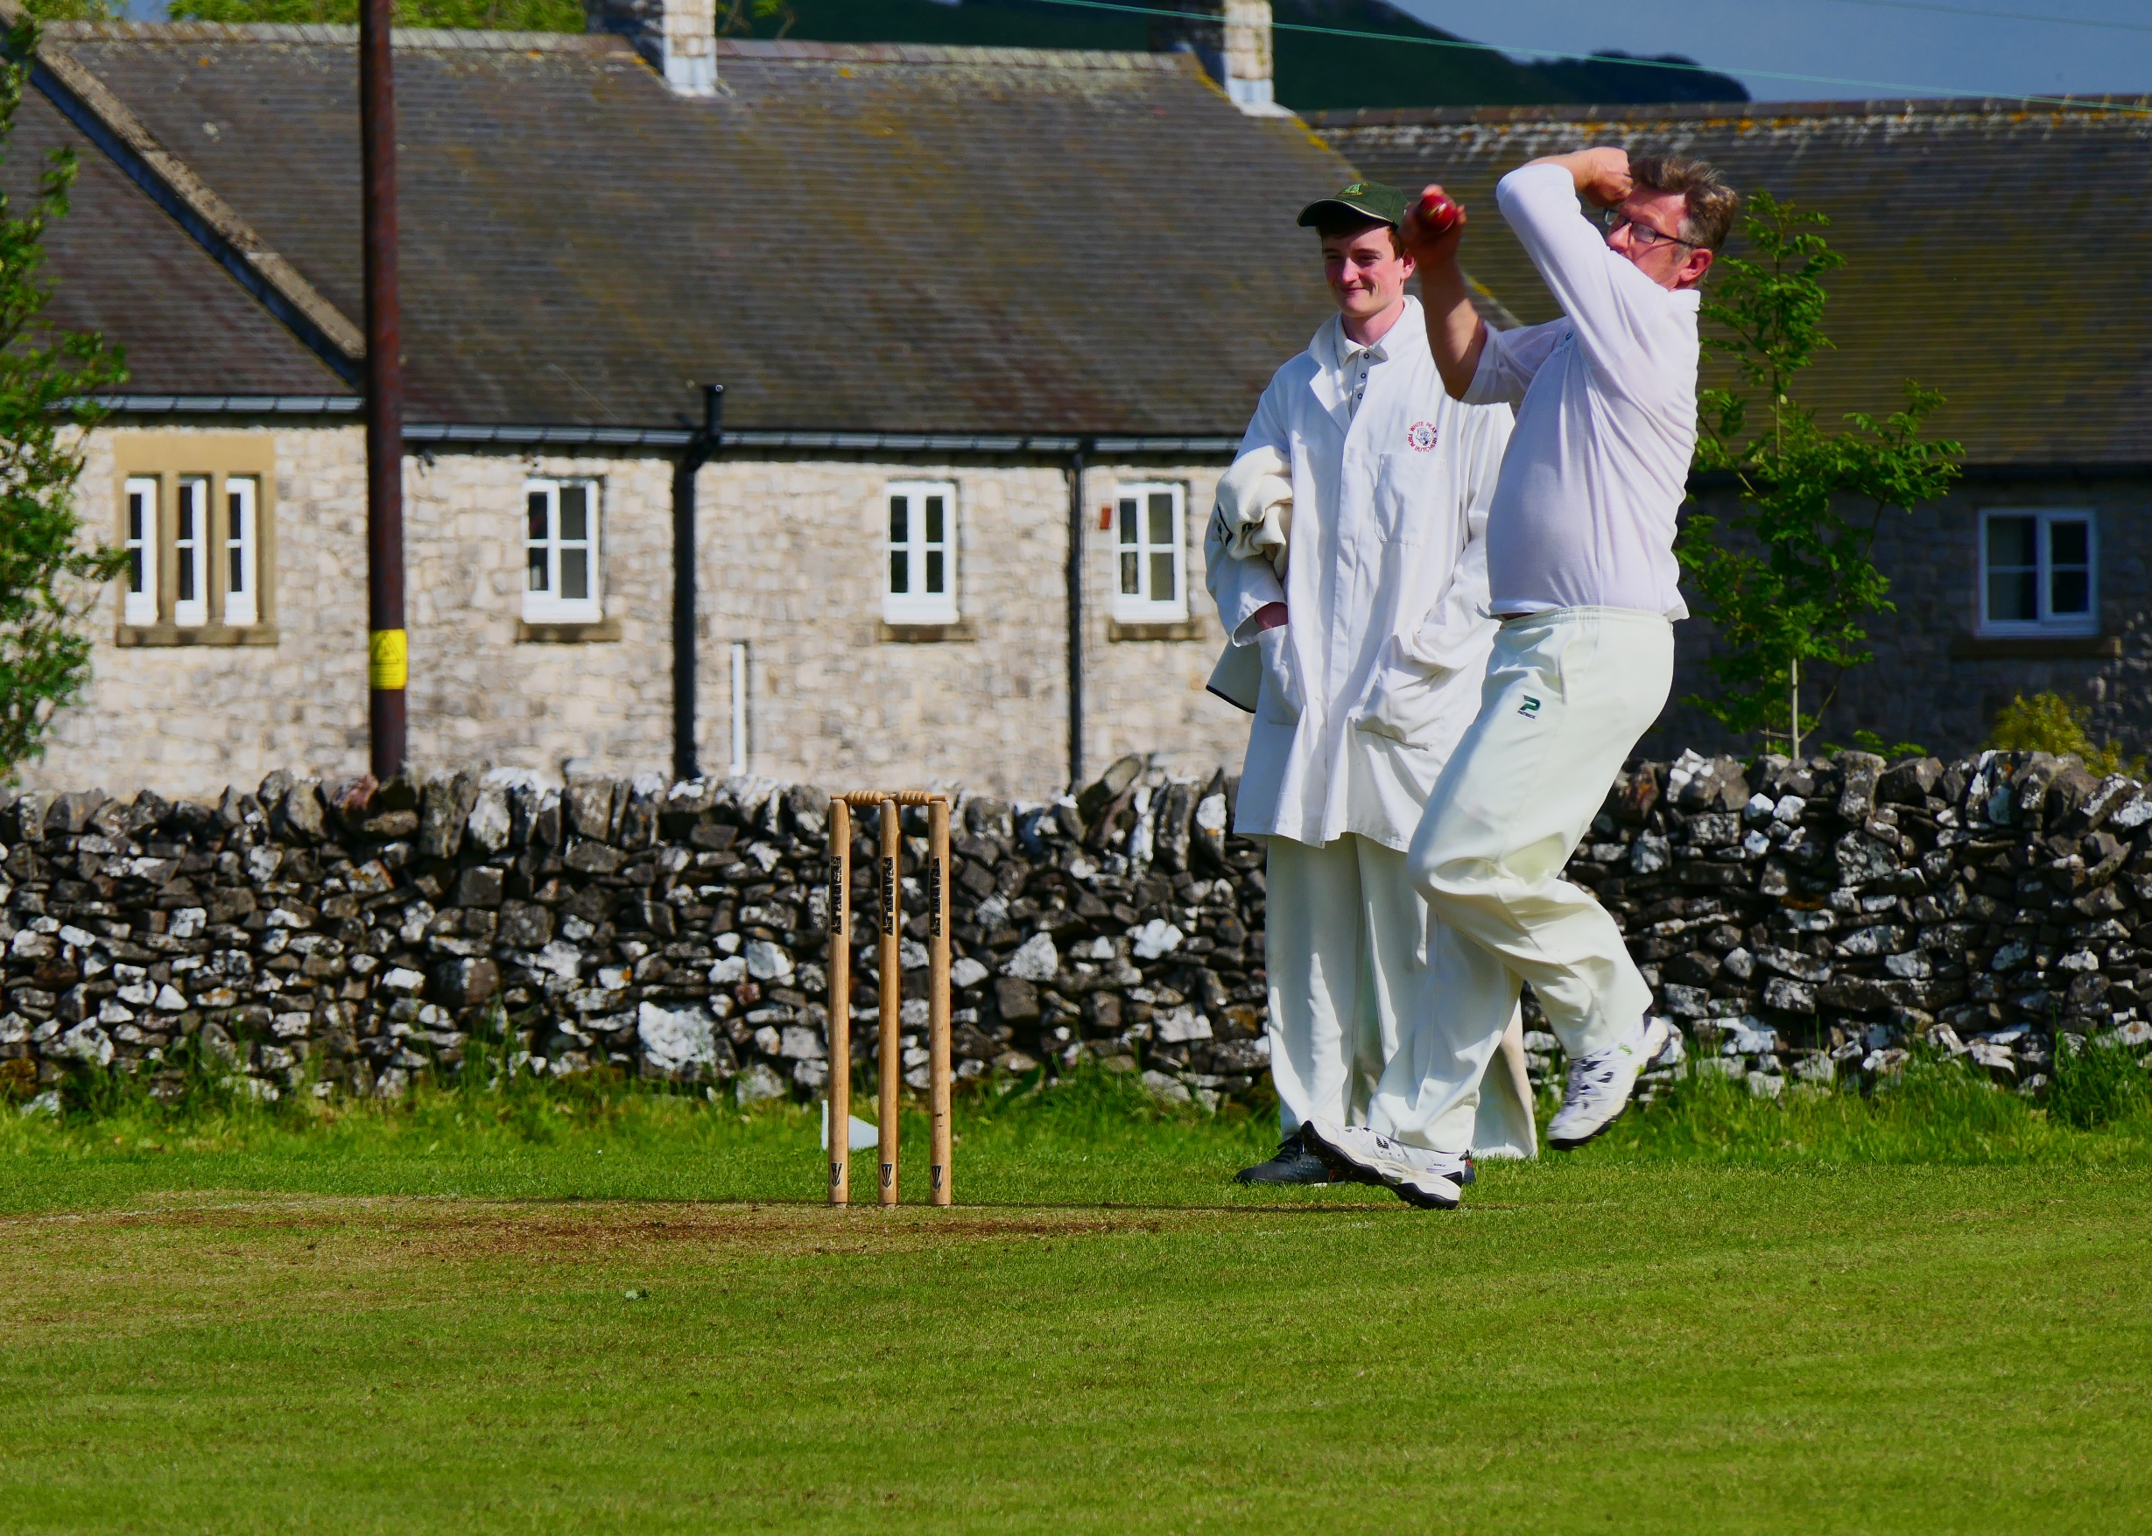
Tony Guest - pick of the bowlers
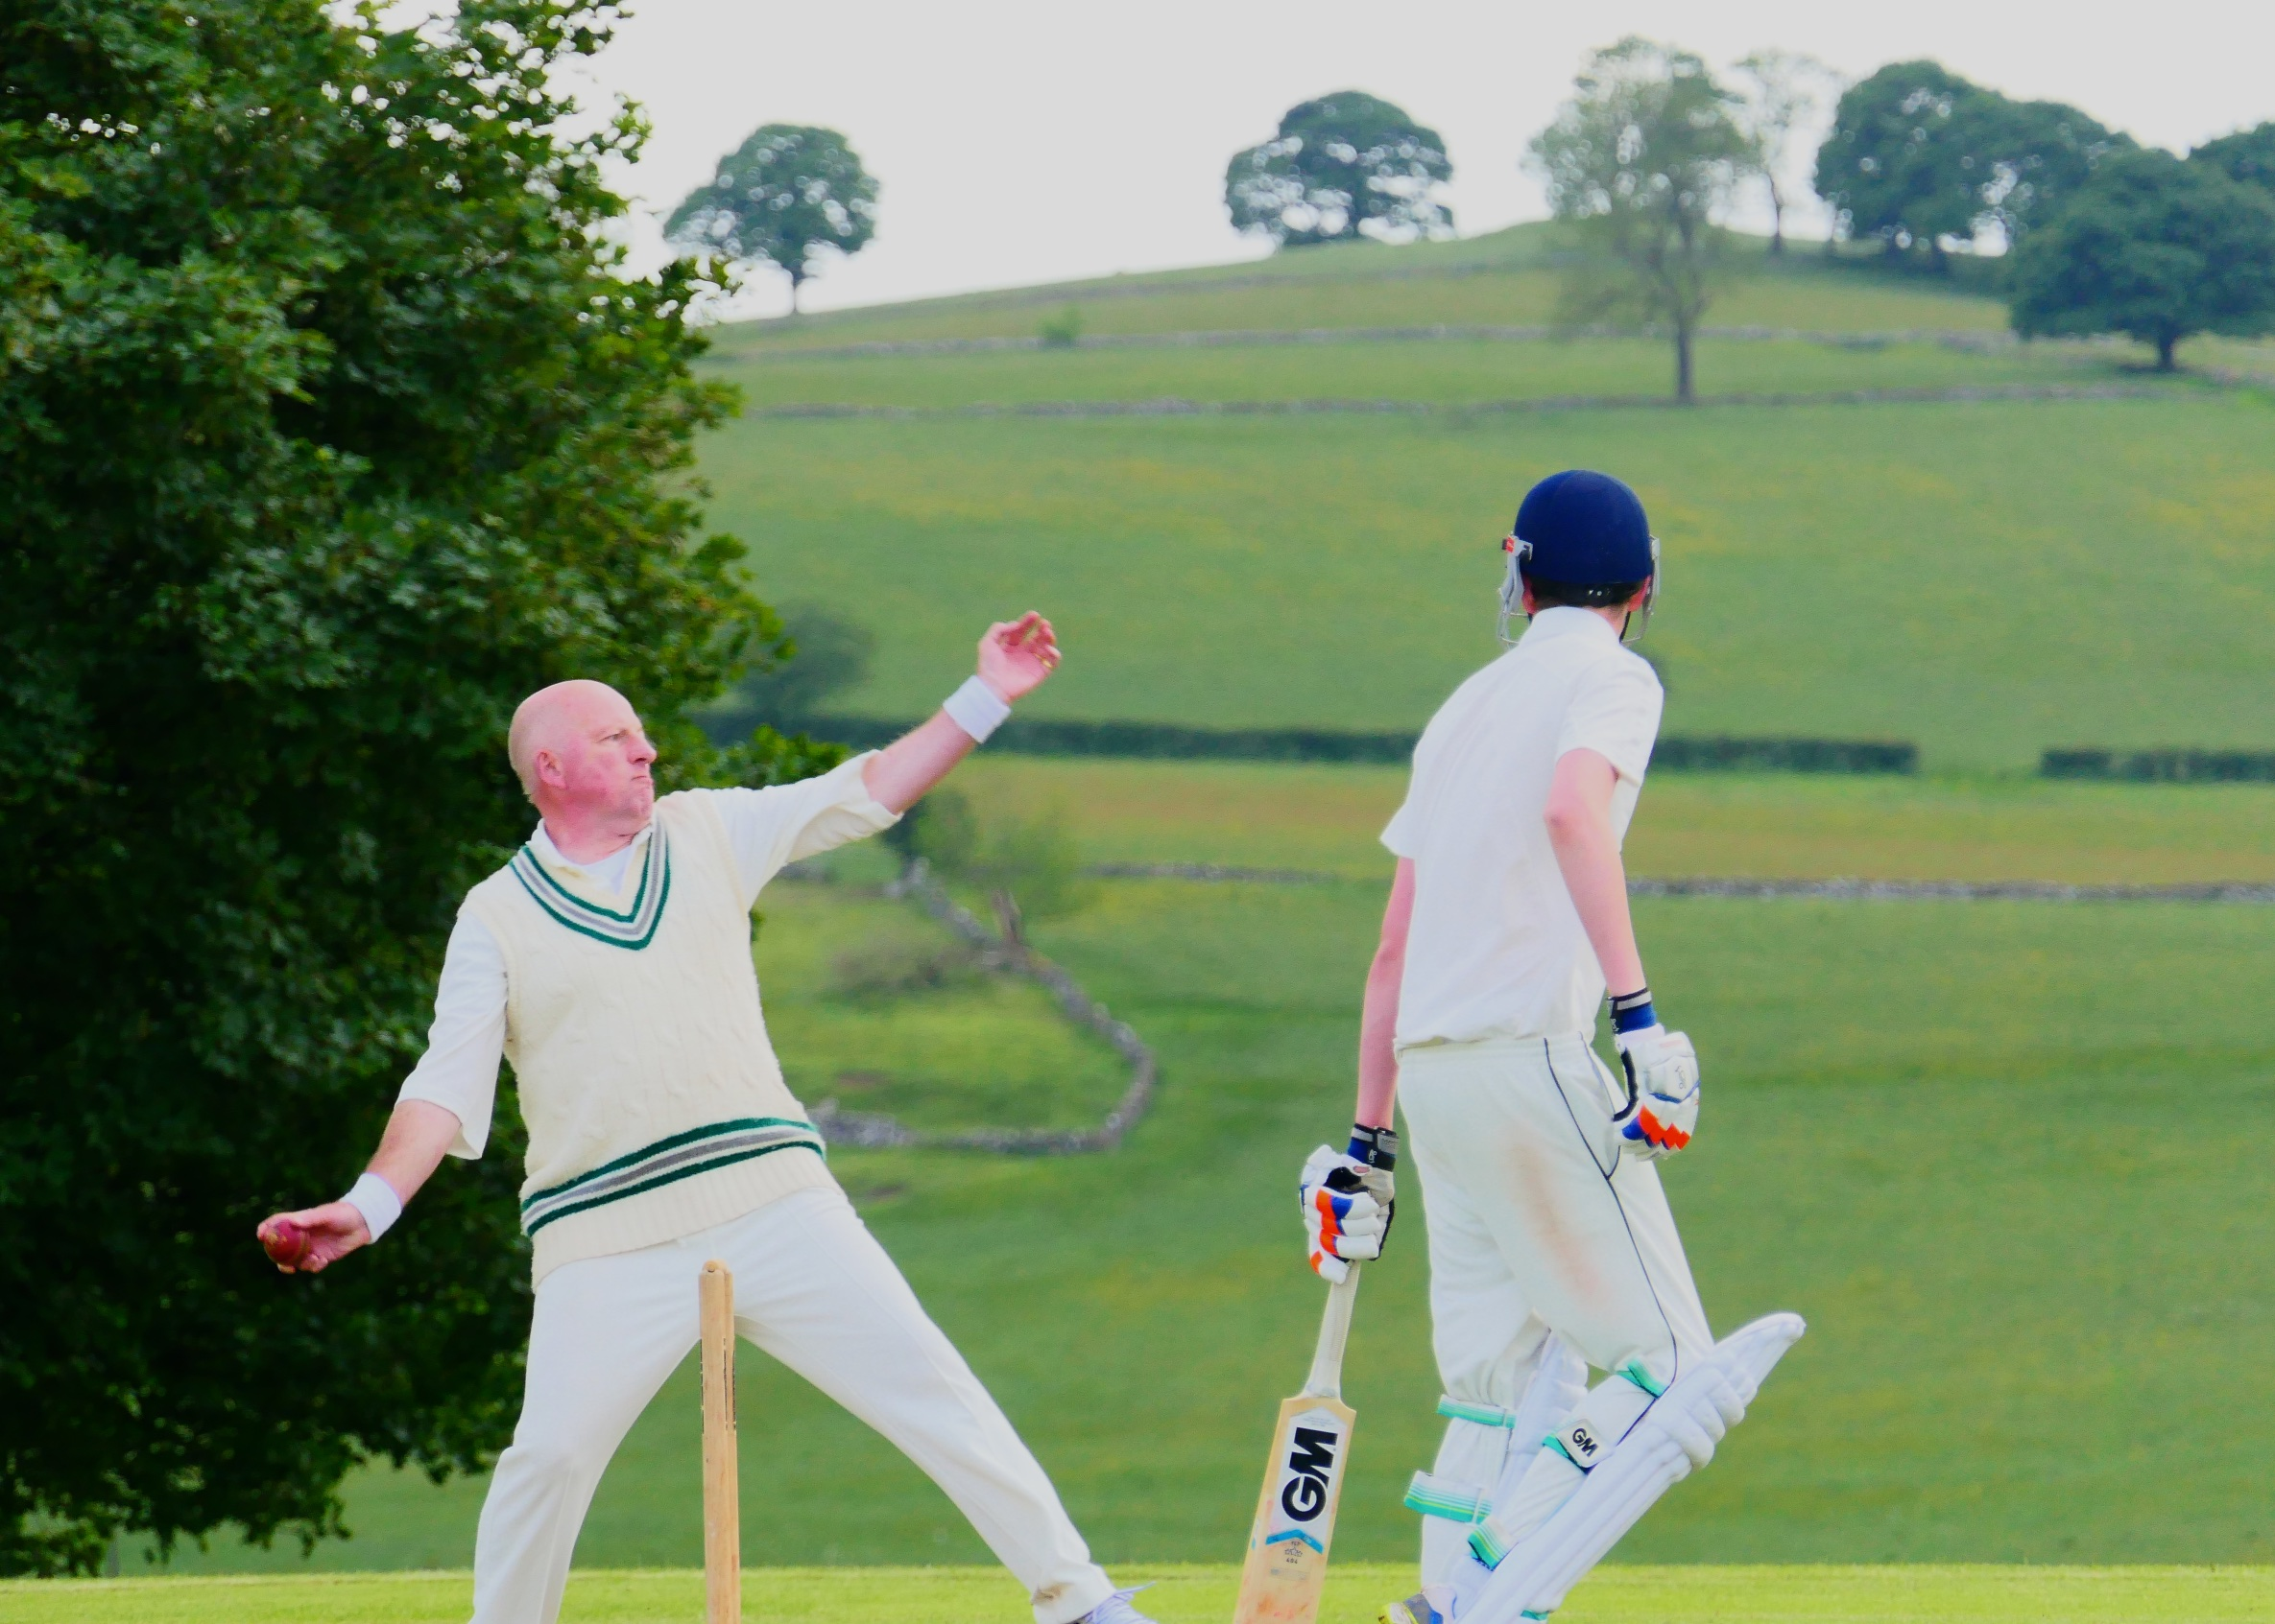
Ian McKay helped mop up the tail
Guest, the pick of the bowlers, finished with 3 for 8. Duffield all out for 85. Another win and another all team performance in the field.

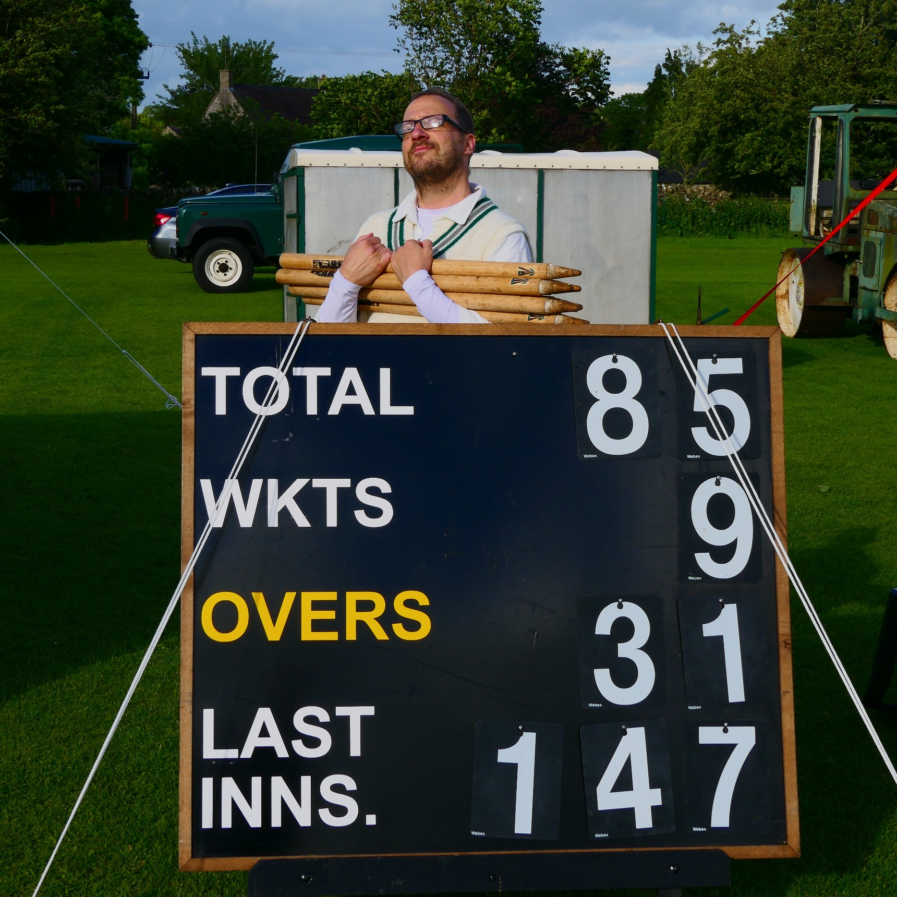
The final scoreboard with Neil Shotton gathering the stumps at close of play

ALSTONEFIELD CC 147 ALL OUT BEAT DUFFIELD CC 85 ALL OUT BY 62 RUNS

