IT’S DOCTOR’S ORDERS FOR CLINICAL GARGOYLES

Occasionally in life, everything just clicks into place and the moment needs to be savoured. In their first match of the 2017 season against Abbots Bromley, Alstonefield Cricket Club appeared to be in the rudest of health. The weather and wicket were excellent and the performance had none of the usual first match of the season aches and pains about it. And to top it all, new blood contributed to a resounding six wicket victory……

Click here to read more…

Bowling first, the Gargoyles’ opening attack of Shahid Ali and Will Siddons was so accurate that Abbots Bromley were barely scoring at a run an over and as frustration built, they lost both openers cheaply. At 15 for 2 off 12 overs, Simon Smith, captaining in Andy Bray’s absence, felt able to ring the changes and give all of his bowlers a run out.

Shahid Ali set the tone with his opening spell

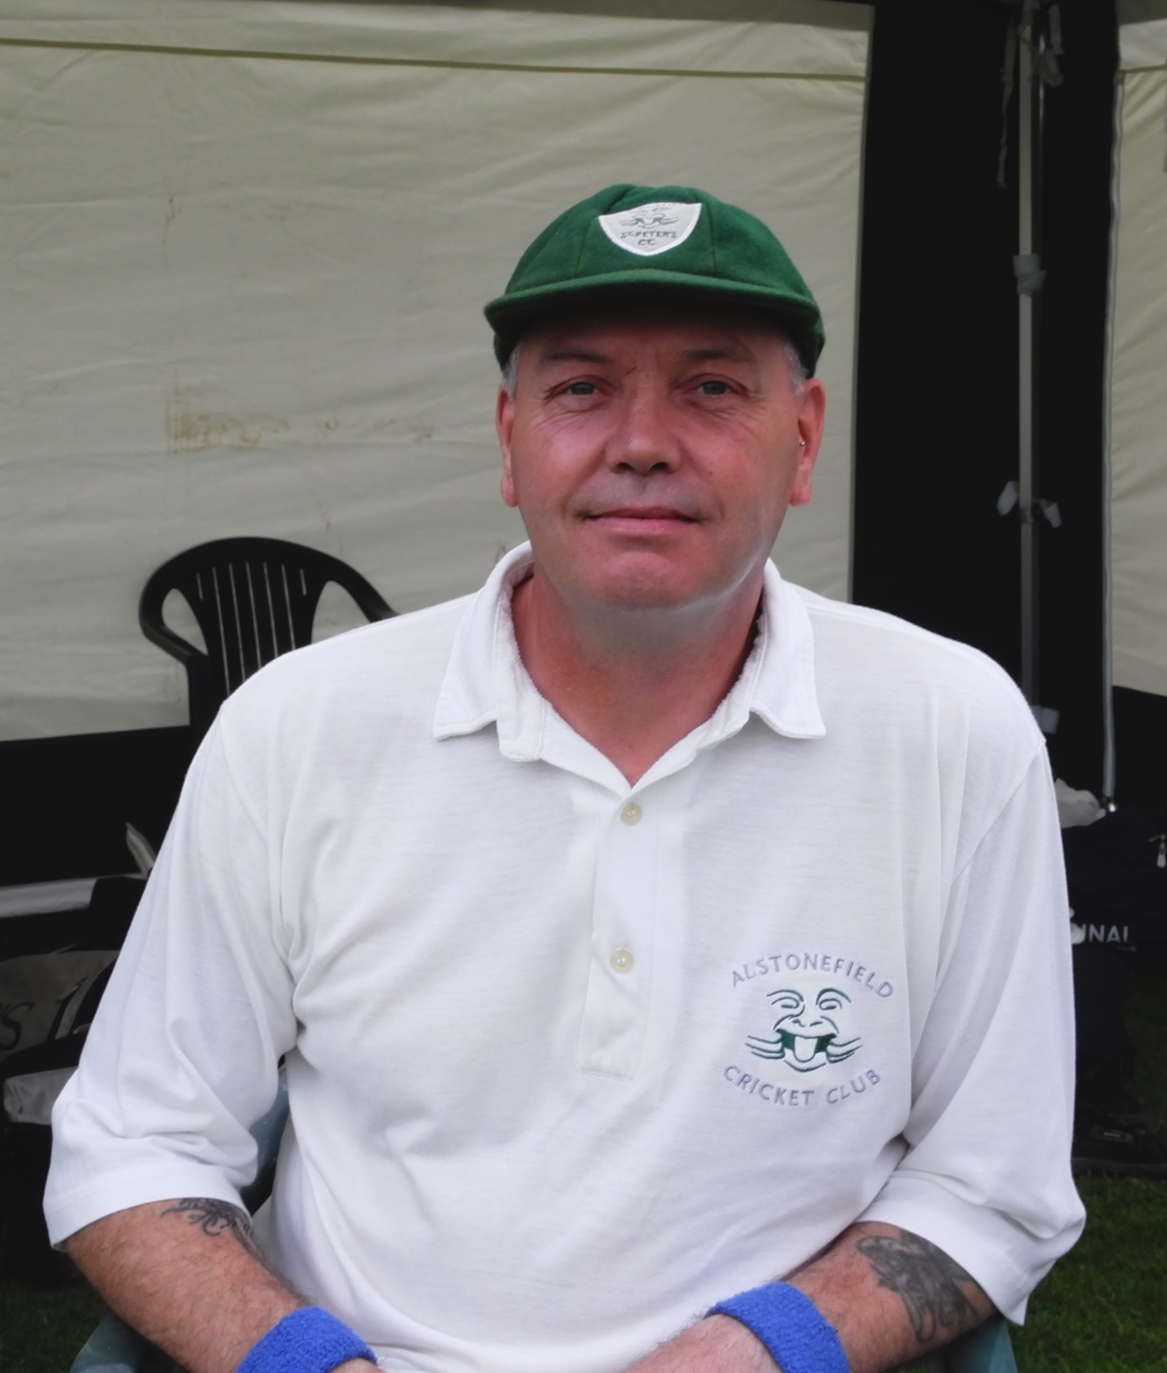 Steve King – delighted to be back bowling

For Abbots Bromley, Haywood and Norris slowly built the biggest stand of the innings, before Haywood was bowled for 22 by Steve
King in his first spell since major shoulder reconstruction.

Norris went on to make a fine and chanceless, unbeaten 50, but at the other end the comings and goings resembled A&E on a Saturday night. Liam Duffy, fresh from his acclaimed league exertions, was his usual nagging length. Andy Farmer’s loop looks to be in fine fettle, while captain Smith bowled his leg breaks to great effect. There was even a modest little cameo from Ian McKay, bowling for the first time in two years after spine surgery, who removed Kirkland’s middle stump with his first ball. This was followed by another wicket and eleven dot balls!
Captain Smith made sure the fielding was sharp throughout, and although there were dropped catches, runs were keenly restricted leaving Abbots Bromley to struggle past the 100 in the 38th over.

ABBOTS BROMLEY 108 FOR 8 WICKETS AFTER 40 OVERS.

Harry Jones and Will Siddons began the Gargoyles’ response, with a Jones trademark late cut for four. Young fast bowler Haywood was impressing with his line and movement off the pitch and the ball that moved from middle to clip Jones’ off stump deserved a wicket. At 18 for 1, Siddons was joined by Liam Duffy and began to assert himself with textbook forcing shots off front and back foot. These two had moved the score to 48, when Duffy edged another peach from Haywood and was caught behind. Siddons had looked untroubled until, on 25, he misjudged the line and was bowled by Fitzgerald. At 62 for 3, the club’s resident GP, John Curry, was joined in the middle by vice-captain Shahid Ali. After an under-the-weather 2016 with the bat, Curry was clearly determined to show a full recovery in form. After seeing off the dangerous Haywood and with his feet moving nicely, he began to work the ball around the ground. A couple of exquisite lofted drives had the spectators purring. With Ali in calm support, these two were heading for victory when Ali felt a twinge and retired, giving debutant David Joyce the chance of immediate stardom by scoring the winning runs. It didn’t quite go as prescribed, as a complete bedpan of running between the wickets left
Curry stranded and run out for a top score and Man of the Match earning 27. Fortunately for Joyce, the next man in was Gargoyles’ veteran Neil Shotton. Exactly two years ago on the same ground, he had been one of the two protagonists in the legendary, last over victory-into-defeat carnage, which can haunt a batsman of doubtful fibre. Cometh the hour and Shotton expertly guided Joyce to score his first run for the club and then assumed control with two perfectly placed drives securing victory in only the 26th over.

The day ended perfectly, with a hearty supper in the Coach and Horses, courtesy of the hosts. Based on this performance, the prognosis for the Gargoyles has to be a good one.

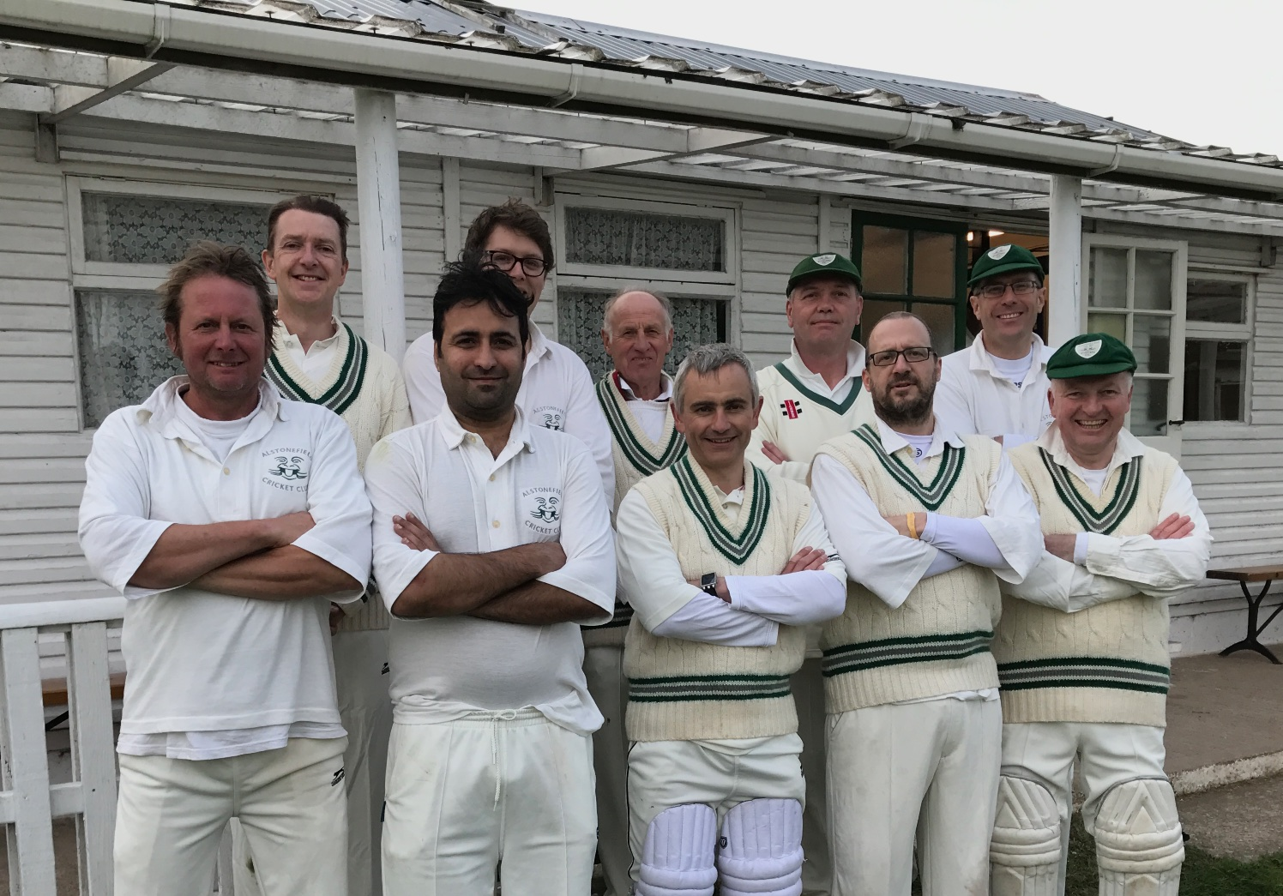
Alstonefield Cricket Team v. Abbot’s Bromley Away

- Man-of-the-Match John Curry is second from left
- Debutant David Joyce is in middle of the front row

ALSTONEFIELD CC 110 FOR 4 , BEAT ABBOTS BROMLEY CC 108 FOR 8, BY 6 WICKETS

