GARGOYLES MEET IRRESISTIBLE FORCE

There are moments in sport when an opponent is just too good. So it was on a beautiful Sunday afternoon at Mugginton, the opening match of the season for Alstonefield CC against Sunseekers.

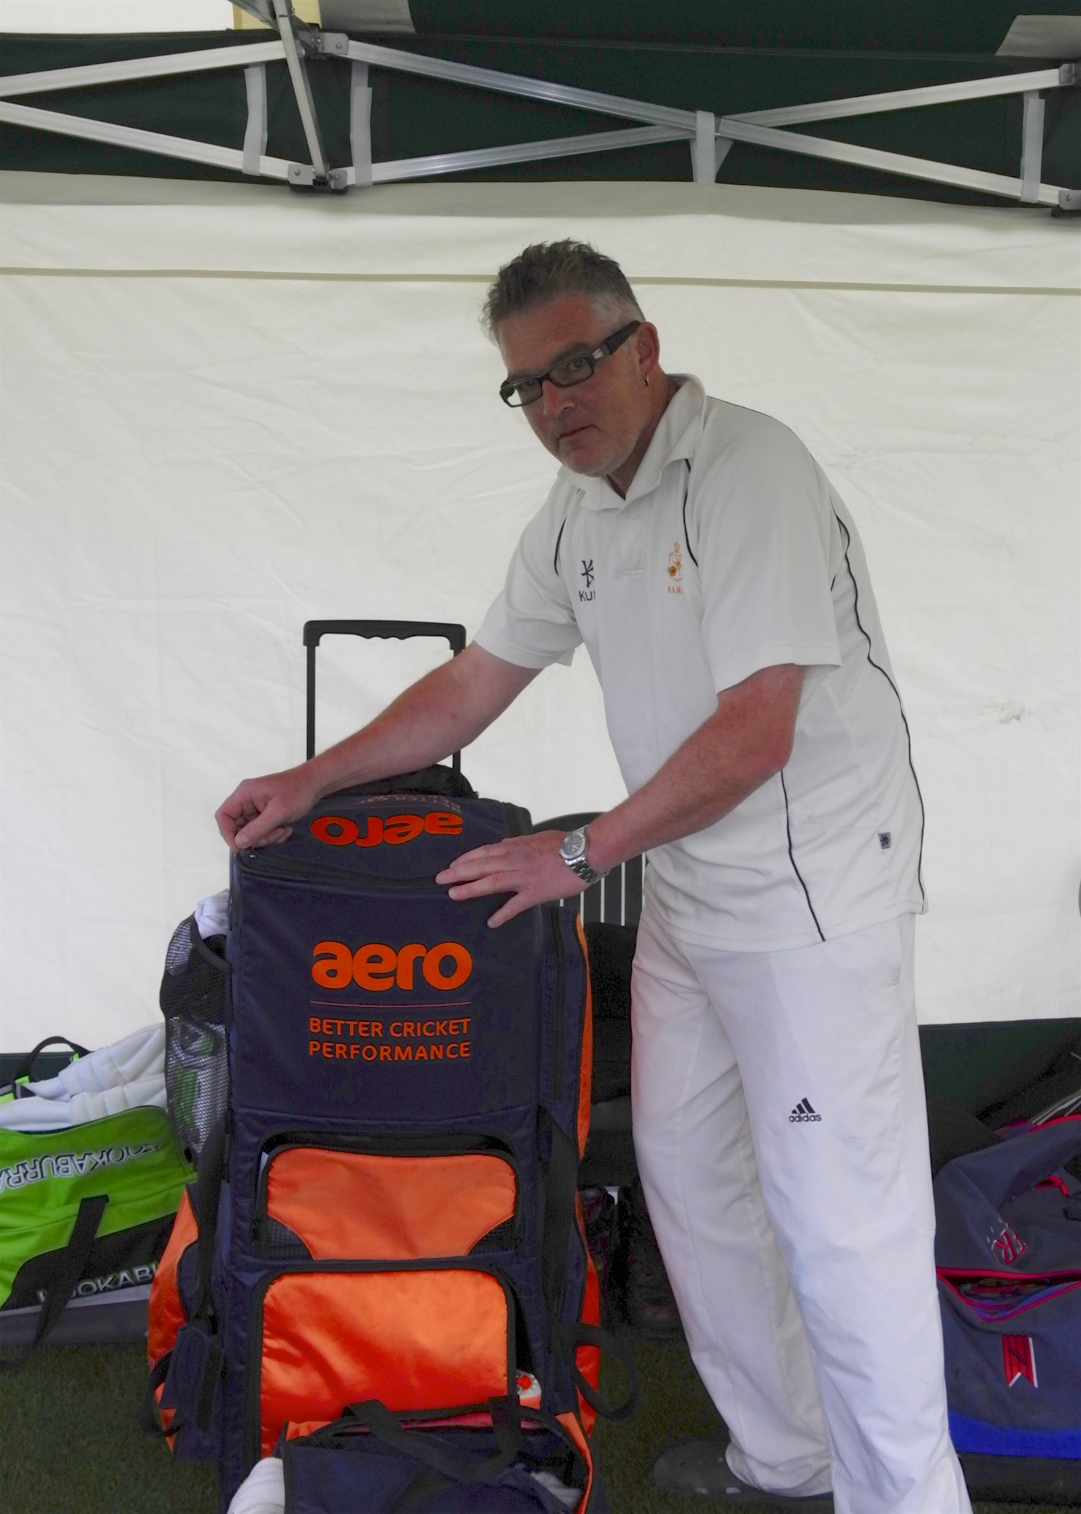
Put into bat, the Gargoyles got off to a nervous start when the prolific Harry Jones was bowled third ball. The fact that 38 overs later they were nicely positioned on 201 for 3 was down to a record breaking innings by Liam Duffy together with
a calm and assured knock from Will Siddons and what can only be described as a revelation from Neil Shotton. Duffy finished marooned on 98 not out in the last over as four batsmen failed to get him on strike so he could secure the first ever century in the club’s history. First with Will Siddons, who made 27 and then with Neil Shotton, he simply mastered a high quality bowling attack with exquisite timing and placement. Shotton’s innings of 46 was his best for the club and was a terrific advert for hours of dedication with a bowling machine. 201 felt a good total to defend.
Record Breaker
Liam Duffy
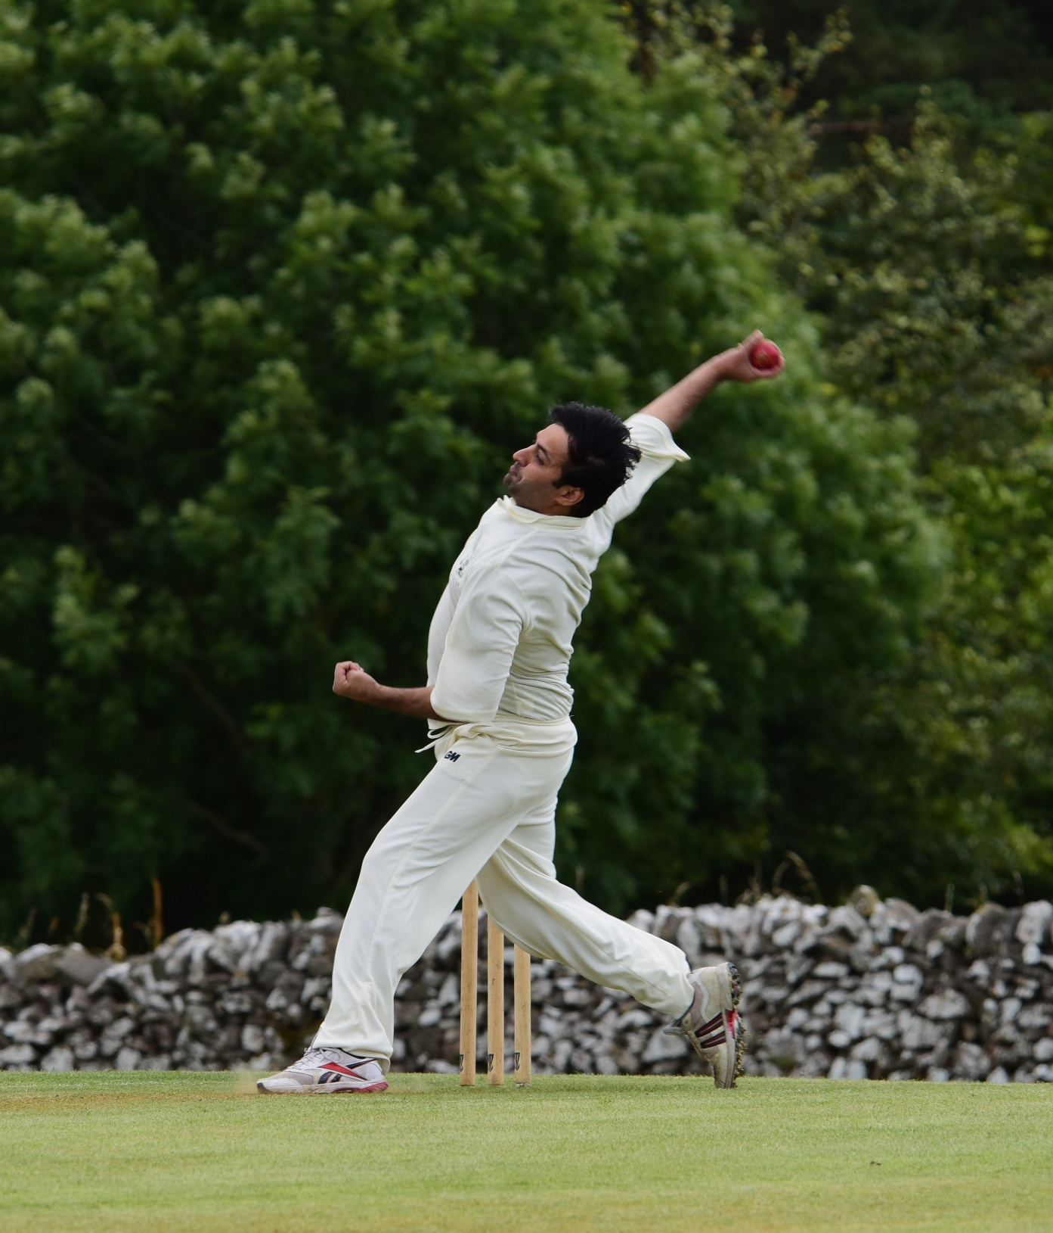
And the Gargoyles’ bowling looked to be up to the task. The fact that they dismissed seven Sunseekers’ batsmen for a combined 19 runs, including a mesmeric 6 for 21 spell from Shahid Ali and still lost the match is down to an outstanding innings of 128 not out from Geoff Longden. For all the Gargoyles who were there, this was the finest knock they had seen. It was chanceless, effortless and totally commanding.
Rare that a 98 not out and a 6 for 21 are not enough for victory, but it took something special. Back to the bowling machine for the Gargoyles.
Shahid Ali :
Mesmeric 6 for 21

Neil Shotton : A revelation at Mugginton
A

ALSTONEFIELD CC 201 FOR 6 LOST TO SUNSEEKERS 202 FOR 7 BY 3 WICKETS

