GARGOYLES IN FESTIVAL MOOD

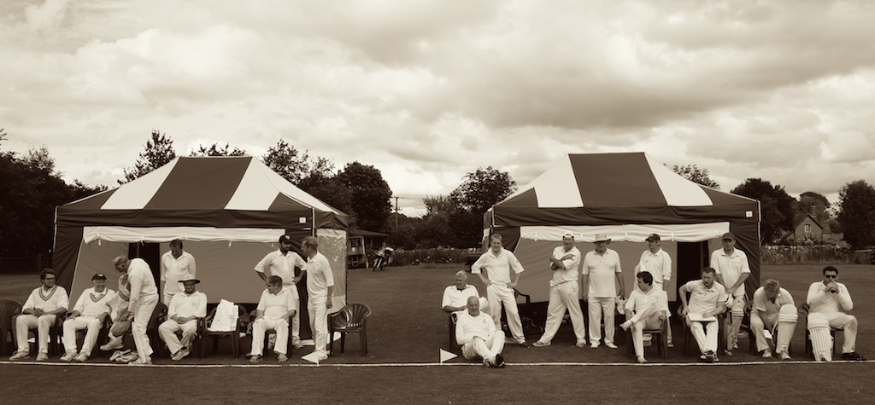

Brass bands, ice cream vans and marquees have been the backdrop to a busy week of cricket for Alstonefield CC, which saw a narrow defeat to Peak Park and a thumping win against Tideswell & Hope Valley Occasionals. The Tuesday evening match against Peak Park at the delightful Bakewell CC ground in the Parks coincided with the opening of the Bakewell Show, and a tense duel was played out to the sound of the National Anthem (three times) interspersed with Land of Hope and Glory and the tinkling sound of Mr Whippy. The Sunday fixture against Tideswell and Hope Valley Occasionals continued in the celebratory vein, albeit without musical accompaniment, as the club unveiled their splendid new marquee changing rooms and put in an impressive show on the field too with an emphatic win.

v. PEAK PARK

An evening match in August favours batting first, but the Gargoyles made the best of losing the toss by putting in a superb bowling performance and restricting a handy Peak Park outfit to 88 runs from their 20 overs, 50 of which were scored by Bradford and Croney. All the bowlers played their part, but Ian McKay’s figures of 3 for 3 (all clean bowled) stand out.

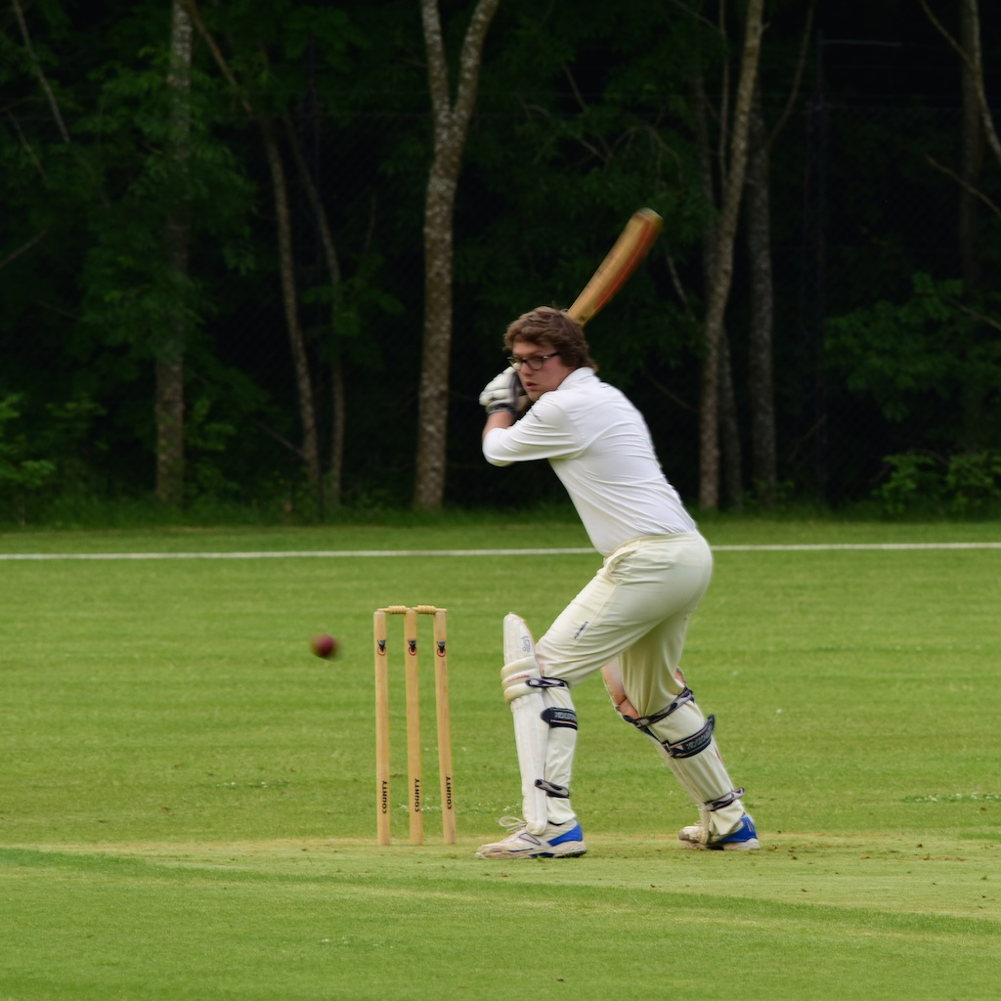
As darkness descended, Harry Jones and Will Siddons batted with some caution against an accurate bowling attack, but both took control and reached their unbeaten 25s having set the platform for a comfortable victory. Unfortunately, the next five batsmen managed only 11 runs between them as stumps were rattled.

Will Siddons - unbeaten 25
It was left to Ian Longdon with his highest score for the club and captain Andy Bray to give hope. They had moved the score to 78 entering the final over, so 11 would win the match. Despite some lusty blows, with the field set right back, only 5 were scored and there was no glory.
Ian Longdon - highest for club

Alas, yet another last over defeat.

PEAK PARK CC 88 FOR 9 , BEAT ALSTONEFIELD CC, 83 FOR 6, BY 5 RUNS

v. TIDESWELL & HOPE VALLEY

On the warmest and brightest Sunday of the season the Gargoyles entertained the Tideswell and Hope Valley Occasionals for the first time. Resplendent with new marquees and boundary rope, the ground was a picture reflecting a bygone era. Batting first, the Gargoyles got off to a poor start when Andy Bray had a rare failure and then Will Siddons was run out for 9 at 28 for 2. Harry Jones had made steady progress to 22, when he mistimed an on drive and was caught.
Ian McKay joined Neil Shotton, who looked like he was playing himself into form, when on 17 he too popped a catch to mid-on. 53 for 4 off 15 overs was not looking so bright. Dave Singleton was straight into his repertoire of straight drives, as he and McKay took charge, putting on 35 in just 5 overs, before Singleton missed a Yorker on 19.
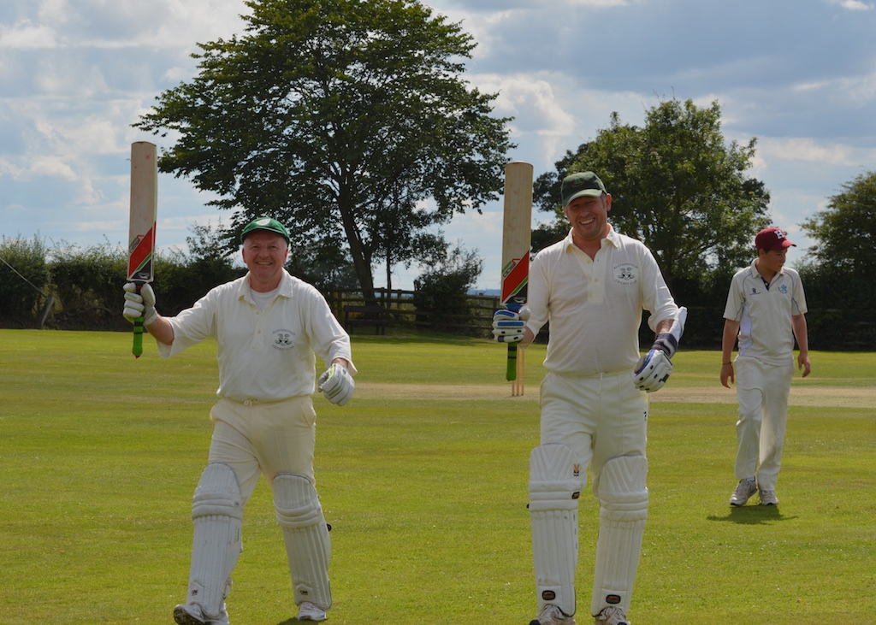
McKay & Guest in biggest stand of the day
Then the biggest stand of the day of 54 in 9 overs between McKay and Tony Guest put the Gargoyles in a strongposition to press ahead in the last 5 overs. Guest’s 27 was his top score for the club and the crispness of his shots square of the wicket suggests there are plenty of runs to come. McKay had reached 45 when he tamely top-edged one, leaving Shahid Ali to finally play an innings his talent deserves, as he made 27 not out in 9 balls, including 3 enormous sixes. So, at tea 189 from
35 overs at 5.4 an over, looked t competitive.

Andy Bray likes to mix his bowling attack with flight and guile at one end and raw pace from the other. After 8 overs of his own deceptive loop and Will Siddons’
“keep the batsman guessing” deliveries, 32 for 0 was a steady start for both sides. Then Siddons struck with 3 wickets in 2 overs, all bowled. 35 for 3, and with the stubborn Johnson gone, the middle order was exposed.
Butcher and captain Taylor dug in and moved from initial resistance to free scoring, moving the score to 69 before Butcher was snaffled in the slips off Shahid Ali for 22 in the 16th over.

Ali began another of his batsmen bamboozling spells and finished with 3 for 15 from his 5 overs, signalling the end of Tideswell and Hope Valley’s run chase. Taylor ran out of partners, as Andy Farmer, back from nuptial responsibilities, quickly found his length, slipping in with 2 wickets at the end. All out for 121 after a very good Gargoyles’ bowling performance, was the perfect way to end a perfect summer’s day.
Shahid Ali bamboozled the opposition !

ALSTONEFIELD CC, 189 FOR 8, BEAT TIDESWELL & HOPE VALLEY OCCASIONALS, 121 ALL OUT, BY 68 RUNS

