GARGOYLES HAVE GROUNDS FOR OPTIMISM

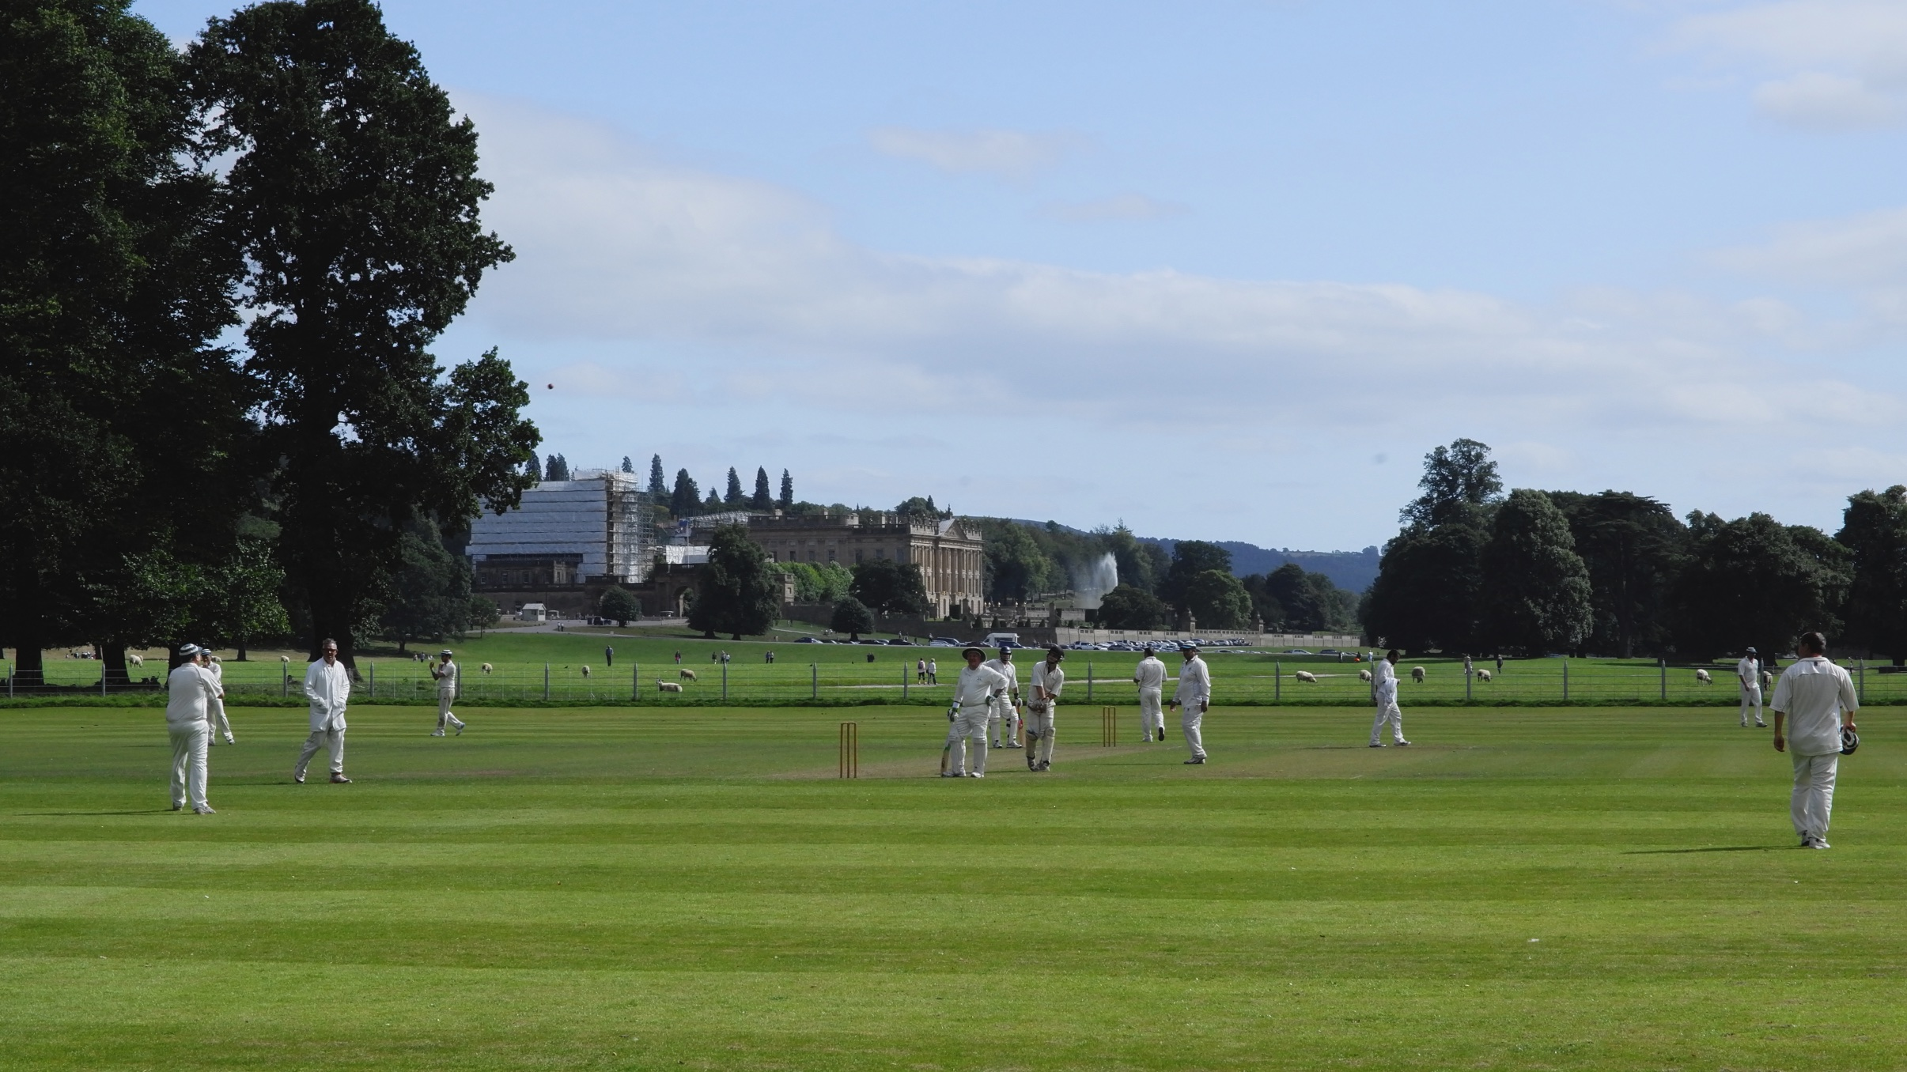
Chatsworth : A quintessential English setting for a game of cricket

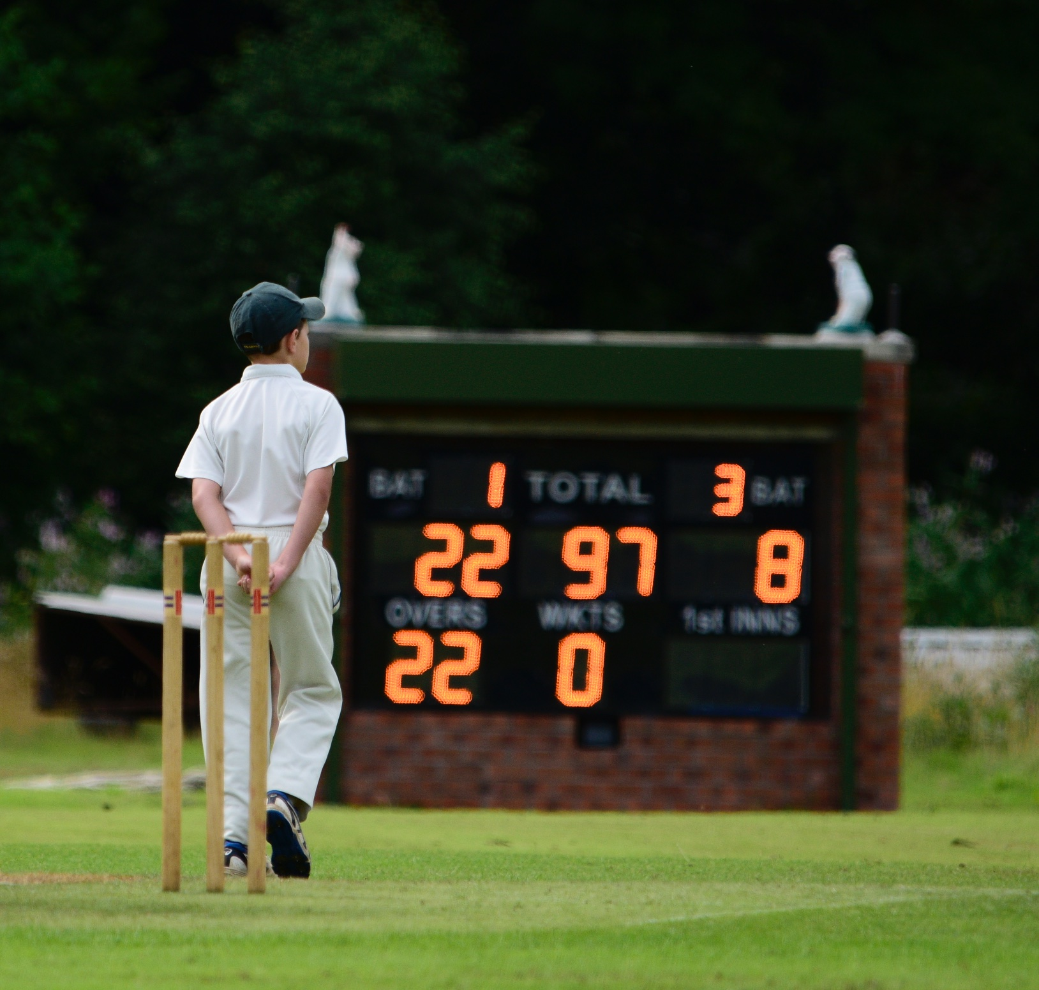
Illuminating cricket at Oakamoor

After the club’s tenth anniversary celebrations, came two tough away matches at Oakamoor and Chatsworth. These two fixtures epitomise the progress Alstonefield CC has made. Both take place in stunning surroundings, on superb cricket grounds. Oakamoor, the site of Thomas Bolton’s copper works and mass employment and CHATSWORTH, an estate seemingly far removed from the heat of industrialisation. Both clubs date back to the mid 19th century and take their cricket seriously. Recent history suggested two close games. And they were…

On a glorious Sunday, the Chatsworth match began with the awarding of Chatsworth CC’s splendid new hooped caps. The ceremony certainly inspired their opening bowlers. Everitt and Pack bowled their first eight overs with too much pace and hostility for Dave Singleton and Andy Bray, who were both back in the thatched pavilion with only 11 on the board.
Liam Duffy joined Neil Shotton and without ever dominating, these two began the repair job. At 39 for 2 in the 20th over, Shotton was bowled for 10 and in the next over Duffy played round one and was gone for 19. By the time Harry Jones was caught mistiming a drive, the Gargoyles had slumped to 52 for 6 off 25 overs and there was an air of a mismatch. The wonder of cricket is how the momentum of a team game can be changed so quickly by individuals. Ian McKay and Tony Guest appeared to be playing a different game, when right from the off, they played their shots all-round the ground. Boundaries and good running between the wickets, saw these two add 64 in just 11 overs, before Guest holed out to mid-on for 23. McKay saw the innings out with a top score for the day of 39 not out and a Gargoyles total of 128 for 9. It could have been a lot worse.
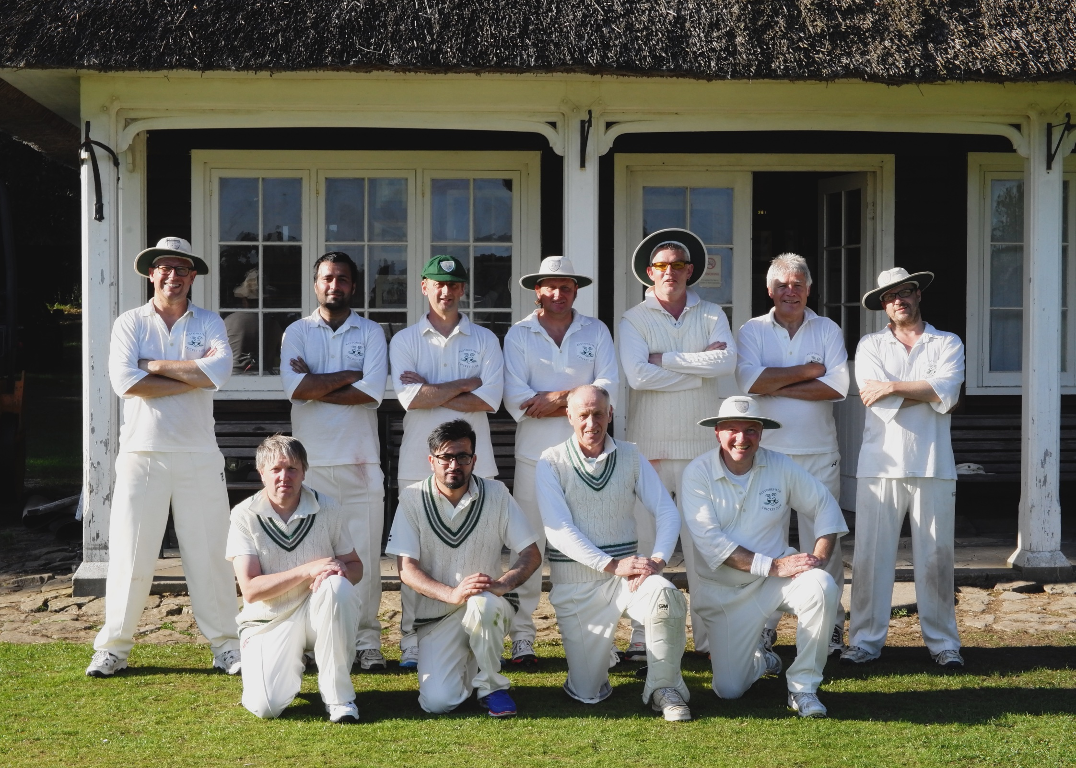
A Real Eleven-Man Effort at Chatsworth
With Chatsworth needing 129 in 40 overs, the Gargoyles could not rely on restricting the run rate alone. They needed wickets. The Chatsworth openers made it clear they were going for their shots and so we had that perfect mix of runs and risk. Captain Andy Bray went to his four most experienced bowlers and asked them to do a job. It almost worked. Tony Guest and Liam Duffy set the tone with a tight opening spell and a wicket apiece. Bray himself and Shahid Ali, followed with probing lines and again a wicket apiece. When Duffy came back on and bowled Doxey for 29 and Ali had Pack caught behind, Chatsworth were 102 for 8. The bowling had been relentlessly accurate, with Duffy’s 3 for 25 outstanding. For once, the fielding and catching had been impeccable and an unlikely victory based on a total team effort, seemed imminent. Then Chatsworth captain Khan joined Powell and these two
wise heads calmed everything down and slowly but surely they knocked off the 27 remaining runs, without scare or fuss.
128 was never enough, but a real eleven man effort almost made it so.

ALSTONEFIELD CC 128 FOR 9 LOST TO CHATSWORTH CC 129 FOR 8, BY 2 WICKETS.

OAKAMOOR
A week earlier the Gargoyles travelled to the Churnet Valley and the impressive woodland enclosed ground at Oakamoor. Batting first, the Gargoyles got off to their best start of the season. Openers, Harry Jones and Will Siddons combined superbly, with Siddons the more aggressive and Jones rotating the strike with aplomb. Siddons completed a classy half century, before making way for debutant Jon Lane, who showed promise and unfortunately too spinner Edwards. It was a surprise when Jones miscued for 26 and then Liam Duffy who has been in outstanding form, misjudged an Edwards slider for 12. 115 for 3 at the end of the 26th over. Simon Smith knew the innings needed some impetus in the final nine overs. He was immediately into his stride, dealing in his trademark powerful drives, while Ian McKay was happy to work the ball around, these two put on 36 in 5 overs, before Smith was bowled by the deceptive flight of Edwards for 22. Shahid Ali came and went quickly for an explosive 9 and McKay saw the innings to a close at 170 after 35 overs, a total felt to be about par.
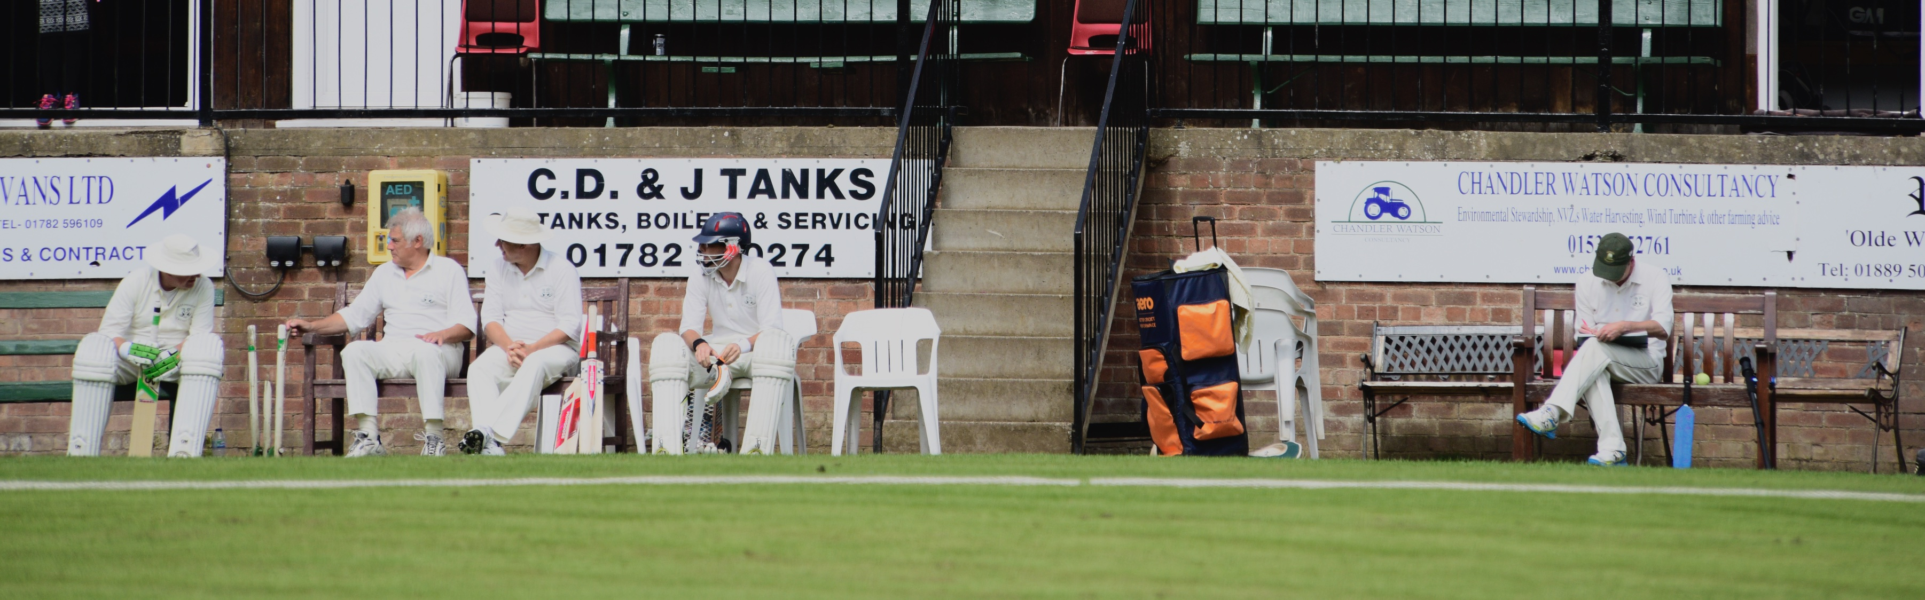
Oakamoor : A Sponsor's Haven
Oakamoor openers Smith and Sutton looked immediately comfortable, with Smith the aggressor, straight driving from the off. After 5 overs they had put on 37 runs.
Captain Andy Bray turned to Liam Duffy to restore some order and he immediately had Sutton caught behind. Smith backed himself once too often when Tony Guest’s perfectly flighted effort ball removed his middle stump and runs were suddenly hard to come by. 49 for 2 after 8 overs. After his impressive spin bowling, Edwards then went about showing his skill with the bat. Steadily at first, but increasingly assured, he crafted a chanceless half century which cemented the Oakamoor innings. When Edwards was joined by Fallows, Oakamoor still needed 67 runs off the last 10 overs. Two overs later, that target was just 28, Fellows taking a fancy to Shahid Ali and Simon Smith, blasting 31 in a mere 9 balls, before Ali’s slower one bowled him.
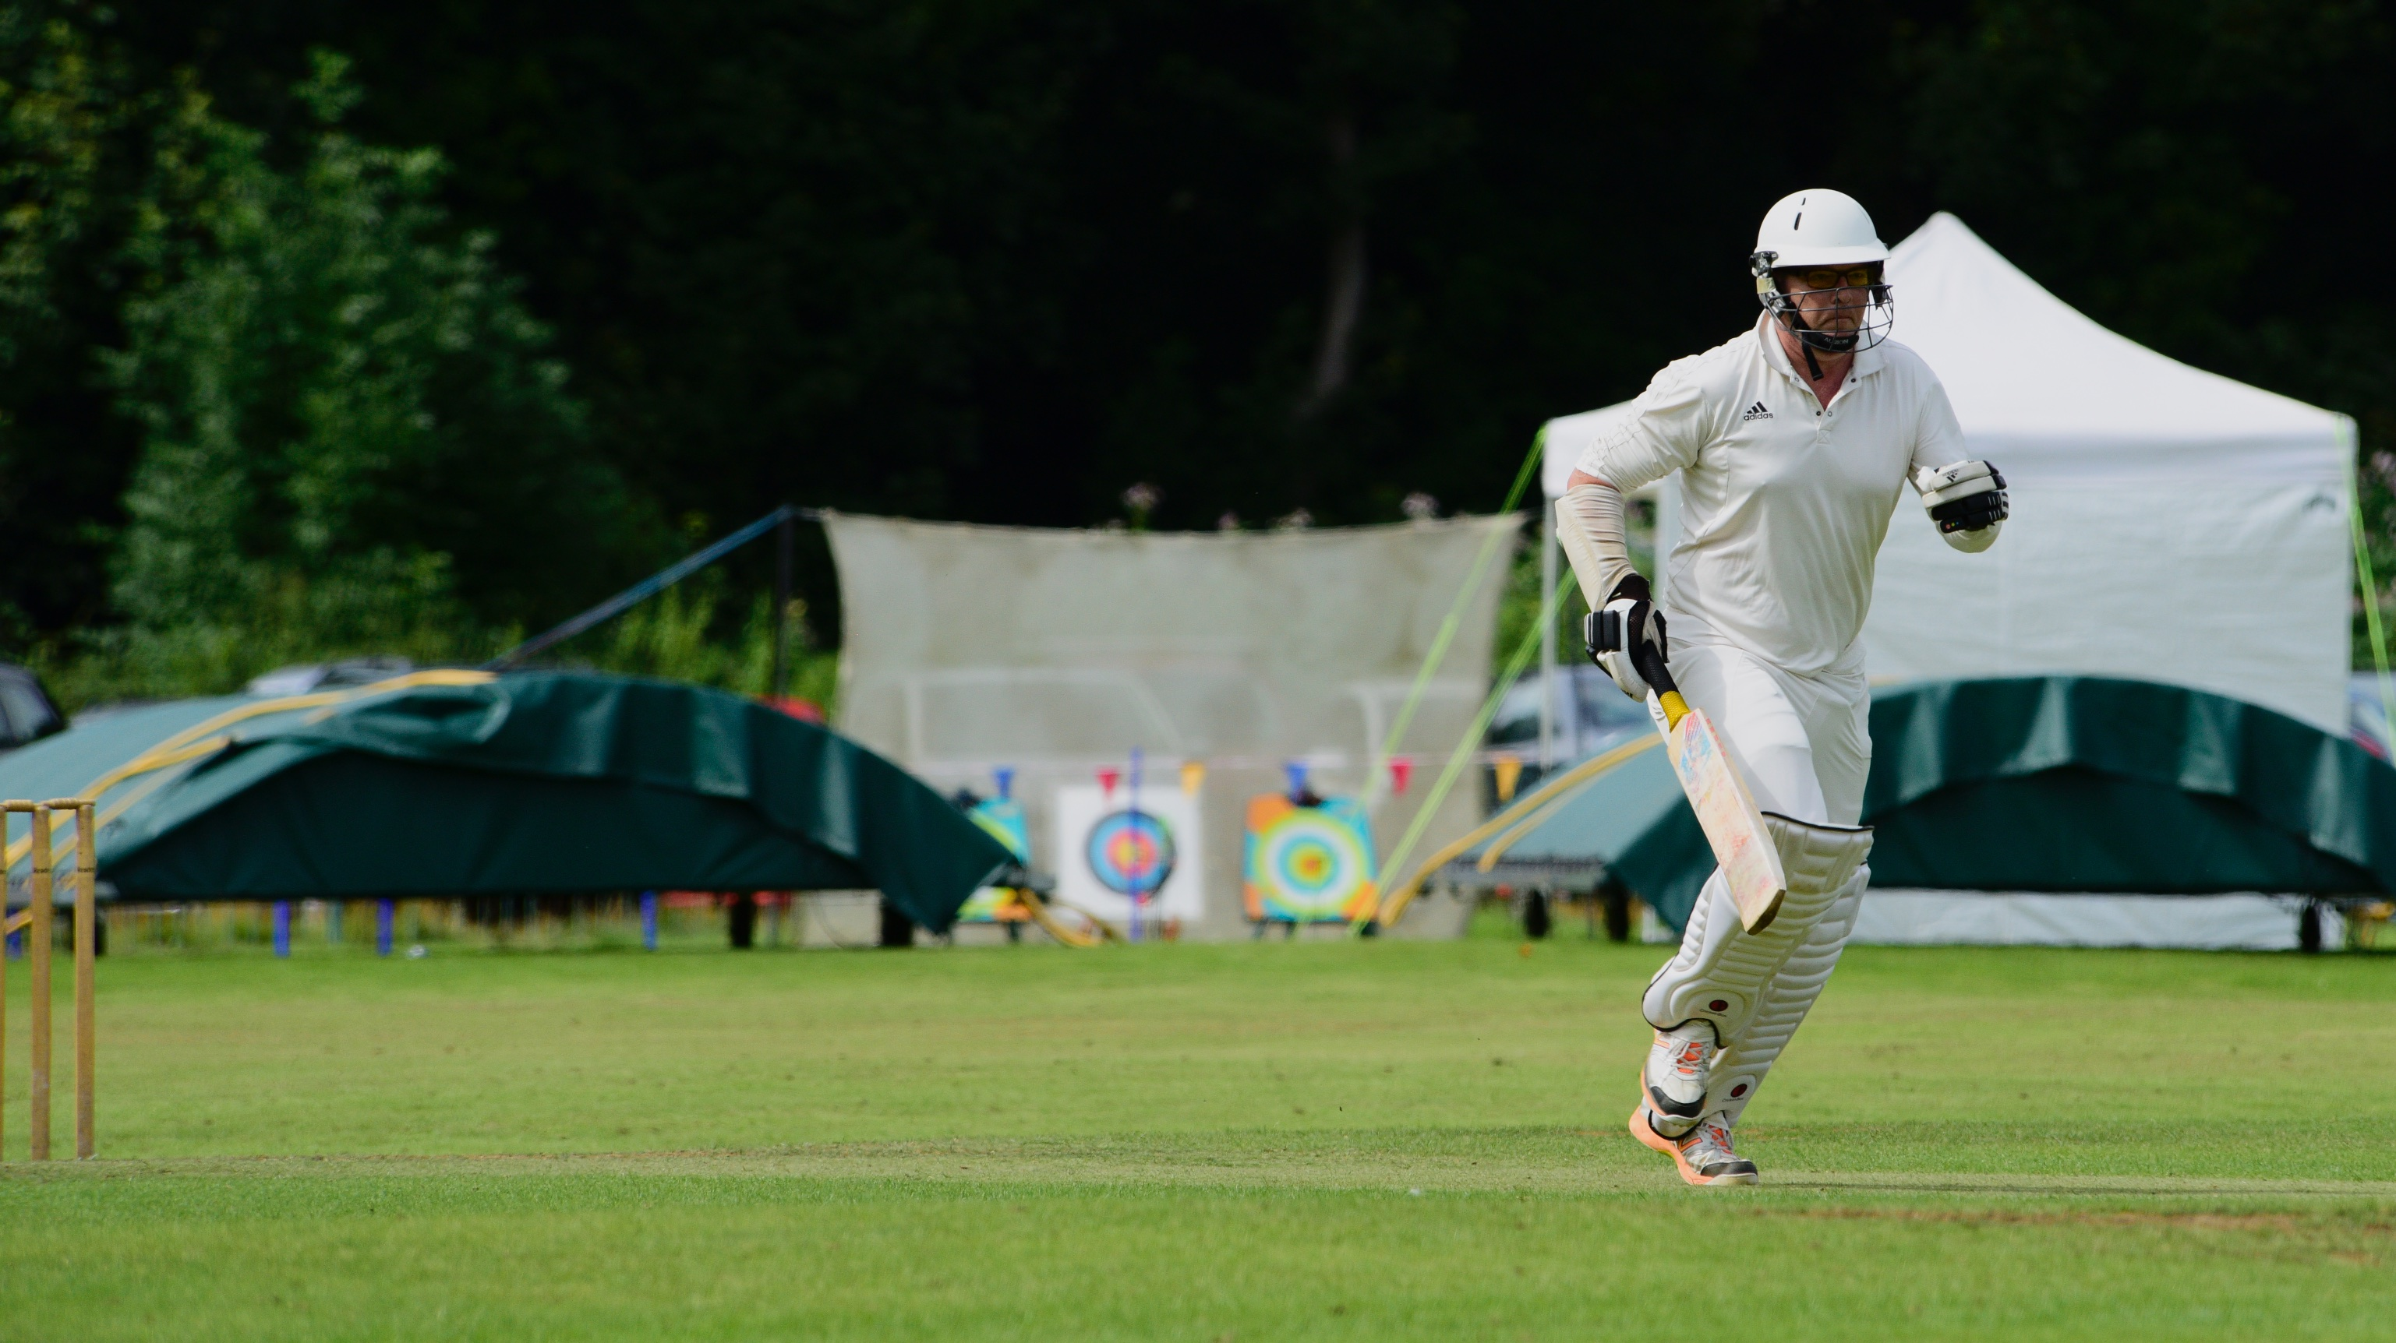
Run for cover ...

The fielding, keen throughout, was now desperate to stop any run. Inevitably, as singles were saved, boundaries were left unprotected and edges hit the rope.
The result in the book was an Oakamoor win by 6 wickets with four overs to spare. That does not do justice to the tension out in the middle for the majority of the Oakamoor innings.

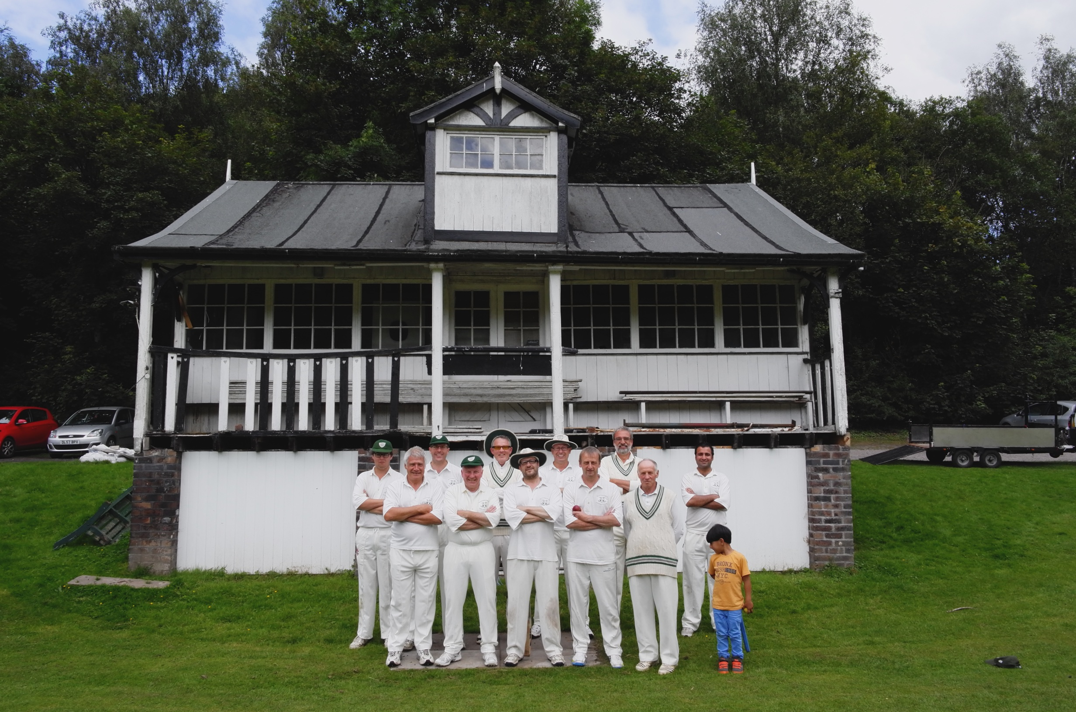

ALSTONEFIELD CC 170 FOR 5 LOST TO OAKAMOOR CC 171 FOR 4, BY 6 WICKETS.

