GARGOYLES GO TO TOWN AND MAKE HAY

A successful couple of weeks for Alstonefield CC, notching up their first ever win against Clifton CC, albeit by only 1 run and then following up with a 1 wicket victory over Ashbourne. That leaves the tally for the season at 7 wins, 1 draw and 5 defeats with 2 matches to play. Even more impressive have been the performances of the less experienced players called upon to bat and bowl during the holiday season, while the more seasoned performers sought a summer elsewhere…

v. ASHBOURNE

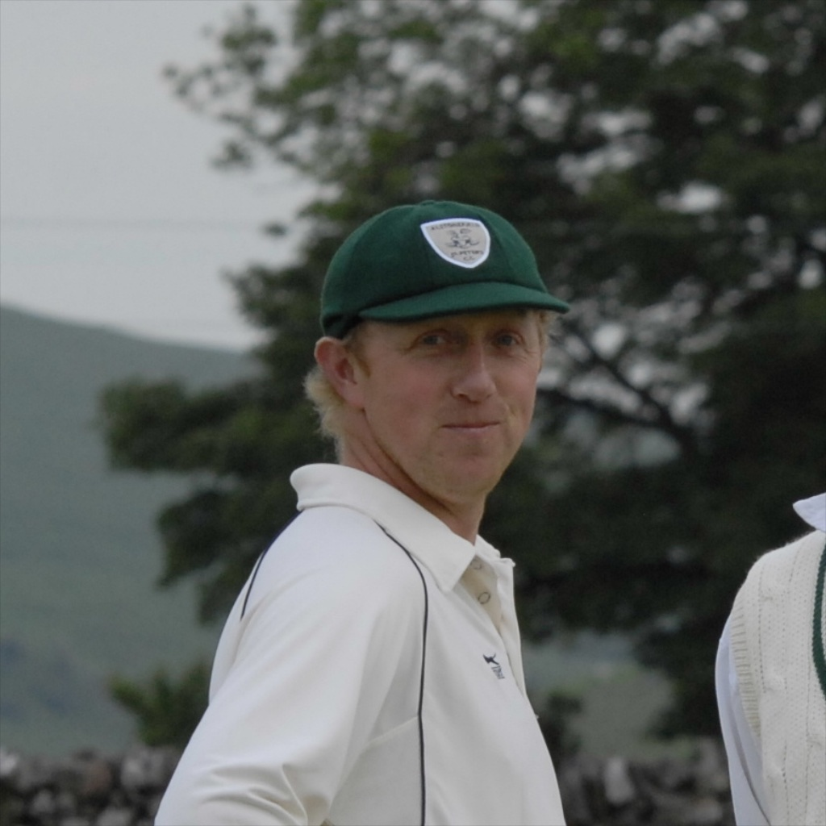
Fielding their least experienced side for many years and struggling to find sufficient bowlers who were not injured, the match at Ashbourne turned into yet another close affair between two evenly matched XIs, with Ashbourne suffering from absent regulars too. Batting first on a damp, slow pitch, the hosts’ progress was slow, as Will Siddons bowled a tight line and length. Andy Farmer eventually removed opener Turner with the score on 33. This brought Ashbourne captain Hill to the middle and he and opener Newsome took advantage of some ragged bowling to take the score to 87, before Newsome somehow managed to direct another Neil Shotton long hop into the increasingly safe hands of Steve King at mid off. Hill was not put off and reached an unbeaten half-century without breaking sweat. He had built a platform for the middle order to prosper on and with no recognised bowlers available, captain for the day Harry Jones turned to the idiosyncratic action of Alan Hayes. Desperation it may have been, but the move proved a masterstroke. Hayes had batsmen rattled with his heavy ball and immediate off stump groove. 7 overs and 1 for 10 was a magnificent and ultimately defining performance. Captain Jones, forced to bowl himself, was also economical with his flight and guile. So, instead of pressing on to a big score, Ashbourne were restricted to nudging and nurdling their way to 135 for the loss of 4 wickets.
Alan Hayes : MOM

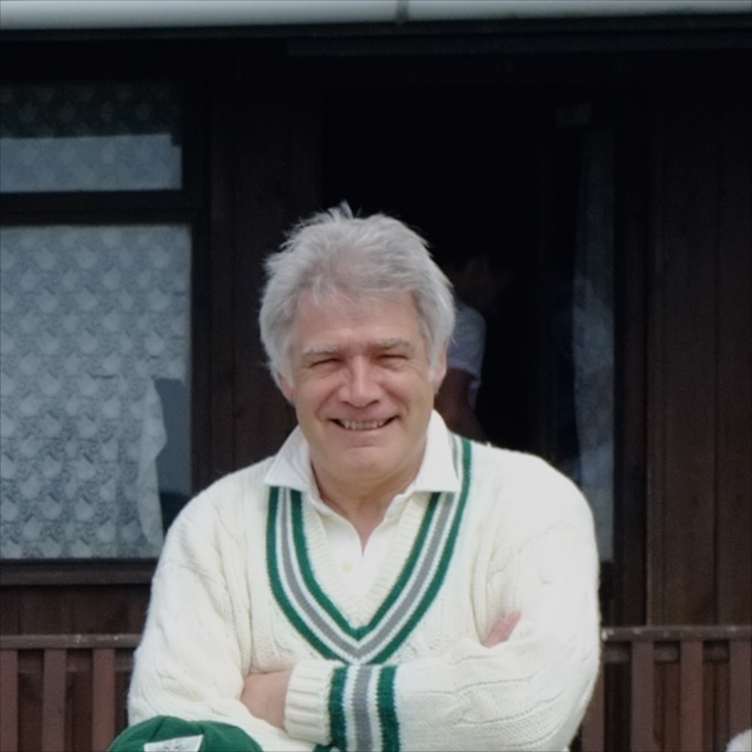
Harry Jones had a new opening partner in Will Siddons as the Gargoyles began their chase. Both began in confident mood until Jones mistimed a short ball and was caught in the gulley for 7, a rare failure for the club’s leading runscorer. Siddons went in the next over playing round a straight one. 21 for 2. Neil Shotton looking to re-establish his batting credentials was positive and orthodox in his shot selection until he spooned a full toss to cover for 19. Steve King nursing his injured shoulder showed a natural eye with his first boundary for the club and Andy Farmer again looked the part with his 9 quick runs. But wickets were falling and at the half way stage the Gargoyles were 62 for 4. Dave Singleton has been there before of course, and he immediately looked to unsettle the Ashbourne bowlers with his willingness to go aerial. He and bowling hero Alan Hayes had taken the score to 97 in the 27th over when Hayes marred his day by running out the fluent Singleton for a top scoring 26. Hayes was caught behind 9 runs later for a vital 11, leaving Ian McKay and the tail to score exactly 30 off 5 overs. 3 overs later, the task was just 2 to win, when McKay was needlessly run out for a brisk 18. One lusty blow later and the Gargoyles had won with 2 overs to spare.
Singleton - top scored for Alstonefield

A true team performance, with everyone making telling contributions and no one player dominating, but Alan Hayes deserving of his Man of the Match award.

ALSTONEFIELD CC, 136 FOR 9 BEAT ASHBOURNE CC, 135 FOR 4, BY 1 WICKET.

v. CLIFTON

GARGOYLES SECURE NOTABLE FIRST

Clifton CC are the strongest club in the area and it was a pleasure to host the Clifton Development XI after an absence from the Gargoyles’ fixture list of 4 years. Made up of talented youngsters and a few guiding senior club members the Clifton XI helped produce another cliff hanger of a finish, with the result down to the very last ball…….

The Gargoyles couldn’t have got off to better start. The prolific opening pair of Harry Jones and Andy Bray matched each other shot for shot, rotated the strike intelligently and scored at 5 an over from the very first ball. It was a total surprise when Jones was bowled by spinner Sun for 41 and then Bray out lbw to Angris shortly afterwards. Chris Wilkins has been in imperious form and with a 100 runs already on the board with 16 overs still to come, fireworks were anticipated. Just when the game seems easy, cricket has a way of biting back and a woeful piece of running to a sharp throw left Wilkins stranded. Suddenly, scoring runs was difficult, as Clifton’s bowlers tightened their line and length. Gregory was particularly accurate. Will Siddons made a vital 21 before he became the first of Gerrard’s 3 wickets in an impressive spell. The innings spluttered to its close at 163 for 6. It felt 20 runs too few.

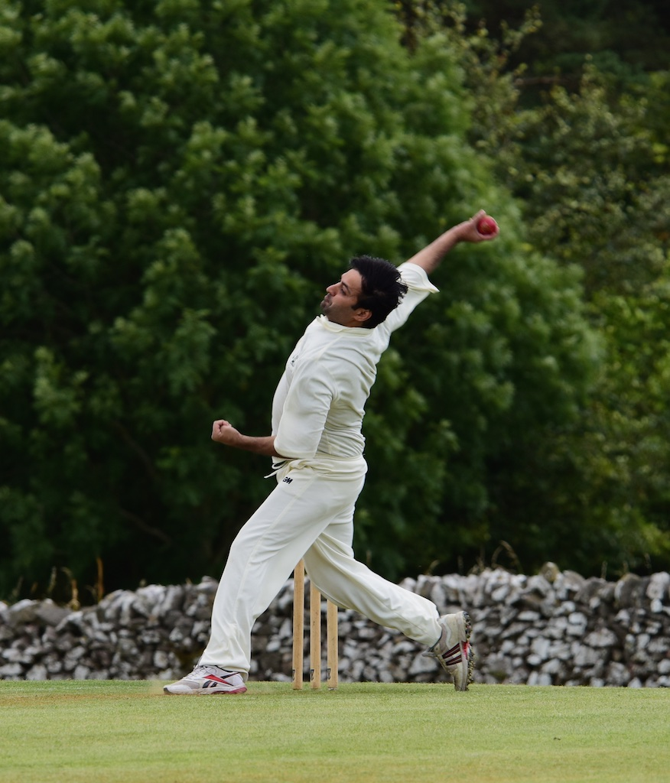
Mixing the order with experience accompanying youth, Clifton started steadily reaching 30 for the first wicket. Moran and Litchfield accumulated without risk until Steve King took a wonderful diving catch to remove Litchfield off Will Siddons. Sunil Angris came out and chanced his arm with his trademark swings, including 2 sixes off the shoulder of his bat. He and Moran, brilliantly caught by Wilkins off Shahid Ali for 44, had put Clifton into a commanding position at 110 for 4 with 11 overs remaining. Much depended on Ali to maintain his outstanding form with the ball and put the choke on the run rate. That is exactly what he did, even with the experienced Clifton captain Wilson at the crease, he bowled his 7 overs for only 24 runs at a critical stage of the match and removed the two top scorers. Wilson was shepherding the youngsters well and nudging the score along threateningly. Not for the first time this season, all results were possible heading into the last few overs. Wilson expanded his repertoire and Clifton needed 17 off the last over. Captain Andy Bray took the bowling responsibility and
Shahid Ali – critically slowed down Clifton’s run rate

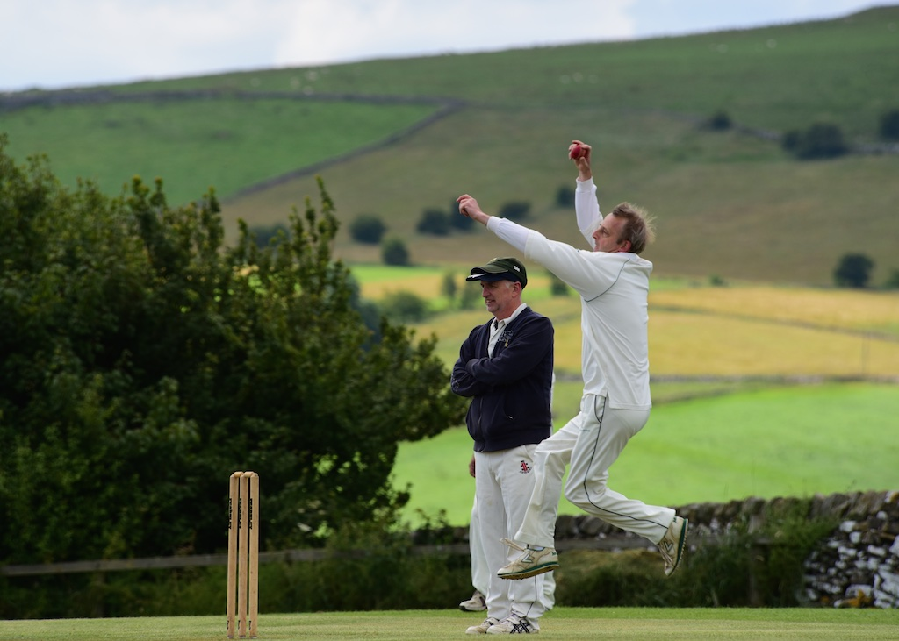
was immediately rewarded with a wicket. Gregory joined Wilson, pinched a single off his second ball and left his captain to score 16 off the last 3 balls. That became 10 off 2, with a monstrous straight drive. Bray kept his nerve and conceded only 2 off the next delivery. 8 to win, 7 to tie, meant no balls and wides were needed. Bray committed neither and was relieved to only go for another towering 6 towards the Raikes. The two captains shook hands on a duel fought to the last and for the Gargoyles, a first ever win over their opponents.
Bray - showed courageous leadership

ALSTONEFIELD CC, 163 FOR 6, BEAT CLIFTON CC, 162 FOR 7, BY 1 RUN

