GARGOYLES GET GLIMPSE OF NEW ORDER

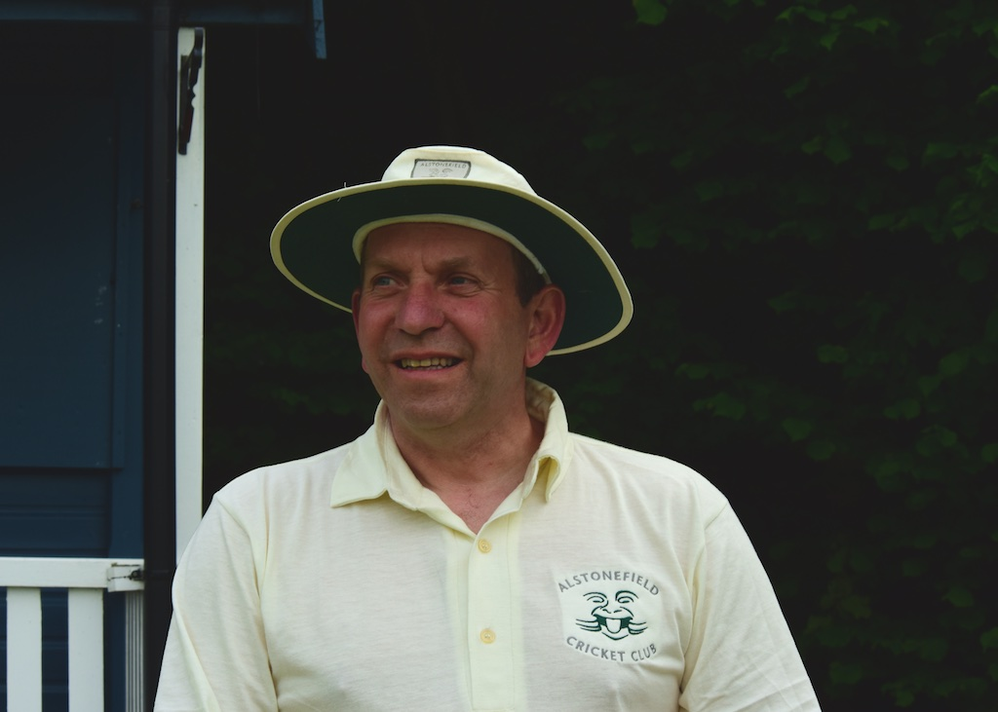
Everything about this match was new or a first. The first time Alstonefield Cricket Club had played at Youlgreave; a new captain in Chris Wilkins as club captain Simon Smith had a more important engagement; a new opening bowler in Steve King and a fifteen year old bowler taking the most wickets. Add in some individual firsts, like Ian Longdon’s superbly held catch, a Neil Shotton over that was not the most expensive of the day, a brilliant first half century for the club by Liam Duffy
Ian Longdon – a superb catch

and Harry Jones’s questioning of the umpire’s not out decision (it was a blatant run out) with his brand of Lancashire subtlety, and this was a memorable outing.
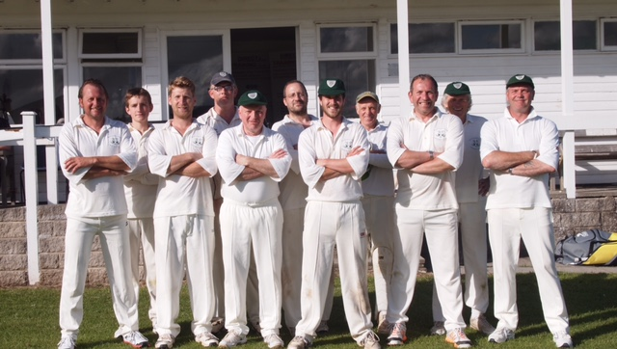
Alstonefield XI v. Youlgreave Lodge
But, some aspects of this match were reassuringly familiar. Harry Jones looked to have the measure of an unpredictable surface until even he was surprised by a “popper” and was caught and bowled for 23. Captain Wilkins, initially circumspect and well aware of his new responsibilities, took the brave decision to attack the Youlgreave bowling on its merits, rather than worry about the pitch. The result was a thrilling, elegant and at times brutal career best 72 not out. He was matched in a third wicket stand of 80 by Liam Duffy, making his highest score for the club, with 38 of his unbeaten 50 coming in boundaries. The innings finished as Andy Farmer showed further evidence of his new mastery of batsmanship with his 16 not out, in what was his last pre-nuptial knock. 204 for 7 looked a formidable total as the predicted rainstorm arrived and an excellent tea was taken in Youlgreave’s delightful pavilion.

The storm blew through and the sun re-appeared. Captain Wilkins wanted to exert that scoreboard pressure from the off and played his two Kings opening attack hand and the most aggressive field settings in the club’s history. Starting with the tried and tested, Ben King bowled his 8 overs taking 2 for 15. Rookie Steve King, trusted with the new ball, bowled his 8 overs with increasing confidence, taking 2 for 21. Liam Duffy and Ian McKay, then bowled a combined 13 overs of unerring accuracy for only 15 runs, effectively putting an end to any run chase. The sharpness of the fielding for once matched the bowling. Two brilliant catches and two direct hits for run outs by Ben King set the tone. There was then the performance of young Will Stupples-Newton. Confident and unfazed by batsmens’ attempts to unsettle his rhythm, he thinks about every ball and how he will keep the batsman guessing. Top wicket taker with 3 of the top order for 19 runs off 5 overs, was no less than he deserved.

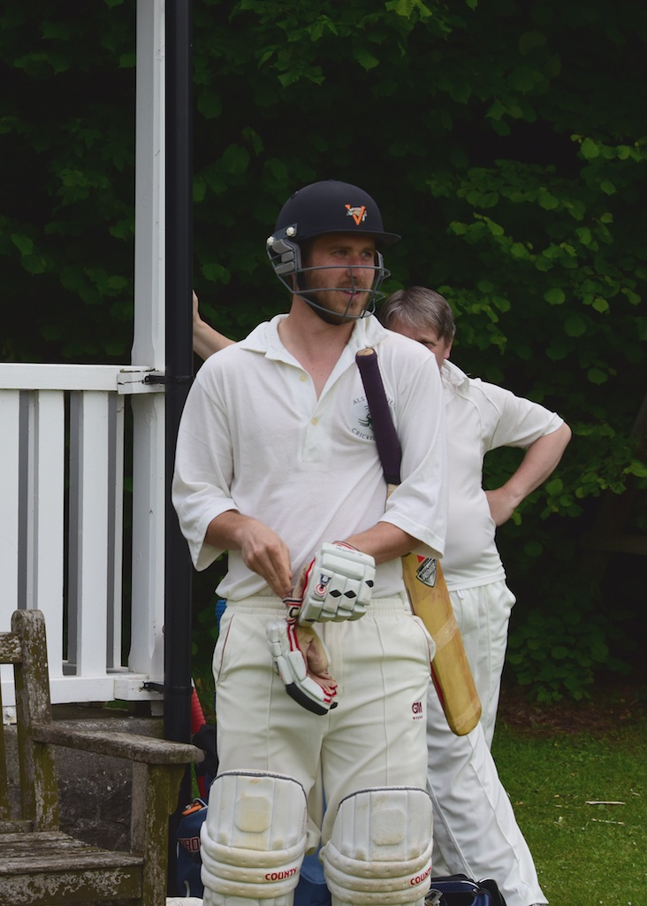
There was no way back for Youlgreave, although captain Wilkins brought himself on to bowl at the end. Fittingly, the match concluded with another first. On the captain’s instructions, a 9 man slip cordon was placed on the third man boundary and as he steamed in from a distance, the Youlgreave spectators just had no idea what to expect. The batsman did and crashed the ball to the extra cover boundary, in a rare moment of supremacy.
Captain Wilkins

Youlgreave 112 for 8.

An important win for the Gargoyles, not just in the margin of 92 runs, but in the way all the players, time served or new, old and young are making winning contributions. The future looks green and grey.

Alstonefield CC 204 for 7 beat Youlgreave CC 112 for 8 by 92 runs.

