GARGOYLES EVEN STEVENS FOR SEASON

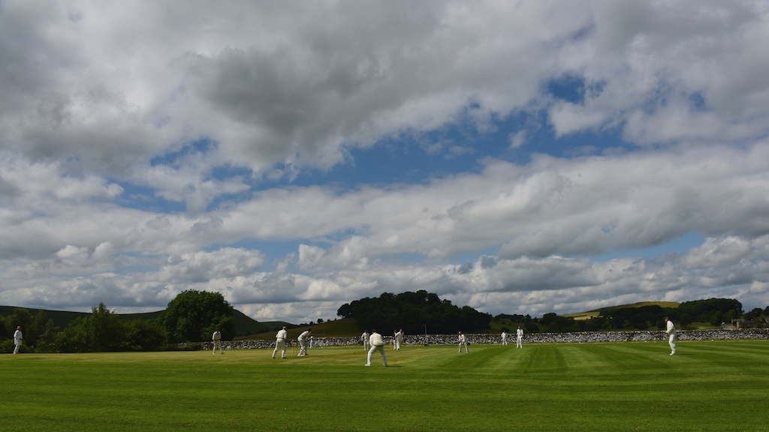

Another close match, a crucial dropped catch and a 12 run defeat for Alstonefield CC as they go past the season’s half way mark with 4 wins, 4 defeats and a draw. Oakamoor have always provided one of the sterner tests for the Gargoyles, but their winning streak was under threat up until the 32nd over of this 35 over match. On a slow pitch and lush outfield following the overnight rain, how would the talented youngsters of Oakamoor set about constructing their innings……

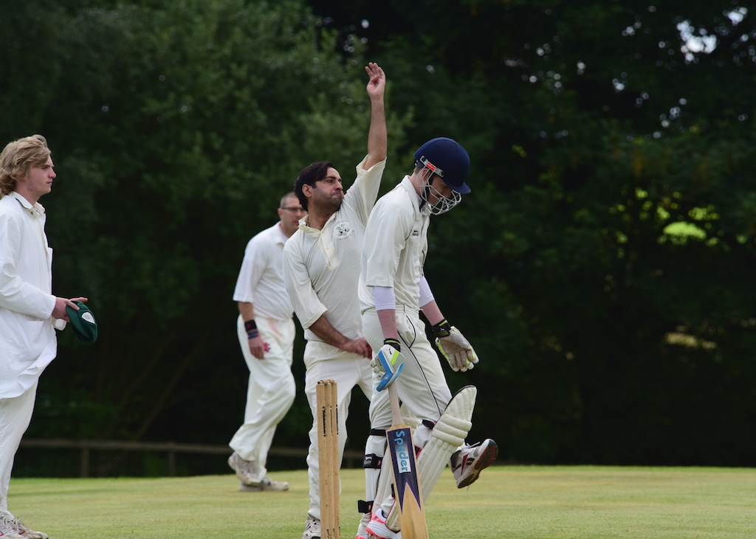
In fact there were two Oakamoor innings. There was the beautifully timed strokeplay from opener and captain James Smith and all-rounder Sean Sutton, whose combined 106 runs contained exactly 90 in boundaries and then there were the rest. The Gargoyles’ bowlers simply couldn’t contain those two, especially their lofted hitting over the short straight boundaries, but did a sterling job in restricting the overall score to 183 for 7 off their 35 overs.
Shahid Ali - masterclass in swing & seam
Shahid Ali gave a bravura performance in medium pace seam bowling, posing all sorts of problems to good batsmen. He finished with 3 wickets for 9 runs off his 7 overs, which in the context of this match, was outstanding.

183 for 7 at tea meaning the Gargoyles needed to score at 5.2 per over.

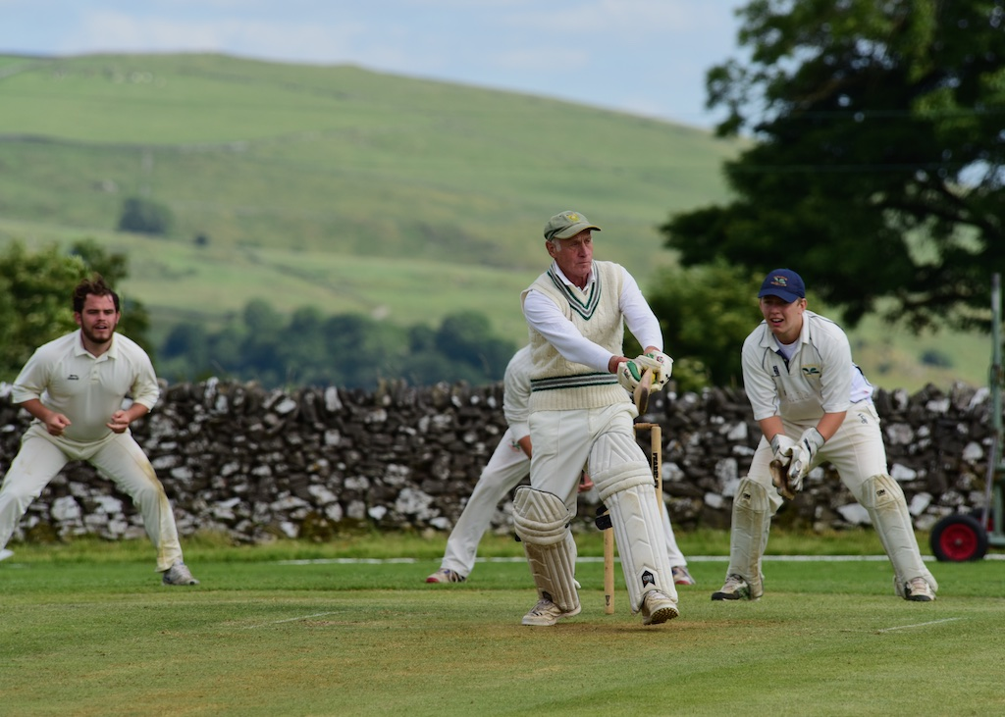
And with the prolific opening partnership of Harry Jones and Andy Bray striding out to the middle, 184 felt achievable. Jones just picks up from his last innings. Timing, deft glances and disdain for the bad ball and he rarely looks out of touch.
Bray typically works his way through the opening overs until finding his touch and unleashing powerful shots square of the wicket, but with the score at 34 after 9 overs, he was adjudged lbw. Will Siddons promoted up the order after some mature innings, got a real snorter early on and couldn’t get the bat out of harm’s way, to be caught for 7, bringing the overworked Chris Wilkins to the crease.
Harry Jones - a well-oiled batting machine

Meanwhile Jones marched serenely on to his third unbeaten 50 of the season, as Ian McKay joined Wilkins with the score on 73 after 16 overs. Wilkins has been in majestic form and quickly came to terms with the two-paced pitch, unleashing his powerful array of front and back foot drives. With McKay rotating the strike and not letting the bowlers settle, these two looked like they could make a dent in the target until Wilkins on 30, middled a short ball, but straight to deep square leg, with the score at 112 for 4 off 22 overs. Simon Smith has rediscovered his batting elan in recent matches, but slow looping leg spin is not his favourite fayre and he perished early. McKay was keeping up with the required run rate until he skied a catch for 31 at 158 for 6 in the 32nd over. Neil Shotton with 10 and a late flurry from Tony Guest with 10 not out, meant that the result was in doubt right into the final over, but Oakamoor were deserving winners for the way they were always just ahead of the game.

ALSTONEFIELD CC 171 FOR 8, LOST TO OAKAMOOR CC 183 FOR 7,
BY 12 RUNS

