GARGOYLES DEVELOPING NICELY

Two glorious Sunday afternoons and two strong victories for Alstonefield CC. Four games into the season and there are positive signs for the Gargoyles. It’s too early to be described as a changing of the guard, but the emergence of consistent, match winning, all round performances with bat and ball by Ben King, Shahid Ali and Will Siddons, has given the Gargoyles’ Captain Andy Bray real options and a genuine fight for places amongst some of his more seasoned players. Add to these performances, the increasingly potent wicket taking of Andy Farmer and the duck to water transformation of Steve King into a genuine gloveman and the club is set fair.

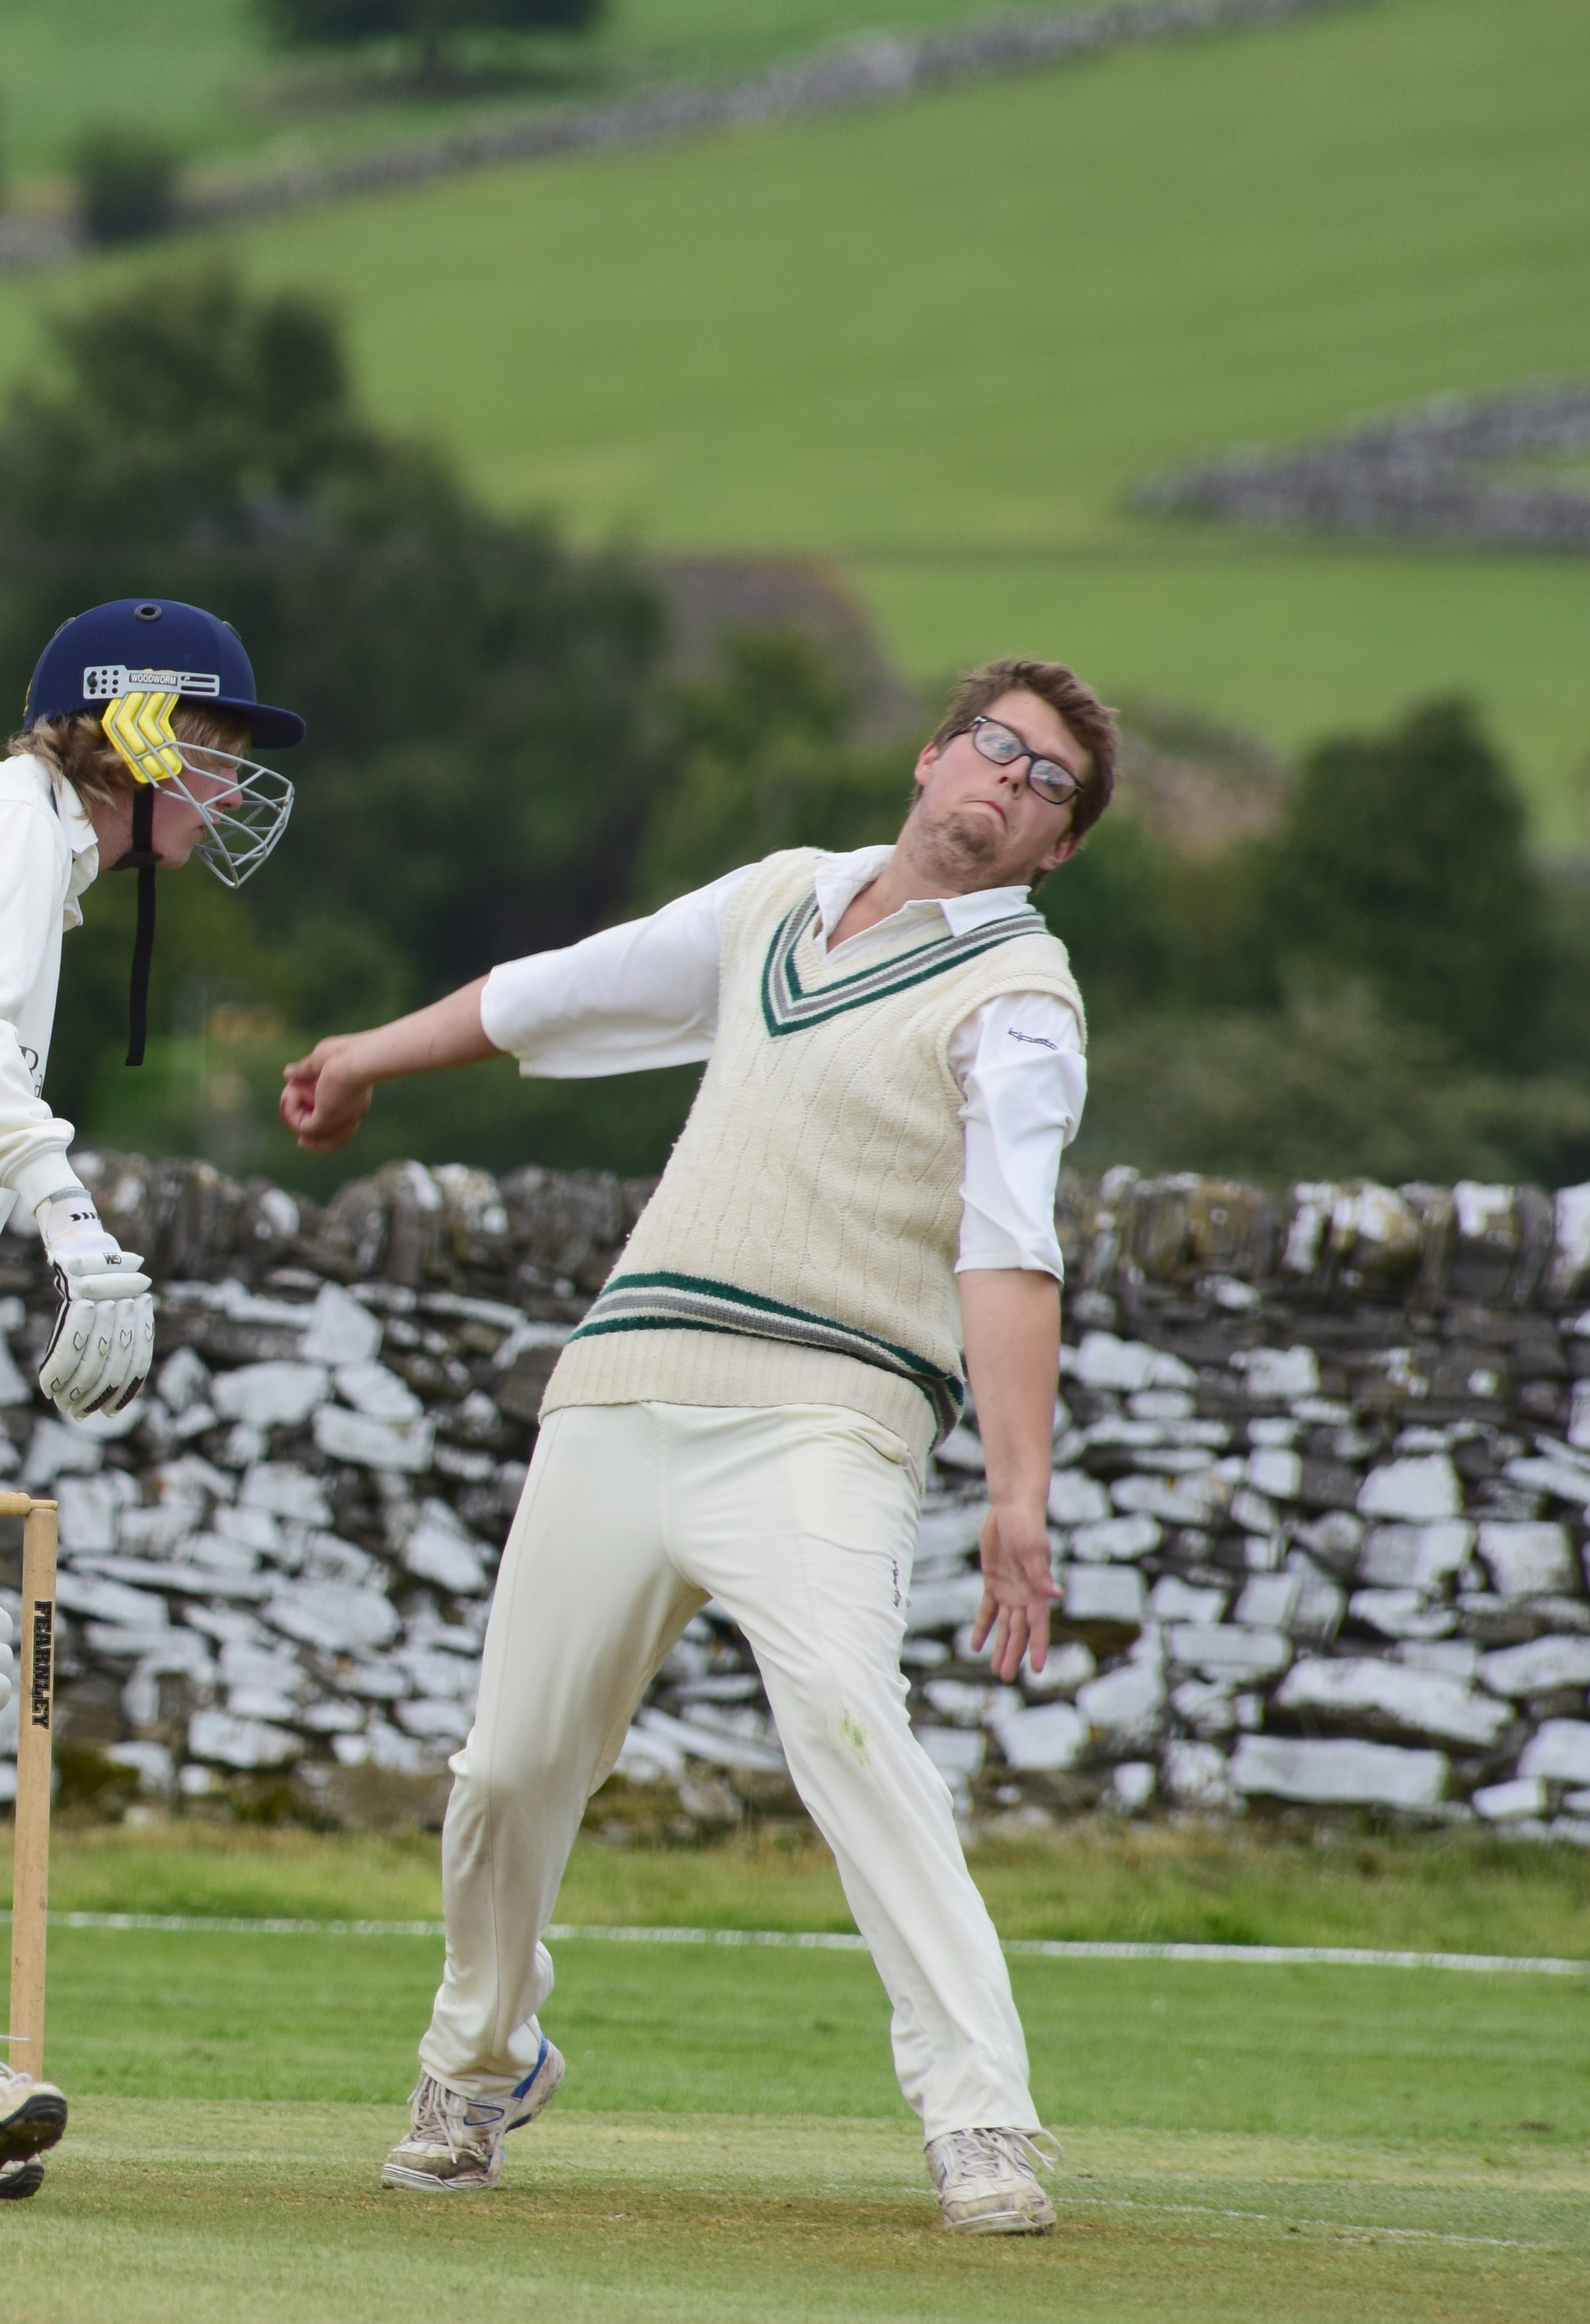
The match at Wootton was a case in point. With the Gargoyles batting first, Shahid Ali, Ben King and Will Siddons made a combined 117 runs of the competitive 190 for 7 total. Ali, promoted to number 3, was particularly fluent for his 40 and Ben King picked up from his 66 at Sutton, to strike a brutal 47, while Siddons’ 30 not out made sure the momentum of the innings carried on to the last over. With the ball, Ali and King tied the Wootton top order down, while Siddons and Andy Farmer shared 6 wickets. And to finish off, a wily spell of leg breaks from Simon Smith reaped a two wicket bonus.
Will Siddons – shared six wickets with Andy Farmer, pictured right
Wootton all out for 144, with opener Root (no relation) last man on 58, and a 46 runs win for Alstonefield.

ALSTONEFIELD CC 190 FOR 7 BEAT WOOTTON CC 144 ALL OUT
BY 46 RUNS

Then to a gorgeous summer’s day and the Alstonefield ground looking splendid after the intense preparations for the first home match of the season against Youlgrave.
Ben King in good form this season
This time, the Gargoyles bowled first, but the story was much the same. Youlgrave opener Parker, was last man out for 56, while at the other end, his team mates just couldn’t cope with the relentless accuracy and skill of the Alstonefield attack. Once Ben King had dismissed opener Yates, courtesy of quite a good slip catch by Ian McKay, Shahid Ali tore the top order apart with pace, flight and movement in equal measure, finishing with 4 for 13. Will Siddons mopped up the tail to finish with 3 for 19 and Steve King took his first catch with the gloves, when he fittingly snaffled Parker off Siddons to close the Youlgrave innings. 105 all out after only 33 overs. Harry Jones survived the early loss of opening partner Neil Shotton to show he was back in form with 41 not out including all his trademark cuts and merciless accumulation off his pads, while Shahid Ali, picked up where he left off at Wootton, with a fluent and powerful array of straight hitting in his 34 not out. After 18 overs it was match won and more time than usual for the post-match analysis at the George.
Shahid Ali

ALSTONEFIELD CC 106 FOR 2 BEAT YOULGRAVE LODGE 105 ALL OUT
BY 8 WICKETS.

