GARGOYLES DEVELOP WINNING HABIT

The sun may have disappeared in the past few weeks, but Alstonefield Cricket Club has been shining brightly. Two more good wins, at home to Tideswell CC and away at Youlgreave Lodge CC, leave the club on track for another successful season. Again, it has been the contributions from all players that have made the difference.

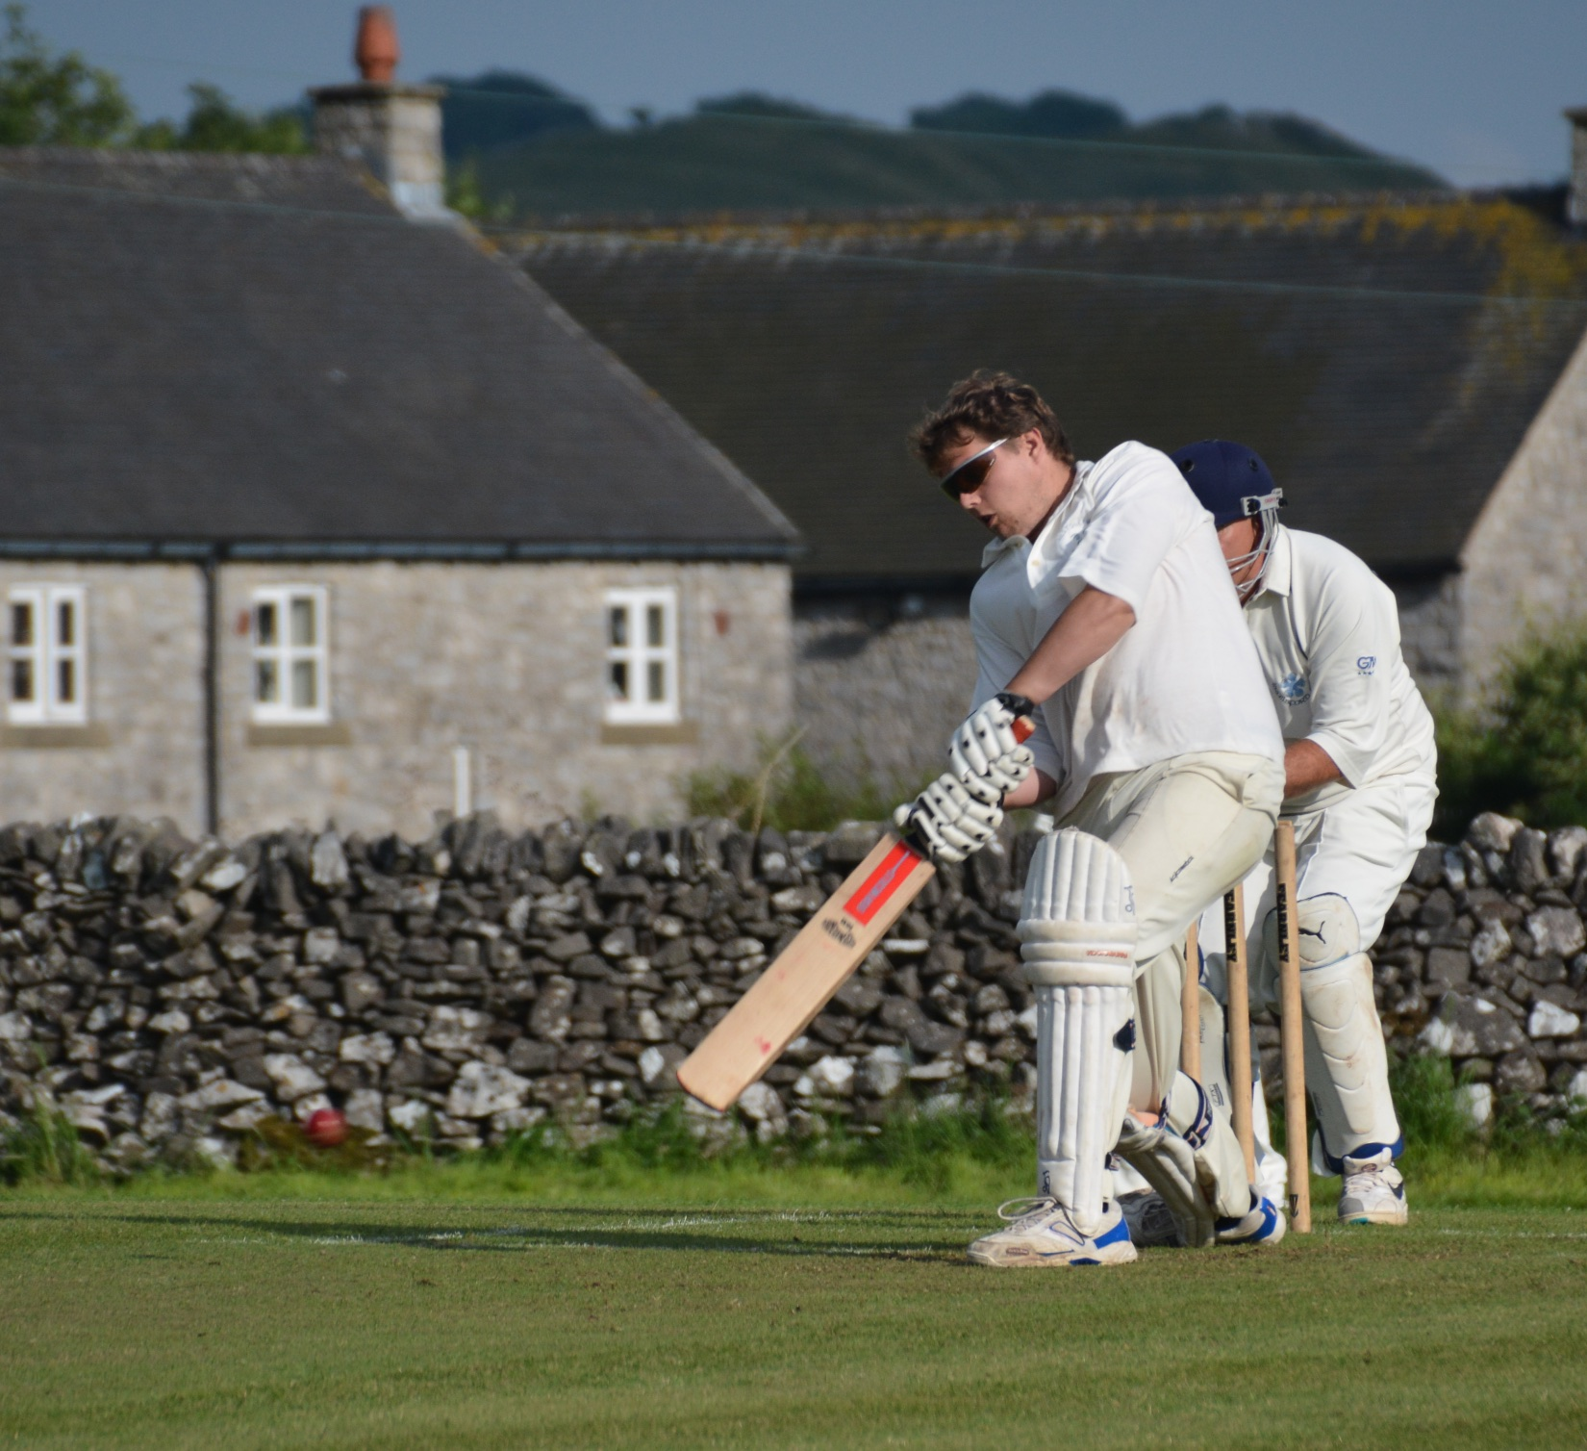
Batting first against Tideswell on a slow wicket and in drizzle was not the cue for extravagant strokeplay. None of the Gargoyles’ batsmen broke free, but sensible accumulation saw most reaching double figures, with Will Siddons top scoring on 31 not out and Tony “Mongoose” Guest enjoying all of his new bat with 27.
Will Siddons - top score of 31
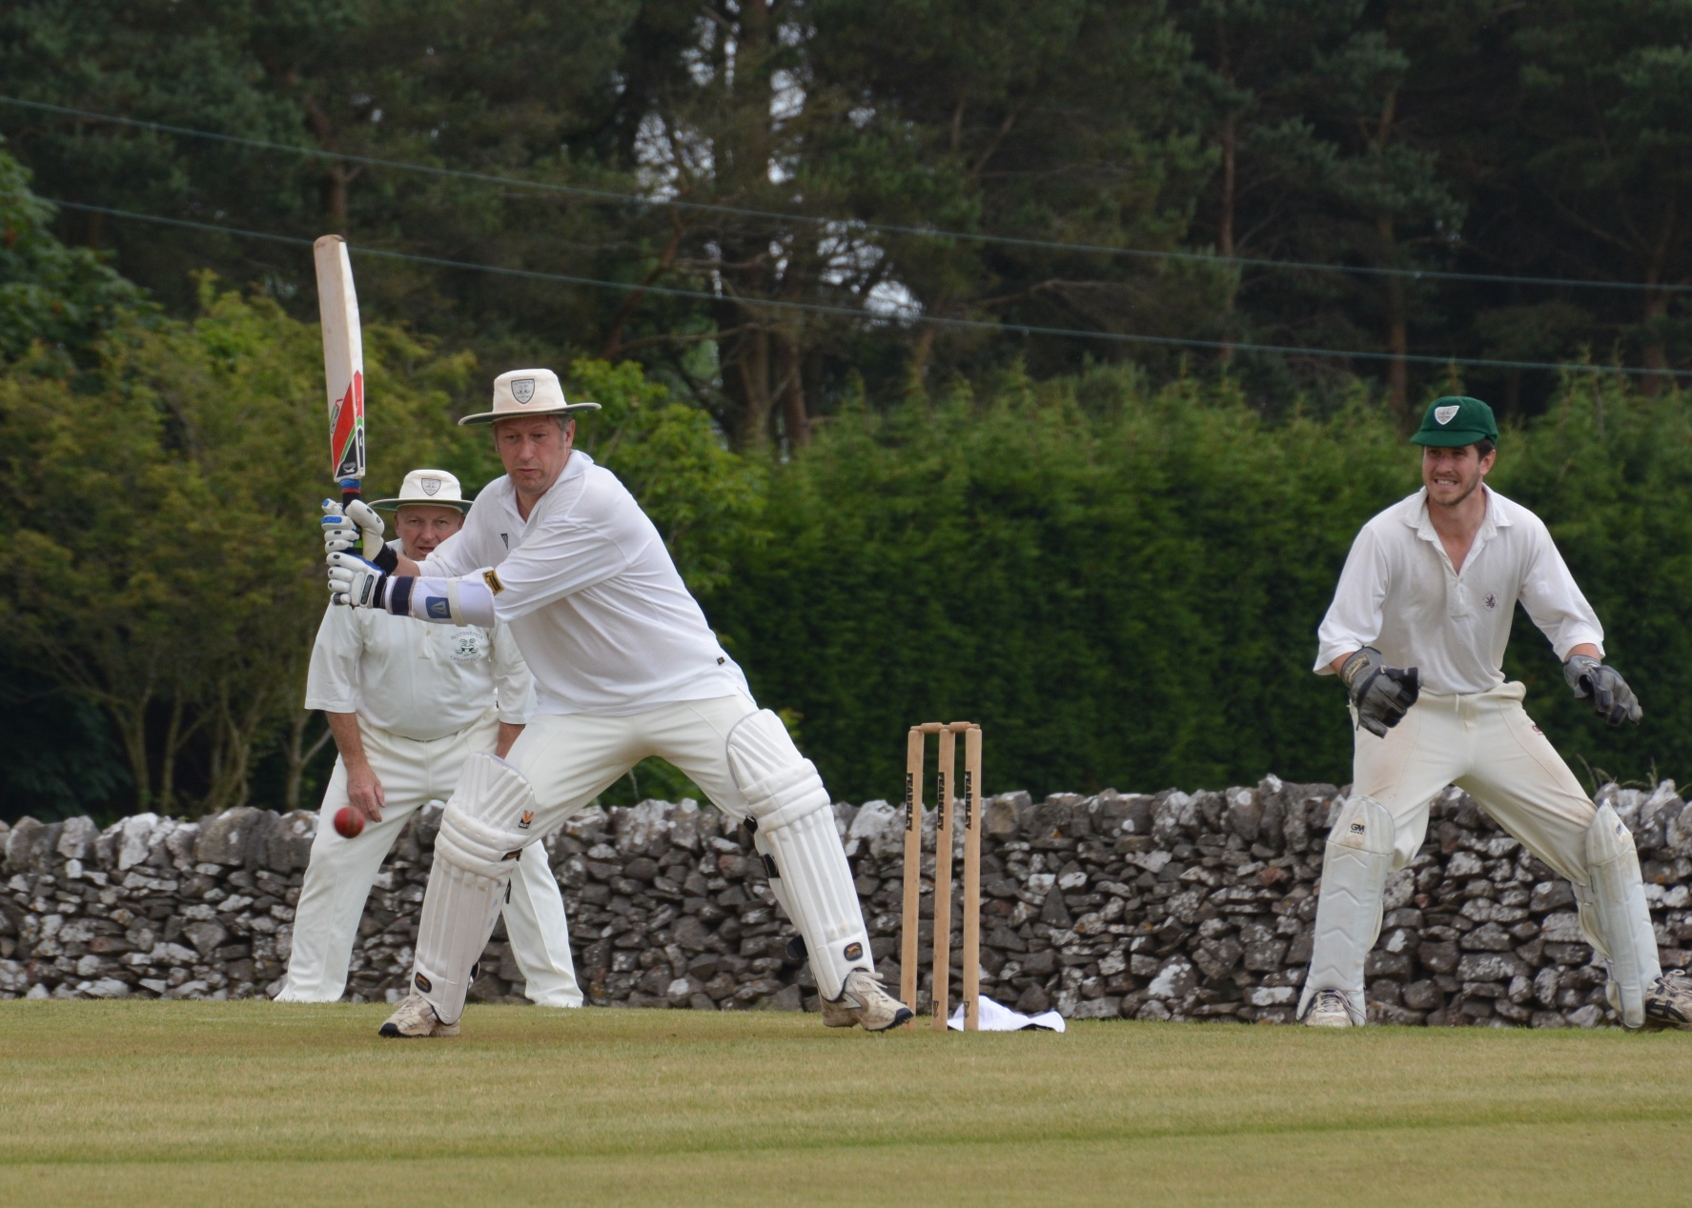
A total of 138 for 7 off 30 overs, in those conditions, was felt to be competitive.
Tony 'Mongoose' Guest

After the first six overs of Tideswell’s reply, 138 just looked daunting, as Ben King and Tony Guest removed the top three for only 1 run. There was plucky resistance from Spencer who made 32 and Taylor who made 16, but these were the only double figure scorers. Captain Andy Bray skillfully used eight bowlers and judged the re-introduction of Ben King to perfection as the rain worsened and threatened to spoil matters. King simply skittled the tail with identical deliveries in three overs, to finish with figures of 5 wickets for 2 runs and not be flattered by them. Tideswell all out for 78.

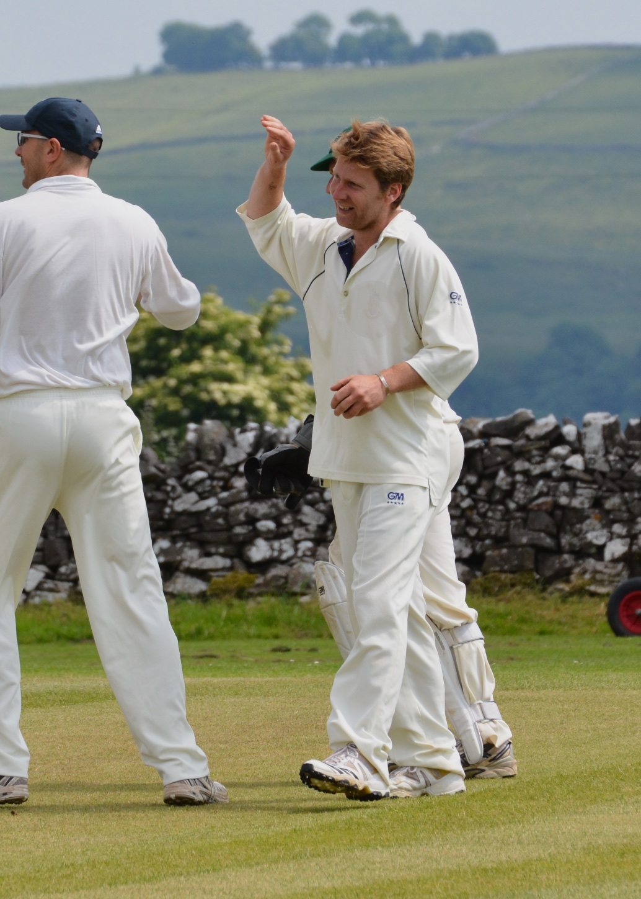
Ben King - magic figures of 5 for 2
Alstonefield CC 138 for 7, beat Tideswell CC, 78 all out, by 60 runs.
Then to Youlgreave and a similar result, but a different story. For the first time this season, the historically prolific opening pair of Andy Bray and Harry Jones, actually were.

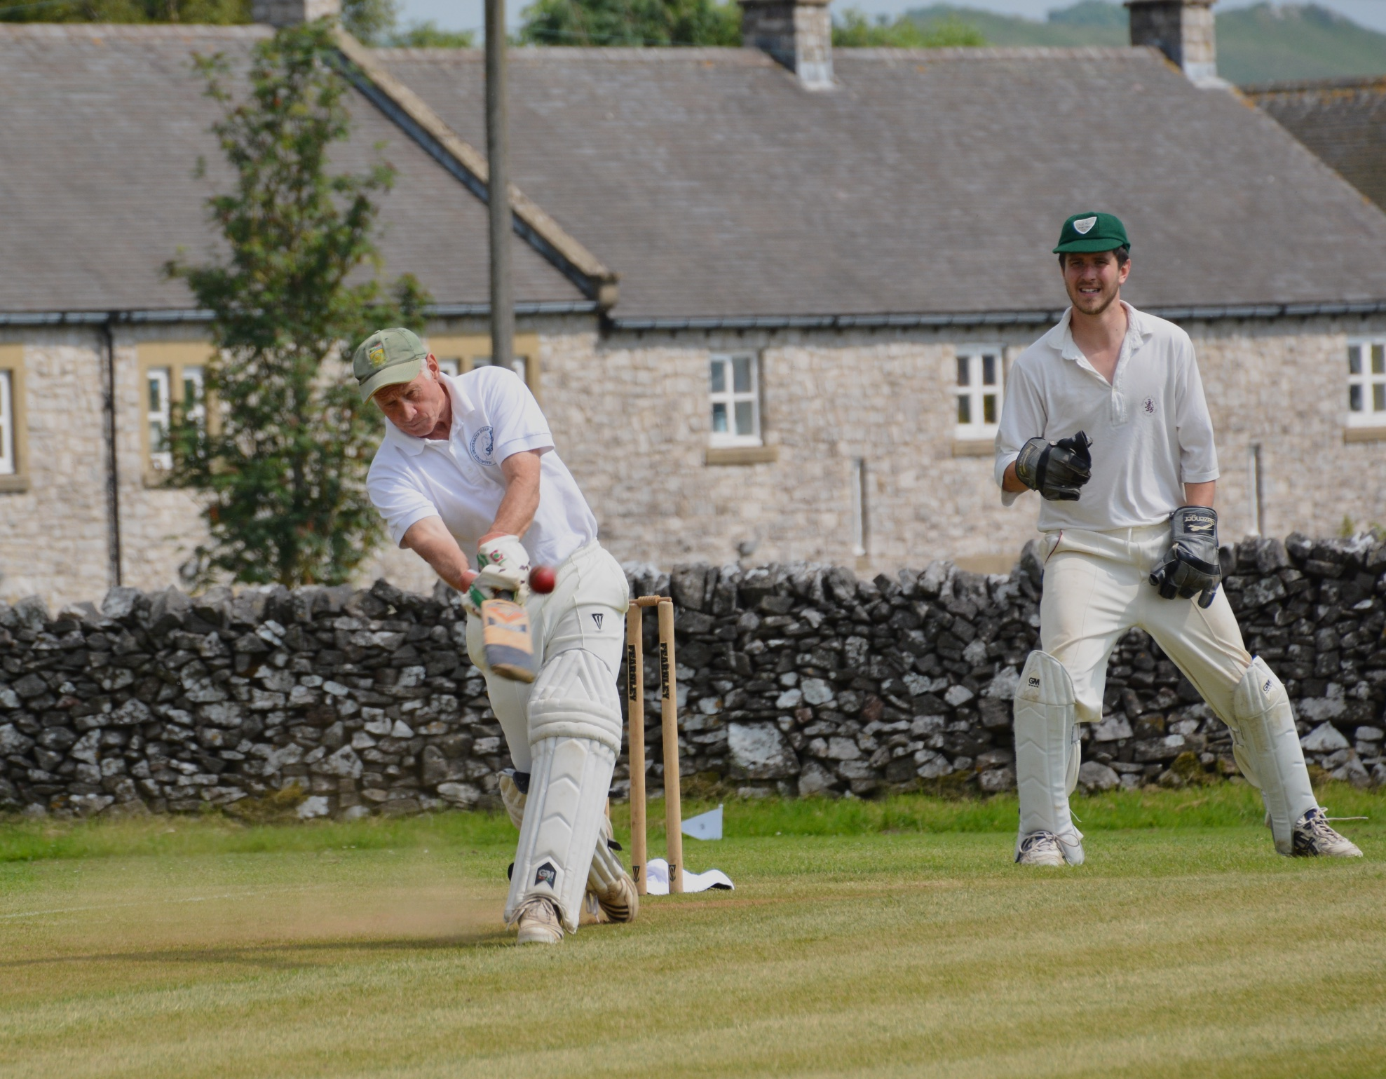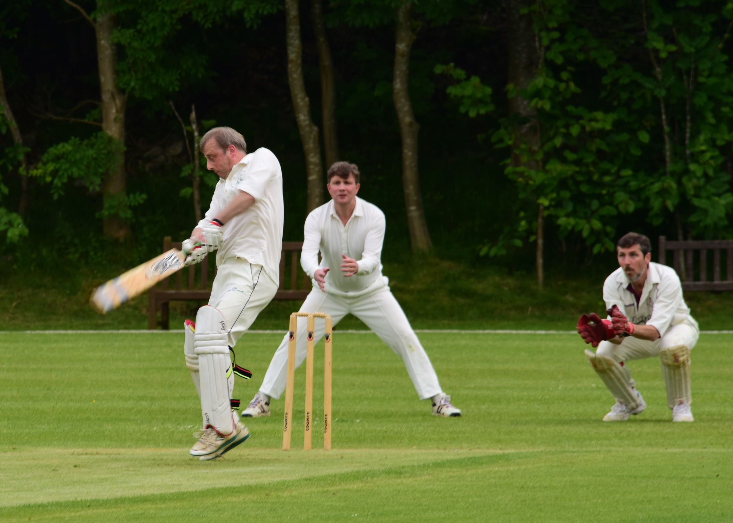
Harry Jones & Andy Bray both scored 50
Both made unbeaten half centuries, which set the platform for Liam Duffy and Tony Guest to put on 35 quick runs and guide the Gargoyles to 160 for 2 from their 35 overs.
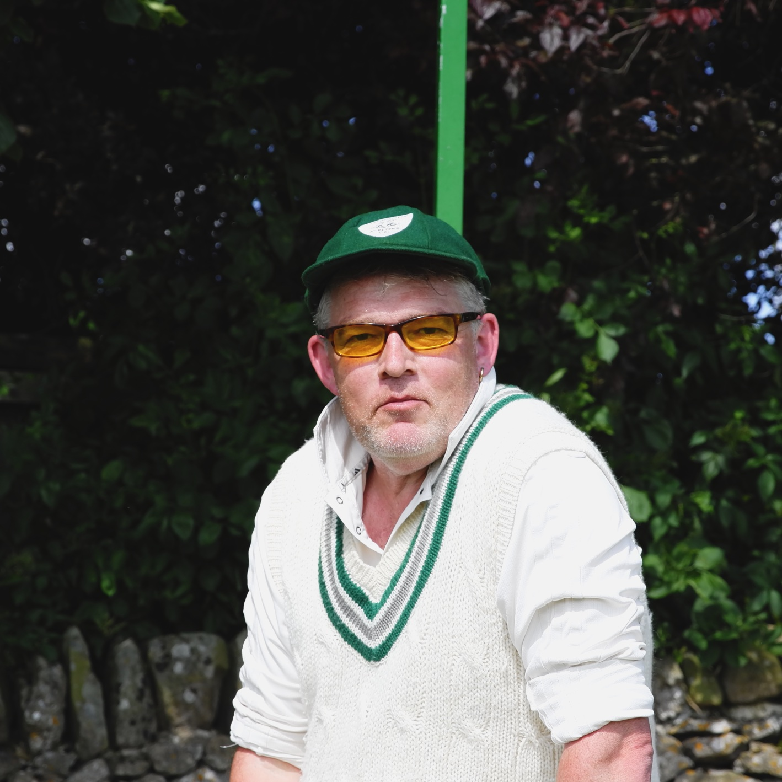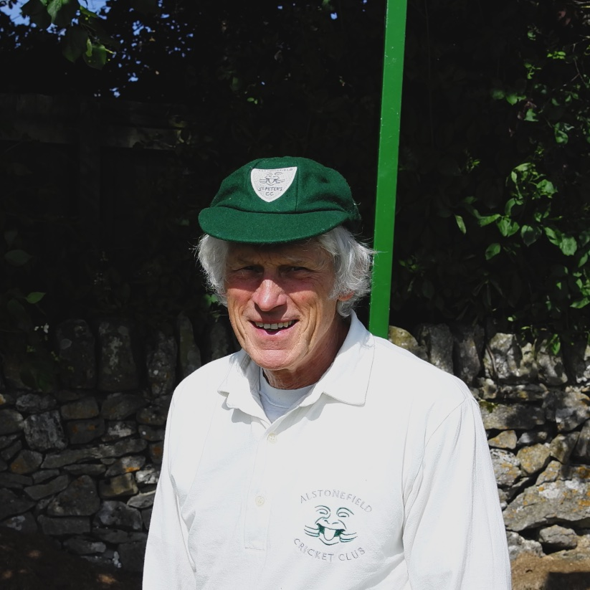
Liam Duffy – masterly bowling Rob Handscombe – stepped up and delivered

Youlgreave immediately looked a stronger batting unit than in the match at Alstonefield a month earlier. Yates played some textbook drives in his unbeaten 52 and Taylor again looked useful in his 32. Captain Bray didn’t have any of his usual opening attack, with King, Ali and Siddons all sidelined, but with Rob Handscombe, Alan Hayes and Harry Jones stepping up, the bowling more than held its own. Nevertheless, as the Youlgreave total moved into the 120s, it was reassuring to see Liam Duffy subdue any thoughts of a home win with a masterly spell of 7 overs two wickets for 5 runs.

Alstonefield CC 160 for 2, beat Youlgreave Lodge CC, 132 for 6, by 28 runs.

So, the Gargoyles move into their 20:20 midweek fixtures in good heart after four consecutive wins, knowing that the second half of the season has a much tougher set of fixtures to test them.
Sunshine would be a good start…

