GARGOYLES BATTERED BUT UNBOWED

For only the second time in their history, Alstonefield Cricket Club were on the receiving end of a brilliant century amid a brutal onslaught by the Sutton batsmen, which saw them score at nearly 6 runs per over and post 235 for 6 off 43 overs. Far from giving up the ghost, the Gargoyles kept their spirit throughout and up until the 20th over of their reply, they were in with a chance of a famous victory……

Click here to read more …….

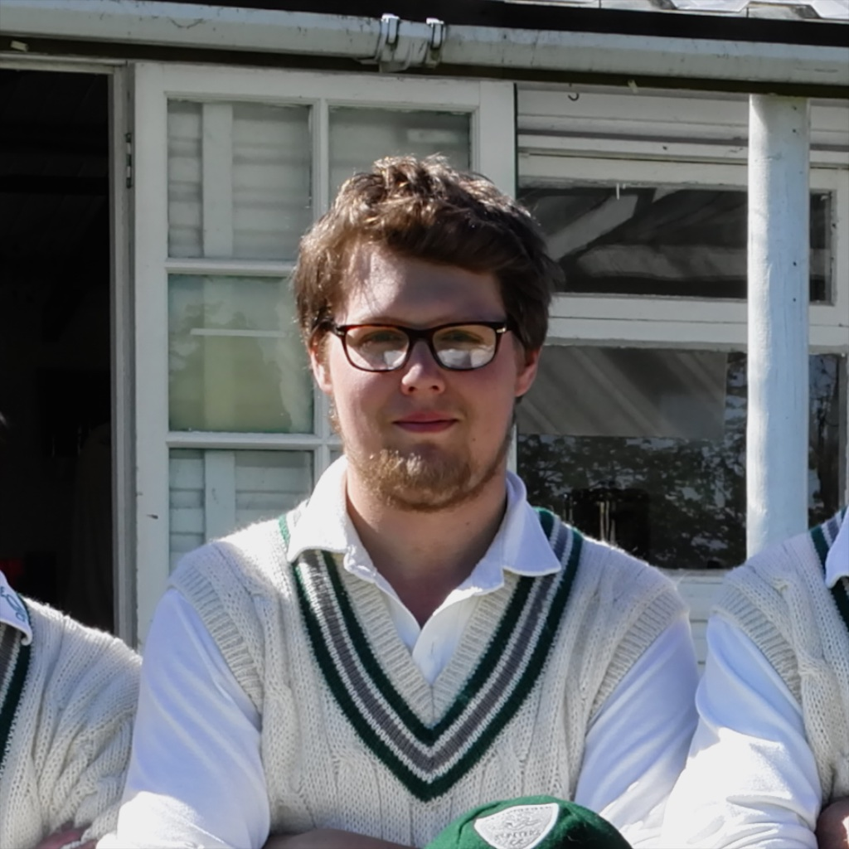
First and foremost Tolley, the Sutton opener, was imperious from the off. Everything came off the middle, such that even his defensive pushes went for runs. Without taking undue risks, his straight drives and his punishing of anything on the stumps to the short leg side boundary, was near perfect. With solid, if less spectacular support from Trevatt, these two put on 138 for the first wicket, before Trevatt, on 34, edged Will Stupples-Newton to Ian McKay at slip. Tolley had reached his century by then and was expanding his stroke play, when Will Siddons, getting much more movement from the pavilion end, deceived him with one that ducked in after two perfect away swingers. Gone for 115. This brought the veteran Wenn out to join Tolley senior and these two were equally effective in finding the leg side fence. If anything, the Gargoyles’ bowlers were bowling too straight and were too predictable, but they stuck at it. Stupples-Newton was the pick,
Will Siddons - deceptive bowing
with his accuracy and swing both ways, his 6 overs 1 for 30 and a good catch too, marked him out as one to watch. Will Siddons found real venom when he switched ends and finished with 3 for 72 off his 15 overs.
At tea, Sutton declared on 235 for 6.

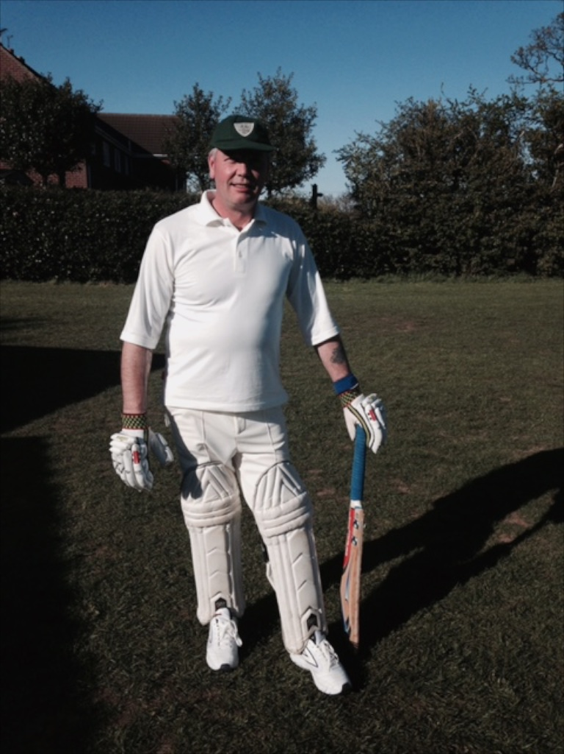
The beauty of this fixture is that it is not a limited overs match. All results are possible, based on when the pavilion clock decrees the final hour is played, but Captain Andy Bray made it quite clear the Gargoyles were going for the win. He and Harry Jones set about building the platform with skill and excellent shot selection against an accurate Sutton attack. Both struck the ball cleanly and from a patient start of 27 off the first 10 overs, the score accelerated to 96 off 20 overs, when Bray was controversially adjudged lbw for 31. For the win to be a possibility, next man Shahid Ali had to convert his undoubted stroke making ability into runs. Instead, he and Jones got into a terrible mix up and Ali was run out. Steve King strode out to the middle and christened his new bat with his first runs for the club. But suddenly in a flourish of wickets, including Jones for a superb 58, the Gargoyles were 106 for 5 and an honourable draw was the new target. Will Siddons and Ian McKay took the score to 127 before Siddons was caught in the gulley. Sensing panic, Sutton brought on Bryan Land to tease the tail with his unorthodox spin and in successive overs he dismissed Rob Handscombe, Will Stupples-Newton and Alan Hayes for just two runs between them. And so, it was left to last man Andy Farmer and McKay to see out the last 3 overs, surrounded by ten close catchers. They did just that and scored some runs in the process, earning the Gargoyles a creditable draw.
Steve King with his first runs for Gargoyles

SUTTON ON THE HILL CC 235 for 6 DREW WITH ALSTONEFIELD CC 147 FOR 9

