GARGOYLES AT TEN - DOWN TO EARTH BUT AGEING WELL

If character really is built on treating both triumph and disaster as imposters, then Alstonefield Cricket Club has matured beyond recognition. Celebrating their tenth anniversary with a double header against Brailsford CC and after five successive victories, the Gargoyles were dumped unceremoniously on both occasions. Brailsford are the only opponents the Gargoyles have yet to beat and they were not in party mood.

to read more and see images of the ten year anniversary match, click here …..

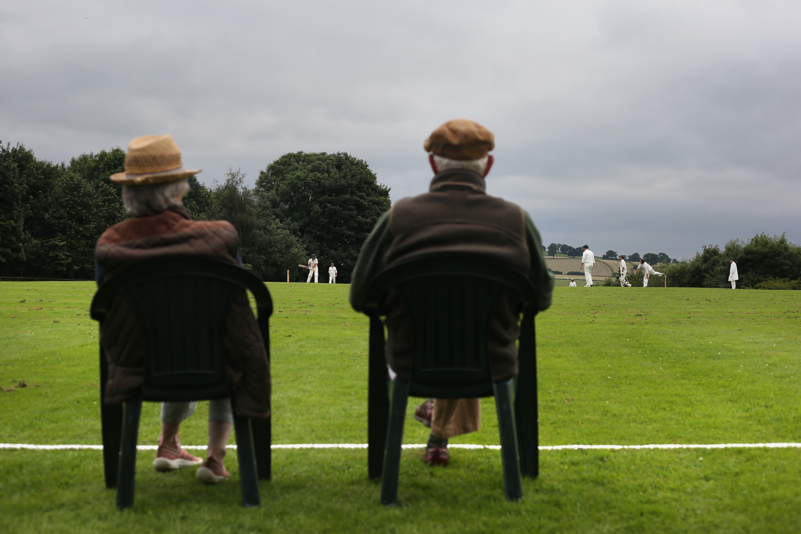
Two Men and ....Where's the Dog ?
With twice the normal crowd for a Sunday, the scene was set for a celebration of village cricket in Alstonefield. Ten years and 125 matches have passed since Tony Spybey and Will Siddons played in the inaugural fixture against Cheddleton. As the only survivors from that match, they were given the honour of opening the Gargoyles innings. Both are still the oldest and youngest club members respectively. Ten years ago they made two runs between them. Such is progress, this time they put on 13 for the opening stand before Spybey was yorked.

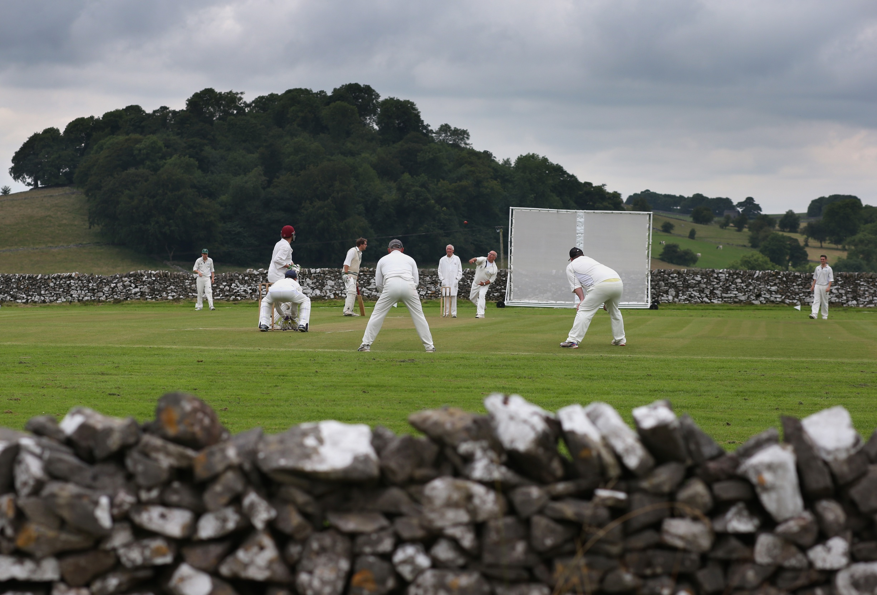
Harry Jones then mistimed a drive, Andy Bray edged to slip and the score was 20 for 3. Neil Shotton joined Will Siddons and these two set about restoring respectability. Shotton in his own bustling way, striking a stark contrast with the increasingly fluent Siddons. These two took the score to 83 before Shotton spooned a return catch to Brailsford captain Daikin.
Siddons completed a composed and elegant 50, probably his best innings in his ten years with the club. With 7 overs still remaining, Rob Handscombe and Andy Farmer showed more experienced batsmen how to set about an attack. Good running and lusty blows combined to put on 34 runs, with Farmer striking four boundaries in his 20 not out.

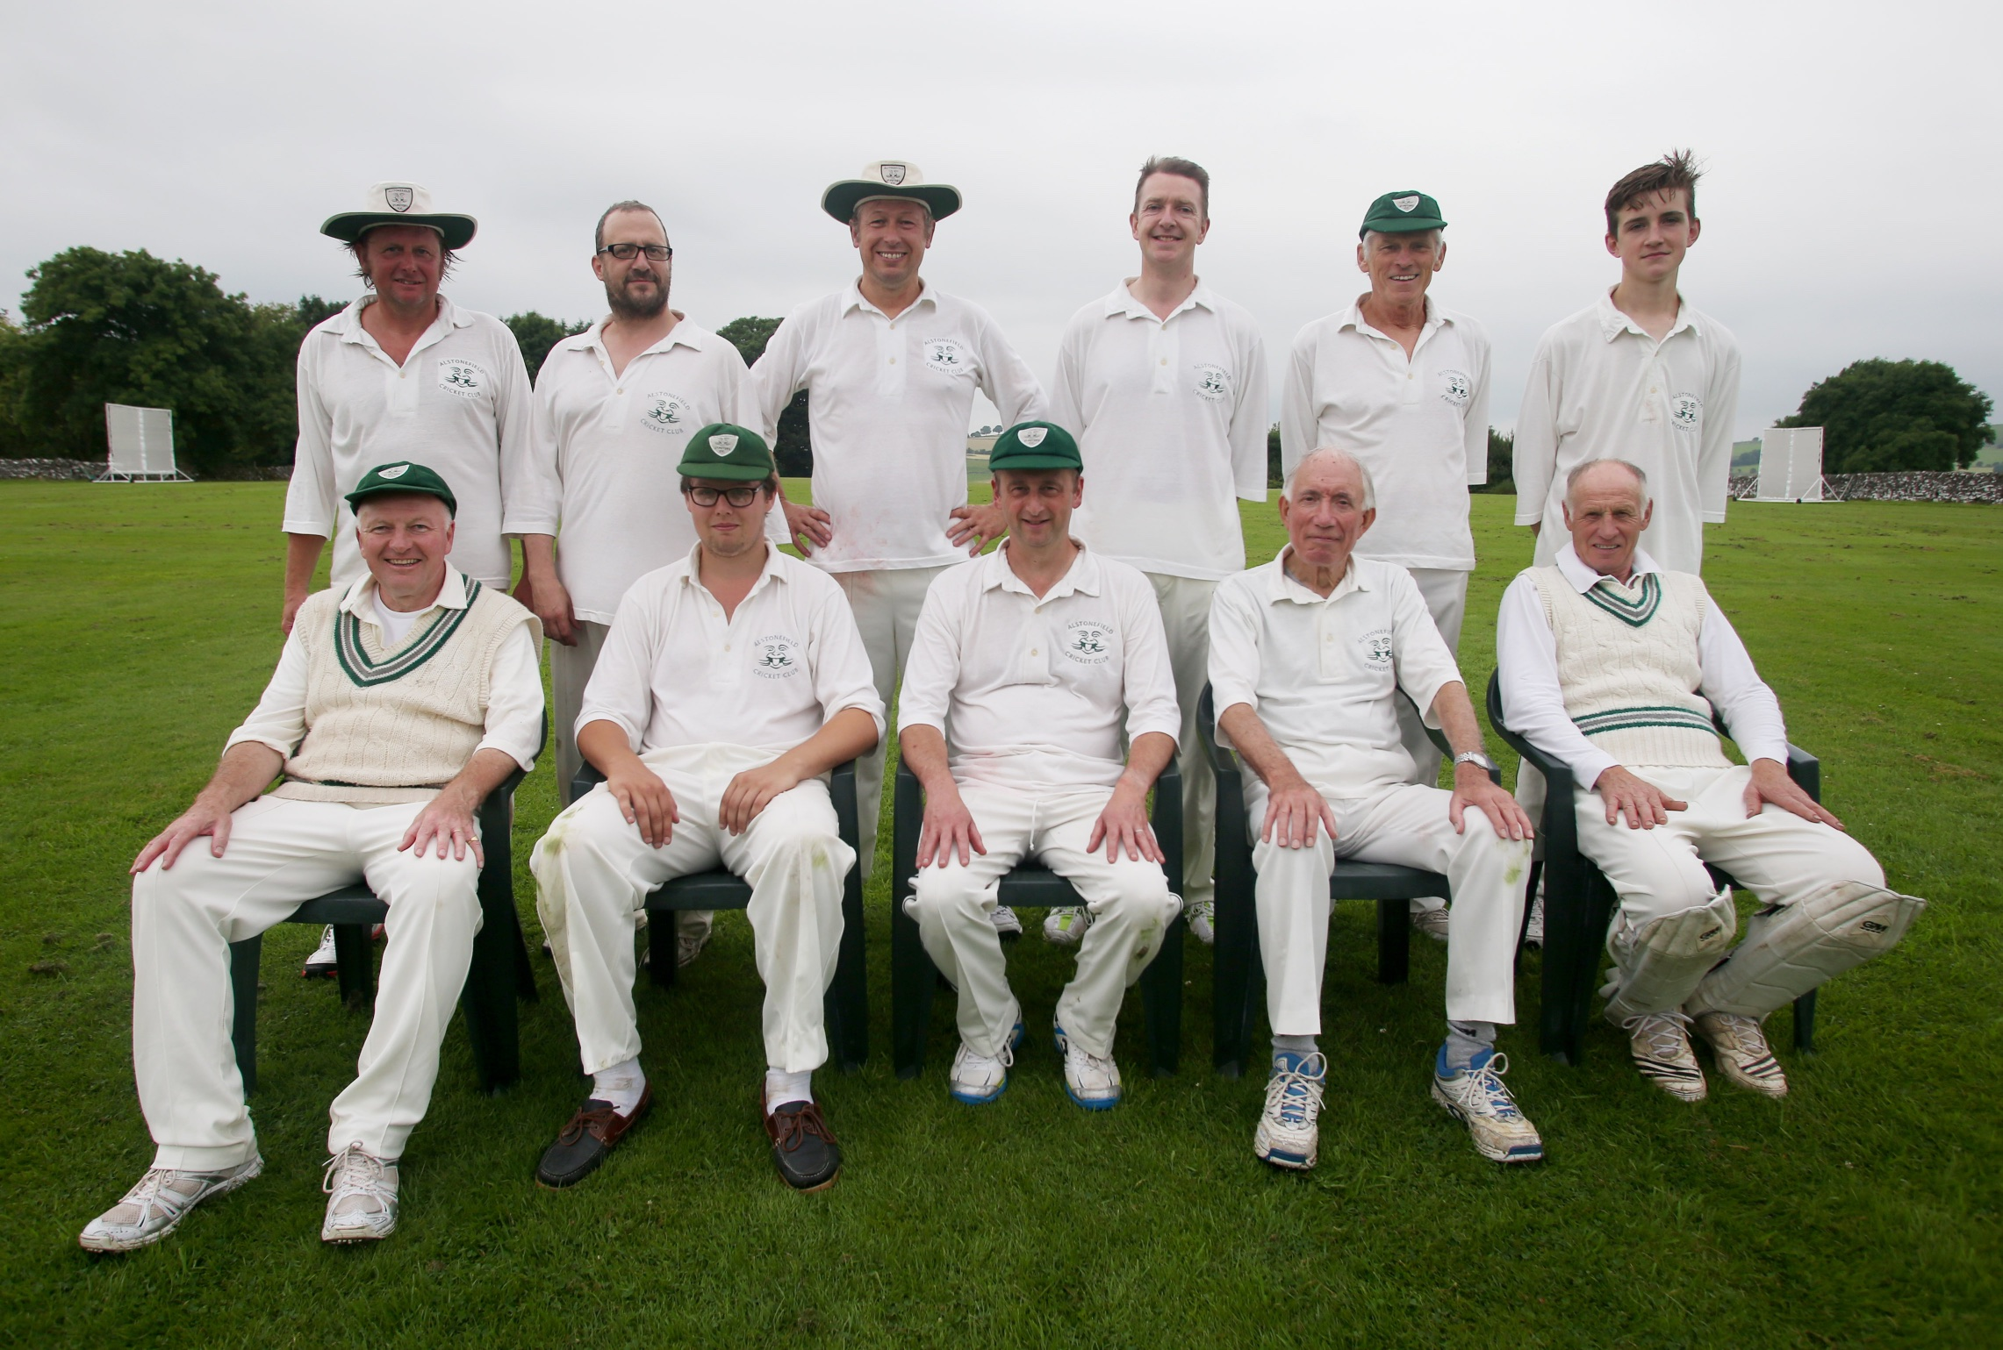
Alstonefield CC Tenth Anniversary Team

But, 117 for 7 from their 35 overs just did not feel enough for the Gargoyles as players and spectators repaired to the Village Hall for a wonderful anniversary tea.
Tea at the Village Hall
It was clear Brailsford had decided to enter into the spirit of the day by ensuring everyone could be at The George well before the rain due at 5:30pm. At the fall of their first wicket in the eleventh over, they were 86, with Connor looking in excellent touch for his 50. The Gargoyles’ Will Stupples-Newton, playing his first match of the season took a couple of quick wickets, to bring Brailsford’s South African professional Meade to the middle. With the rain setting in he struck 21 in 5 balls and 117 was passed in the 17th over. Full marks to Brailsford for allowing the post match celebrations to begin over an hour early!

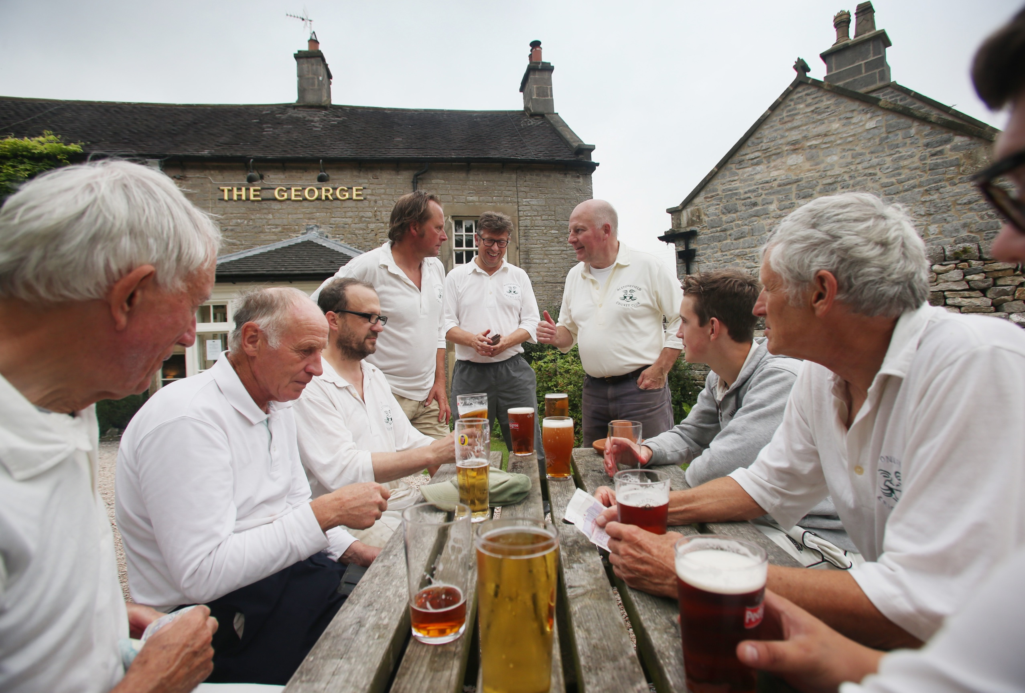
ALSTONEFIELD CC 117 FOR 7 LOST TO BRAILSFORD CC 120 FOR 3 BY 7 WICKETS

A week earlier, the Gargoyles travelled to Brailsford. From the very first ball, when Brailsford’s opener Meade straight drove a perfectly pitched delivery from Ben King, it was clear this was going to be a tougher test than in previous weeks. Great credit to the Gargoyles bowlers therefore for restricting Brailsford to 78 for 2 off the first 20 overs. The next 5 overs then went for 50 runs and the game changed. The experienced Inns and Bould, put on 60 in 7 overs with a mix of power and excellent running. Liam Duffy bowled accurately and Simon Smith took two late wickets to quell the run rate, with Ben King the pick of the bowlers at 1 for 29 off his 7 overs. 184 for 4 at 5.25 per over was always going to be at the top end of the Gargoyles’ range.

Ben King – Pick of the Bowlers
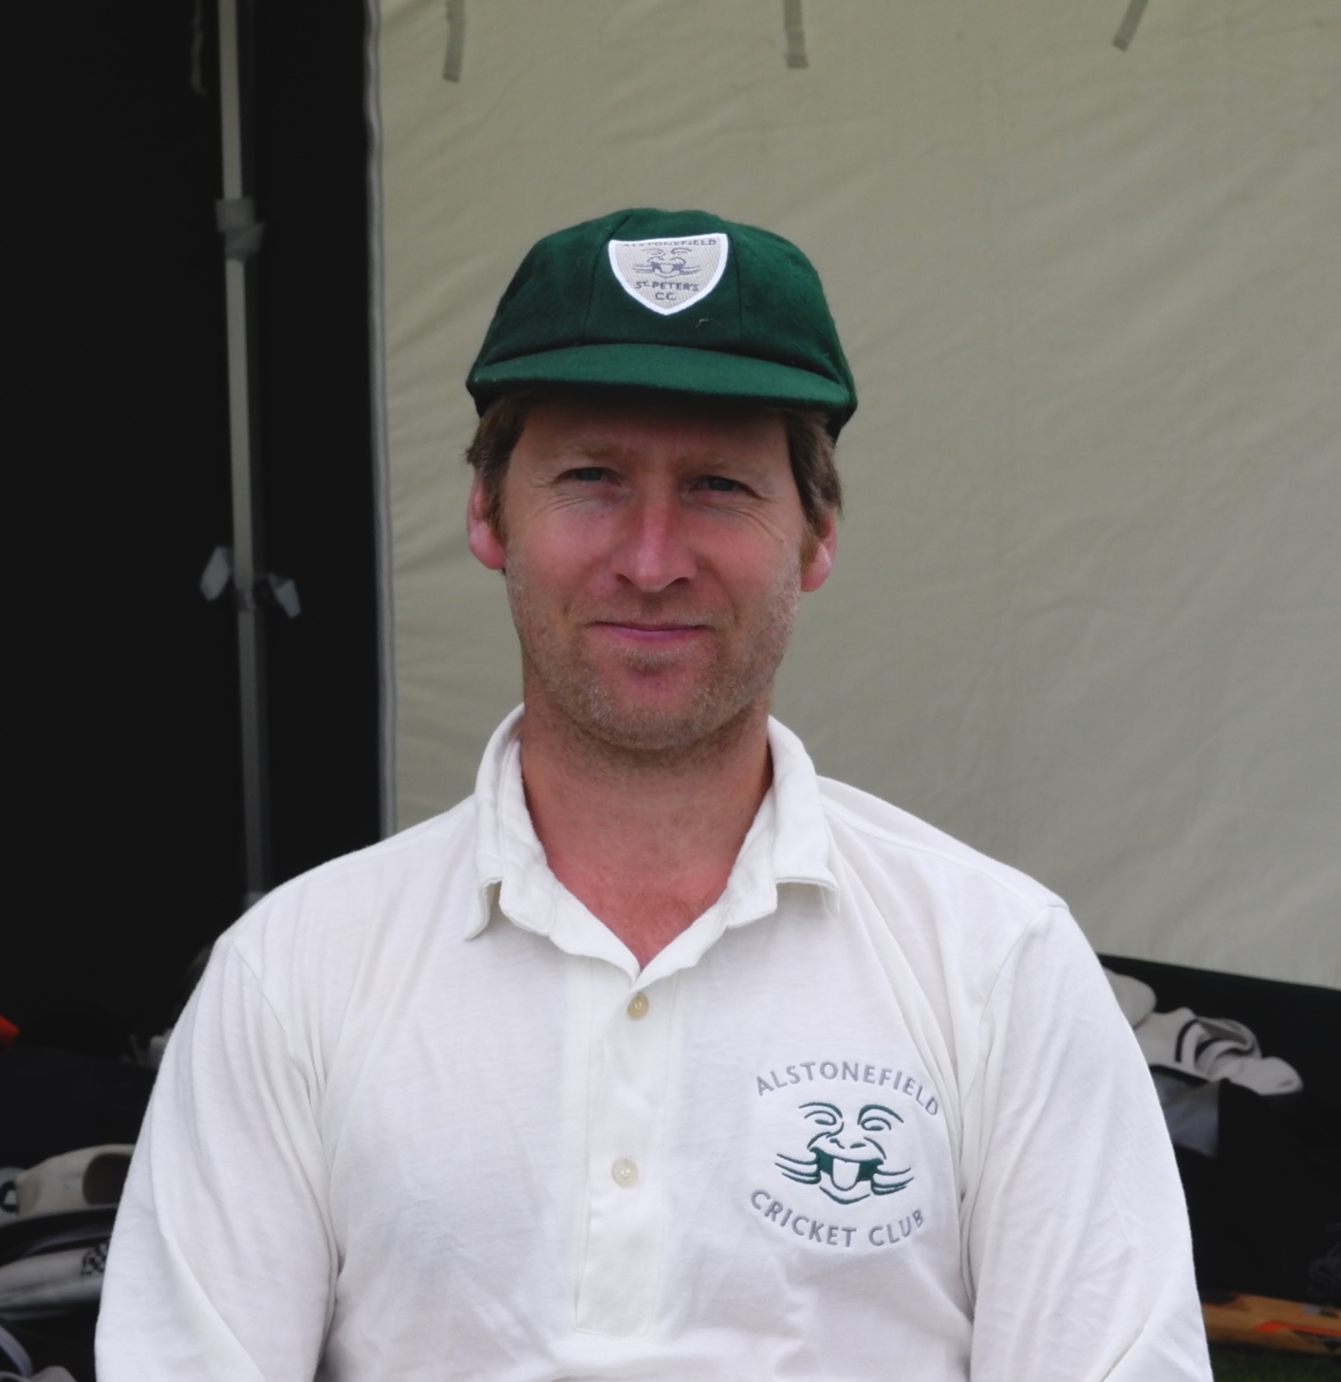
It all depended on a safe and brisk start. Harry Jones and captain Andy Bray looked to have weathered the opening salvos, when both perished at 13 and 12 respectively. Further wickets followed all too soon, with Shahid Ali and John Curry not reading spinner Edge.

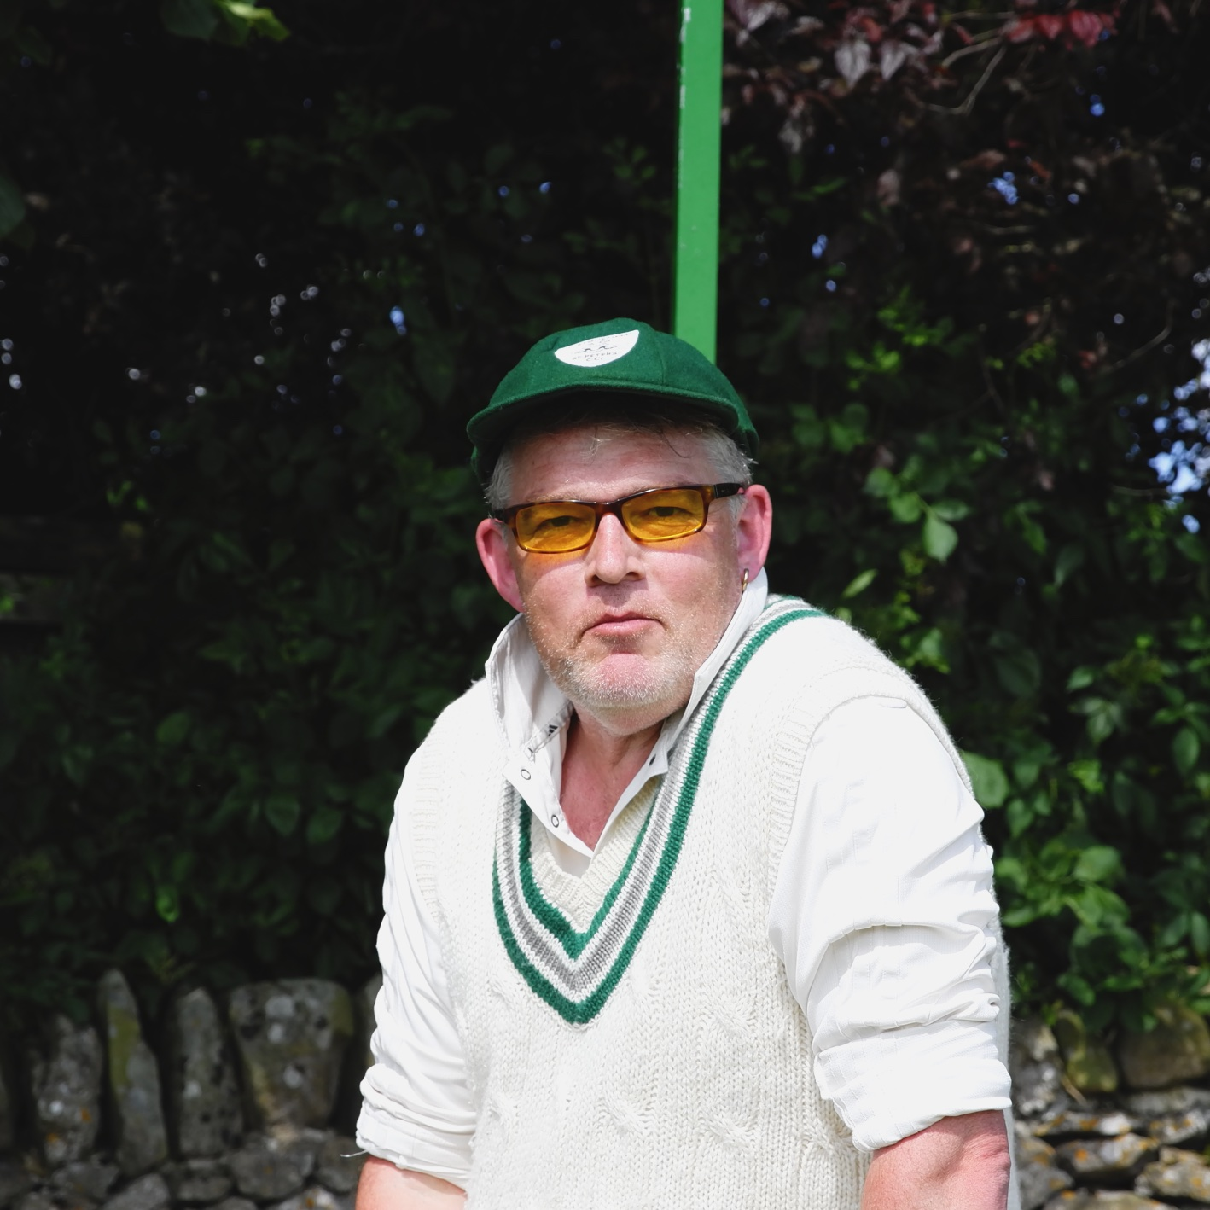
Duffy watched unperturbed
Liam Duffy, watching from the other end, was not perturbed. Showing all his class, he slowly mastered a serious variety of bowlers and then expanded his repertoire to make a superb unbeaten 50, with 32 in boundaries. Student Will Siddons is learning the price of his wicket and this match proved his graduation with honours. In 19 overs he mustered 14 runs and refused to be tempted by the Brailsford bait and go for the win. Only 4 wickets lost, but nowhere near the target.
BRAILSFORD CC 184 FOR 4 WICKETS BEAT ALSTONEFIELD CC 102 FOR 4 WICKETS BY 82 RUNS

