CLOSE ENCOUNTERS OF THE GARGOYLES KIND

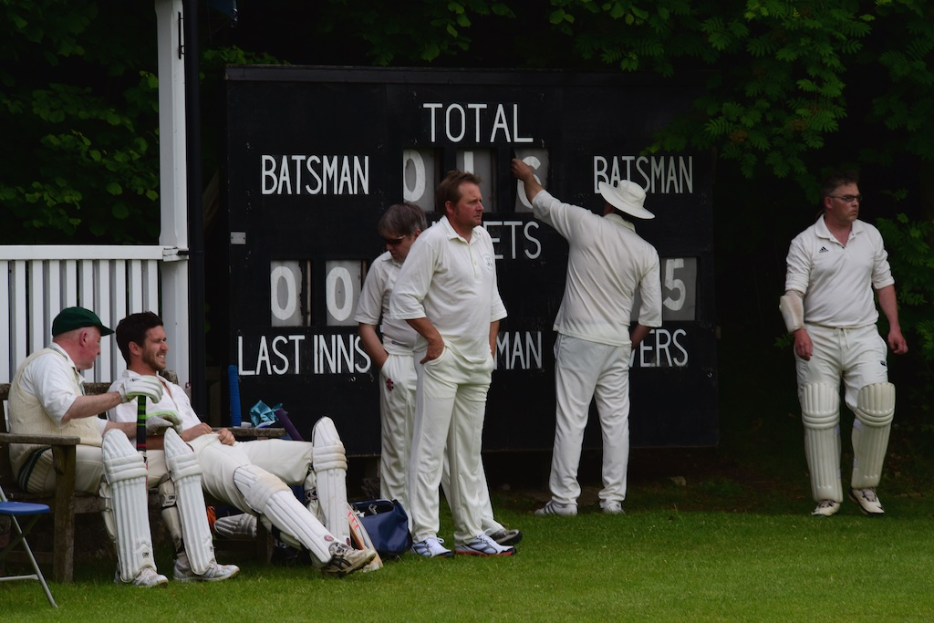

Whether it’s in the stately surroundings of Chatsworth House or the delightfully pristine playing fields of St. Anselm’s School, Alstonefield Cricket Club know how to set up a thriller. June brings the 20:20 mid-week matches to the fore, with the Club’s Annual Six a Side competition as the ideal launch pad for the more explosive form of the game. After a hectic fortnight, the conclusion is that the club is in the rudest of health, competing with good cricketing opposition and with everyone making a contribution. And the Gargoyles’ reputation for last over dramatics remains stronger than ever…...

SIX-A SIDE MATCH
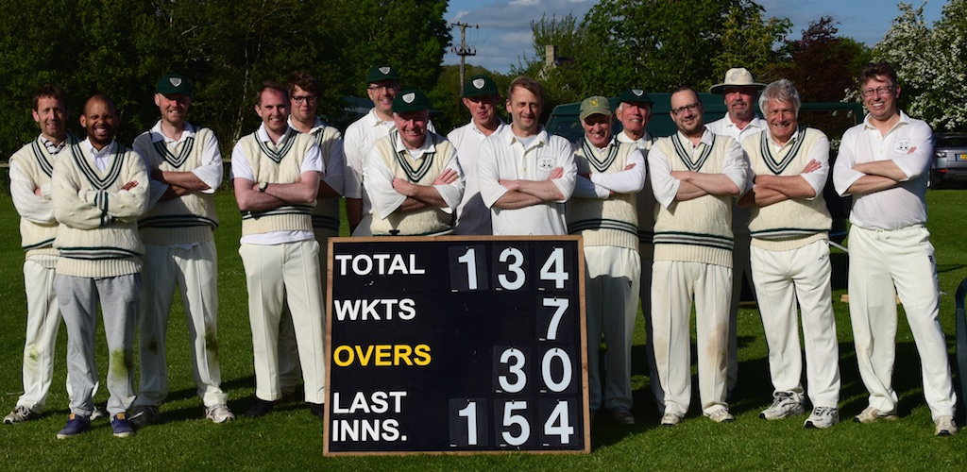
Old Contemptibles & Young Raikes together with the all-revealing scoreboard
The Annual Six a Side match gives the younger players the chance to show
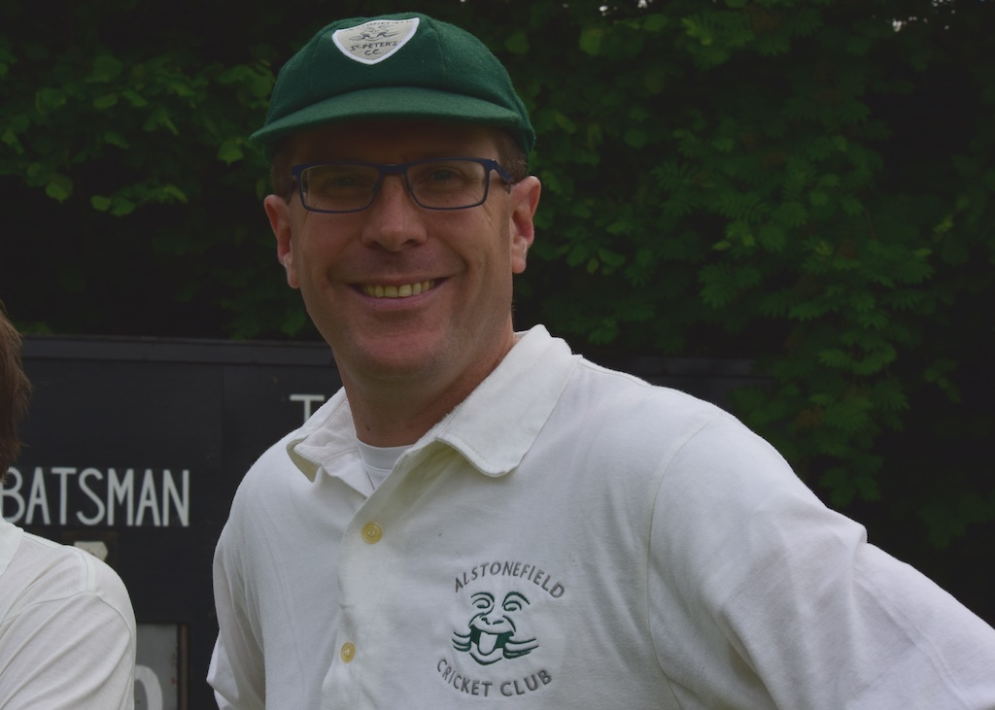
how much they have learnt from their wily older club mates. With the club’s average age at an overall 52, the split between the Old Contemptibles and The Young Raikes was 48 this year. In a match of high quality cricket, the result was yet another comprehensive win for the Old Contemptibles, who once again gave lessons in game management. Perhaps as a portent for the future though, the highlight of the day was the perfect leg break bowled by captain Simon Smith to dismiss the in-form Harry Jones, pitching on middle and leg, turning sharply to beat the Jones drive and clipping the off bail. Brimming with confidence, captain Smith now had to think about his tactics for the first 20:20 at Chatsworth.
Smith bowled perfect leg break

CHATSWORTH AWAY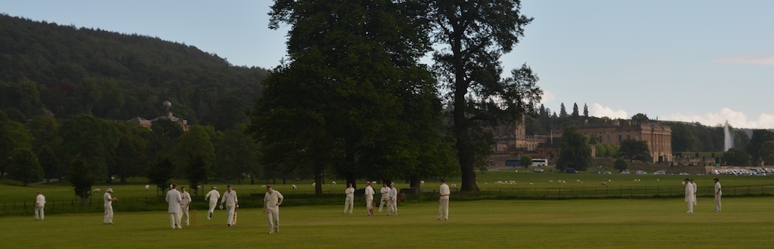

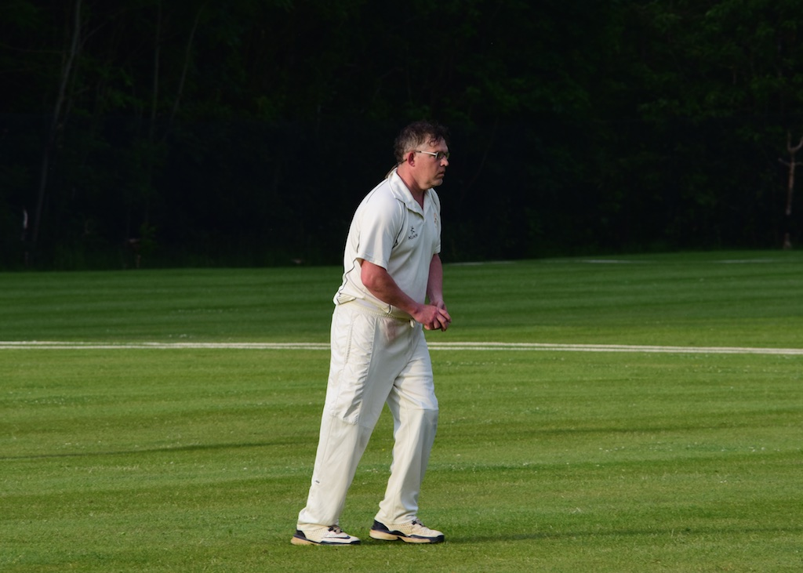
And innovative tactics they were too. Even in what must be the most glorious setting to play cricket, 20:20 demands concentration from the off. Smith decided on a new opening attack of debutant Liam Duffy and veteran Ian McKay. The thinking was to put the batsmen under pressure with accuracy. It worked, with these two bowling their combined 8 overs for only 31 and taking 4 wickets in the process, with Duffy returning 3 for 20, all catches, with Tony Guest’s the most stunning. Ben King took a wicket with his first ball and Tony Guest took 2 wickets in two overs, including a first ever catch for Steve King, proving practice makes perfect. At one stage it looked like Chatsworth would struggle to reach 80, but their captain Billy Khan, brought some urgency to proceedings with a series of lusty blows in his unbeaten 28. Tight bowling, a slow outfield and some sharp fielding, meant a run chase of 95…..
Liam Duffy with figures of 3 for 20

Chatsworth always include some talented young cricketers in their team and this year it was a genuinely fast bowler called Madin who made an immediate impression, by dismissing Dave Singleton in his first over and Liam Duffy in his second. 10 for 2 after 5 overs and the innings was stalled. Harry Jones was joined by Ian McKay and these two began to inject some pace. At ten overs the score was 41, with Jones retired on 25 and captain Simon Smith in the middle. For someone who had not been in the best of form, Smith was immediately into line and looking for singles. And that’s how it continued, Smith and McKay finding gaps and sharp running, started to put pressure on the Chatsworth bowlers. They had reached 75 with just under 4 overs remaining, when McKay was out for 24. Ben King then hit a rapid 10 to take the score to 90 with the final over to come. Ben King was then bowled, Steve King scrambled two more, but was then run out, meaning Richard Allen needed to hit a 4 off the very last ball to become one of the legends in Gargoyles history. It was not to be. Two runs meant a one run defeat for the second time this season.

CHATSWORTH CC, 95 FOR 7 BEAT ALSTONEFIELD CC, 94 FOR 5 BY 1 RUN

S.ANSELMS AWAY
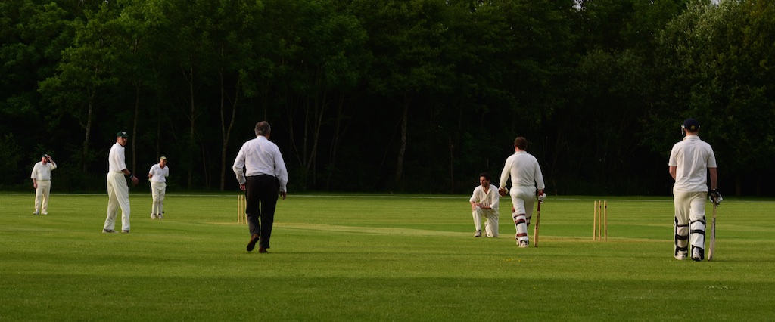

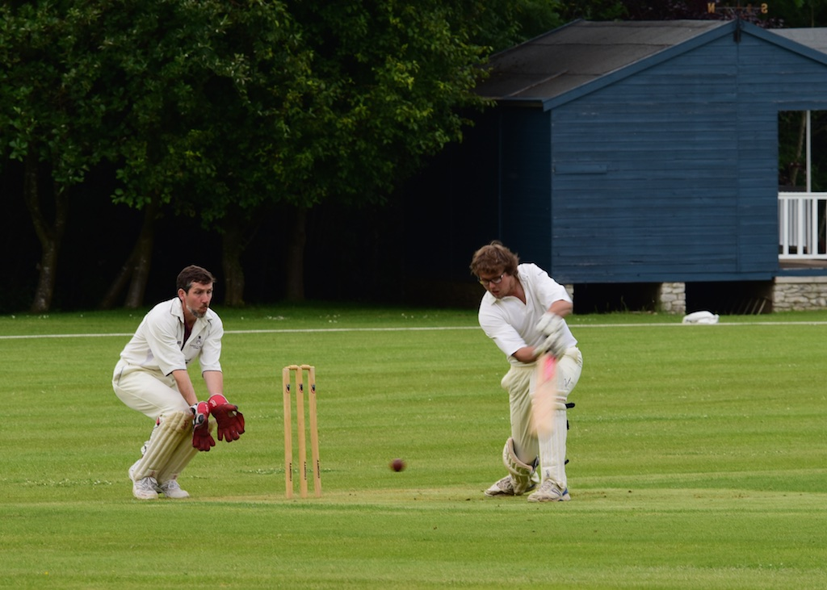
And so, another sunny summer’s evening and off to school at St Anselms in Bakewell. Last season’s encounter went to the last over, with the Strollers winning with 2 balls to spare in a high scoring match. It was soon apparent that runs would be harder to come by in this match, with a slow, green strip and lush outfield. The prolific pair of Harry Jones and Andy Bray opened the batting and found the going tough at first. Only 13 off 5 overs, despite their intent to put bat to
Will Siddons - one of his best innings
ball. At 25 Jones was bowled for 13. Liam Duffy
began cautiously, dealing in singles and rotating the strike, as he and Bray discovered their timing. Suddenly boundaries began to flow and both reached their unbeaten 25s in the 14th over with the score at 68 for 1.

Next man Will Siddons played himself in immediately with powerful drives and deft leg glances, this was one of his best innings. His unbeaten 25 and some sharp running between Ian McKay and Simon Smith yielding 14 off the last two overs meant the Gargoyles had posted a score of 115 for 2. It felt 15 to 20 runs short.

Captain Smith again experimented with his opening attack, this time partnering newly-wed Chris Wilkins, in his first outing of the season, with Ian McKay. Again, runs were at a premium. In their combined opening spell of 6 overs, the score was restricted to 20 for 1 with Wilkins’ 3 overs barely troubling the scorers at 0 for only 4. Liam Duffy proved he will be a valuable asset, again taking a wicket in his first over with the perfect away swinger. Opener Dunn had survived numerous near misses in the opening overs, but was now timing the ball sweetly, while new batsman James looked a class apart as he immediately tore into anything short and elegantly powered good balls to all corners. Both these batsmen reached their 25s, with James doing so in only 11 balls. 66 at the end of the 11th over, put the Strollers in front. Andy Bray was one who had suffered in the onslaught, but he kept his nerve and flight and weaved his magic to great effect, taking 4 wickets in 3 overs and ripping the heart out of the Strollers’ innings. All the dismissals were catches, as Bray’s loop and dip tempted the blade. Harry Jones taking two smart chances behind. Captain Drury was striking the ball well enough to keep the scoreboard moving as wickets were falling, setting up the last three overs finale. Needing 21 to win, Tony Guest bowled the near perfect miserly over, conceding only 3 runs. 18 off 2 and with 8 coming off the 19th over, it was a nice round 10 required from the 20th. Run outs always help and slick hands from Guest had the bails off just in time, leaving 3 for victory off the very last ball of the evening. Fielders were all posted to the boundaries, leaving Guest in calm isolation. Amazingly, when it came, it felt almost anti-climactic, as the batsman swung his blade for glory in vain and his stumps were shattered.

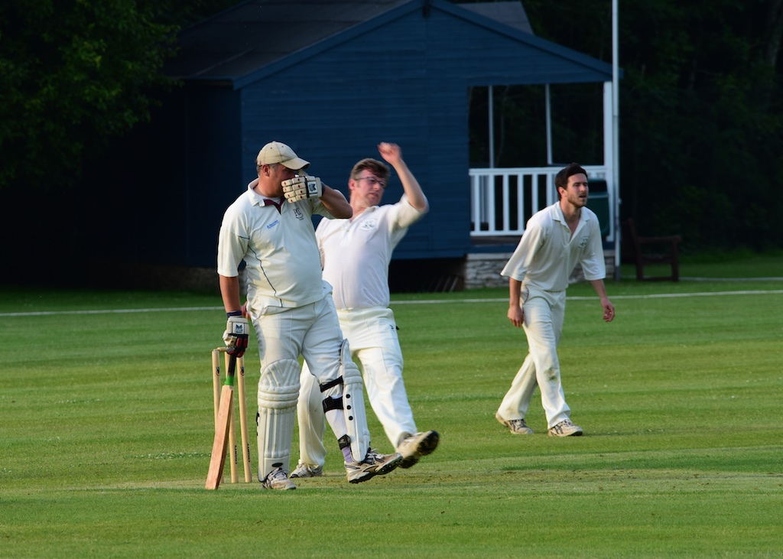
Miserly bowling from Guest
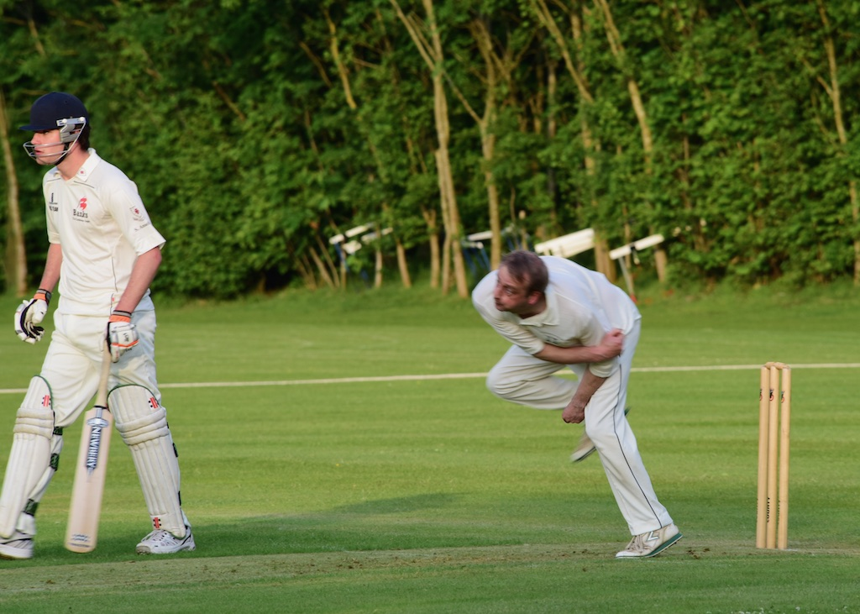
Bray kept his nerve and weaved his magic
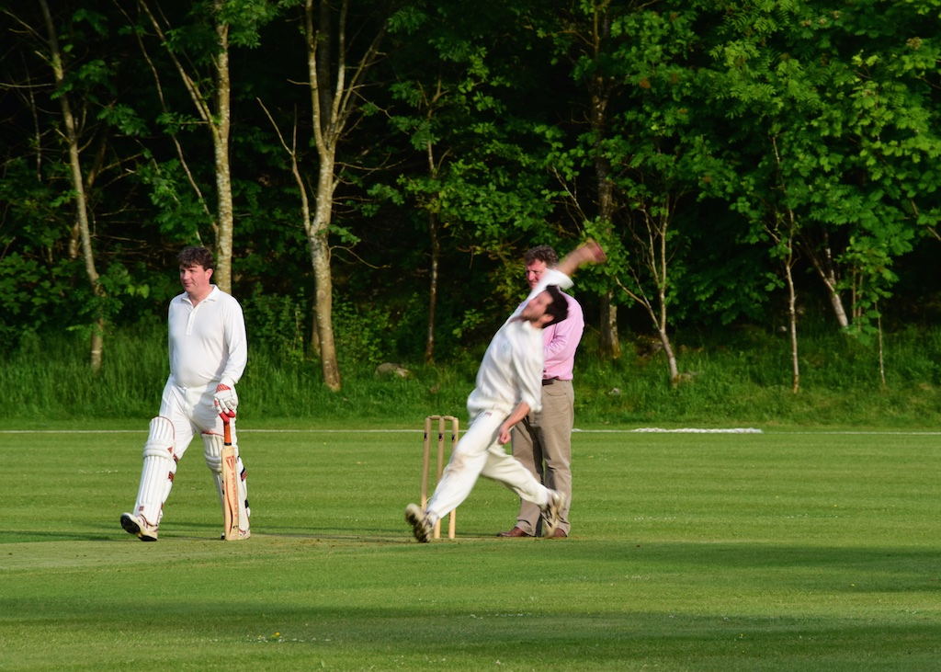
Wilkins - too fast for the camera!
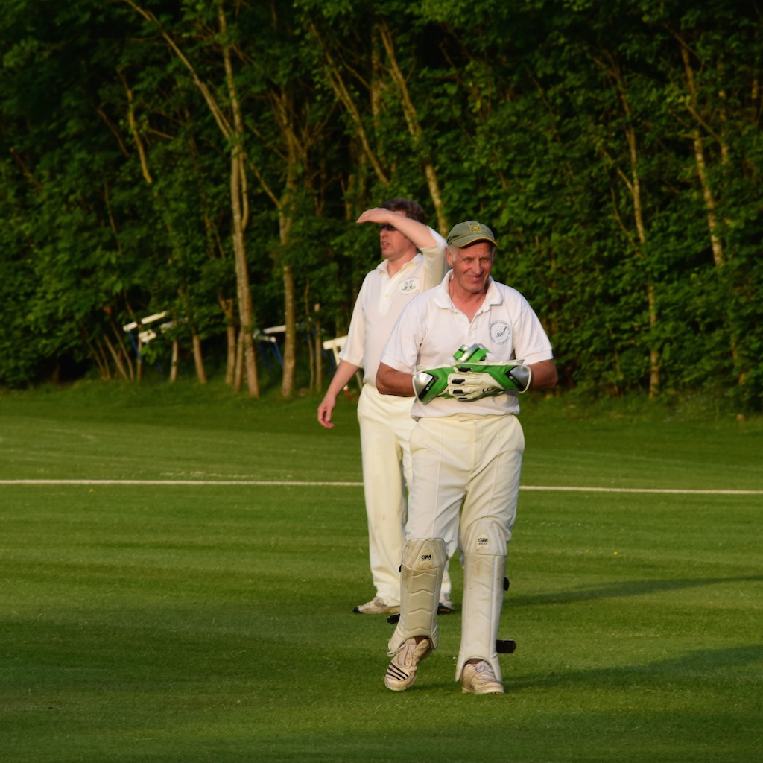
Hary Jones making good use of the club's new gloves !

ALSTONEFIELD CC, 115 FOR 2 BEAT ST ANSELMS STROLLERS 113 FOR 8, BY 2 RUNS

