RECORD WIN FOR GARGOYLES

Unlike Thursday’s election contest, the result of this match was never in doubt from the third over of the first innings. A record winning margin of 10 wickets against the one club they had never beaten, were two more milestones for Alstonefield CC on Sunday. Five wins in five matches, the longest winning sequence in the club’s history, completes a fine start to the 2017 season.

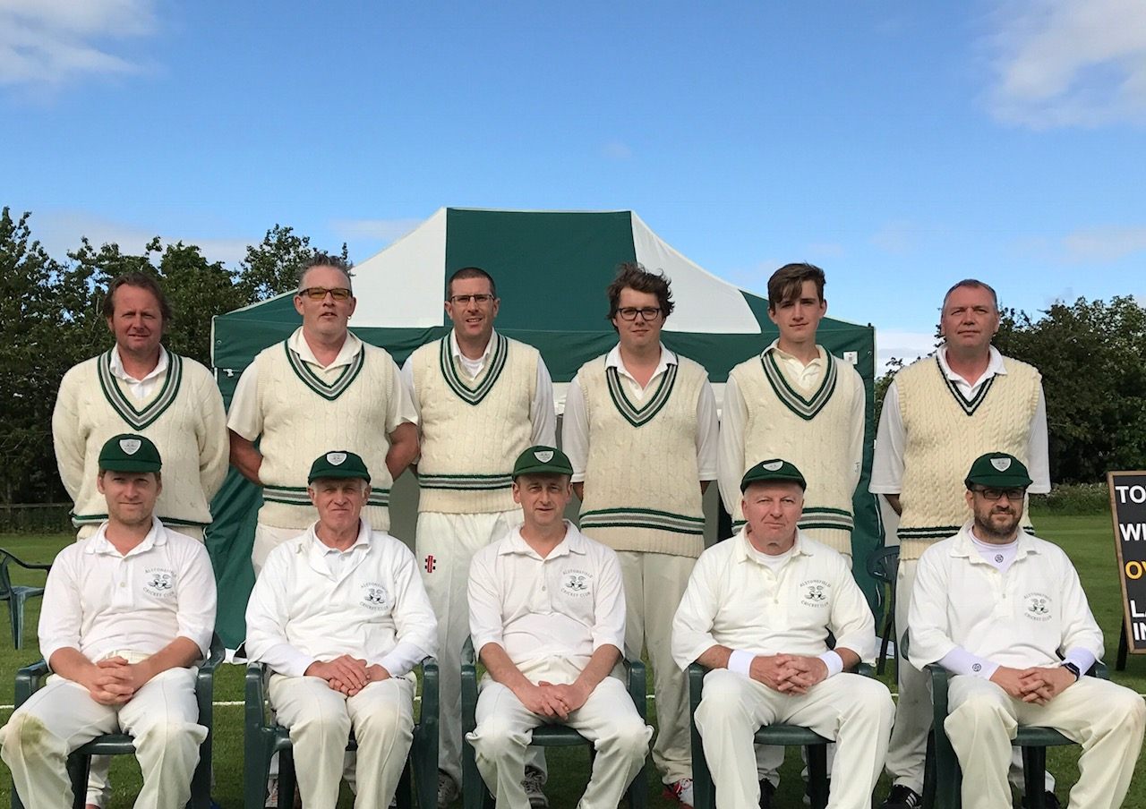
Alstonefield’s record winning team against Brailsford :

Back : A Farmer, L Duffy, S Smith, W Siddons, W Stupples, S King
Front : B King, H Jones, A Bray, I McKay, N Shotton
In their first home match of the season, with the ground looking a picture and the weather favouring the game, the Gargoyles chose to bowl first. By the end of the third over, Ben King and Will Siddons had dispatched both openers and Brailsford’s New Zealand professional for a combined 7 runs. King’s full length nip backers clean bowled his two victims, who join a long list of similar fate.

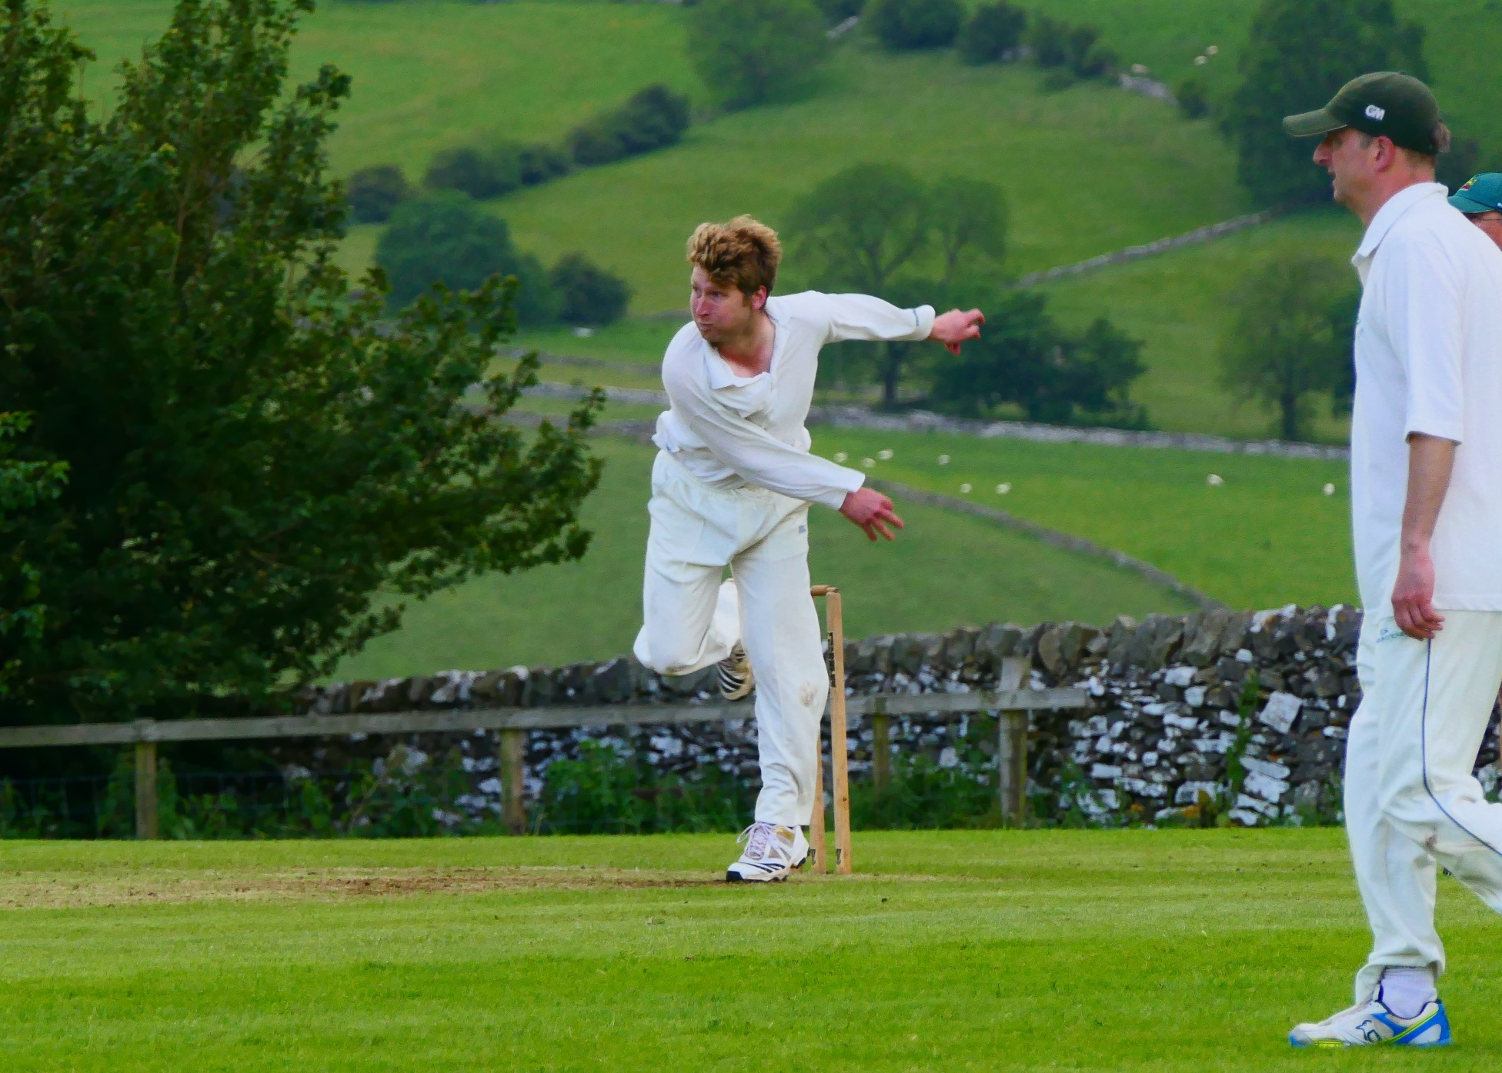
Ben King – Dispatching the opposition with his full length “nip backers”

There was some brief resistance from Brailsford’s middle order, until Will Stupples-Newton found his line and length and then movement off the pitch, inducing sharp edge after sharp edge, one low and one high, both nonchalantly snaffled by first slip. Sometimes, everything just works and for the first time in the season, catches were being held not spilled. No-one personified that improvement better than Steve King, who having grasped a return catch off his own bowling, fell to his knees and gave thanks.
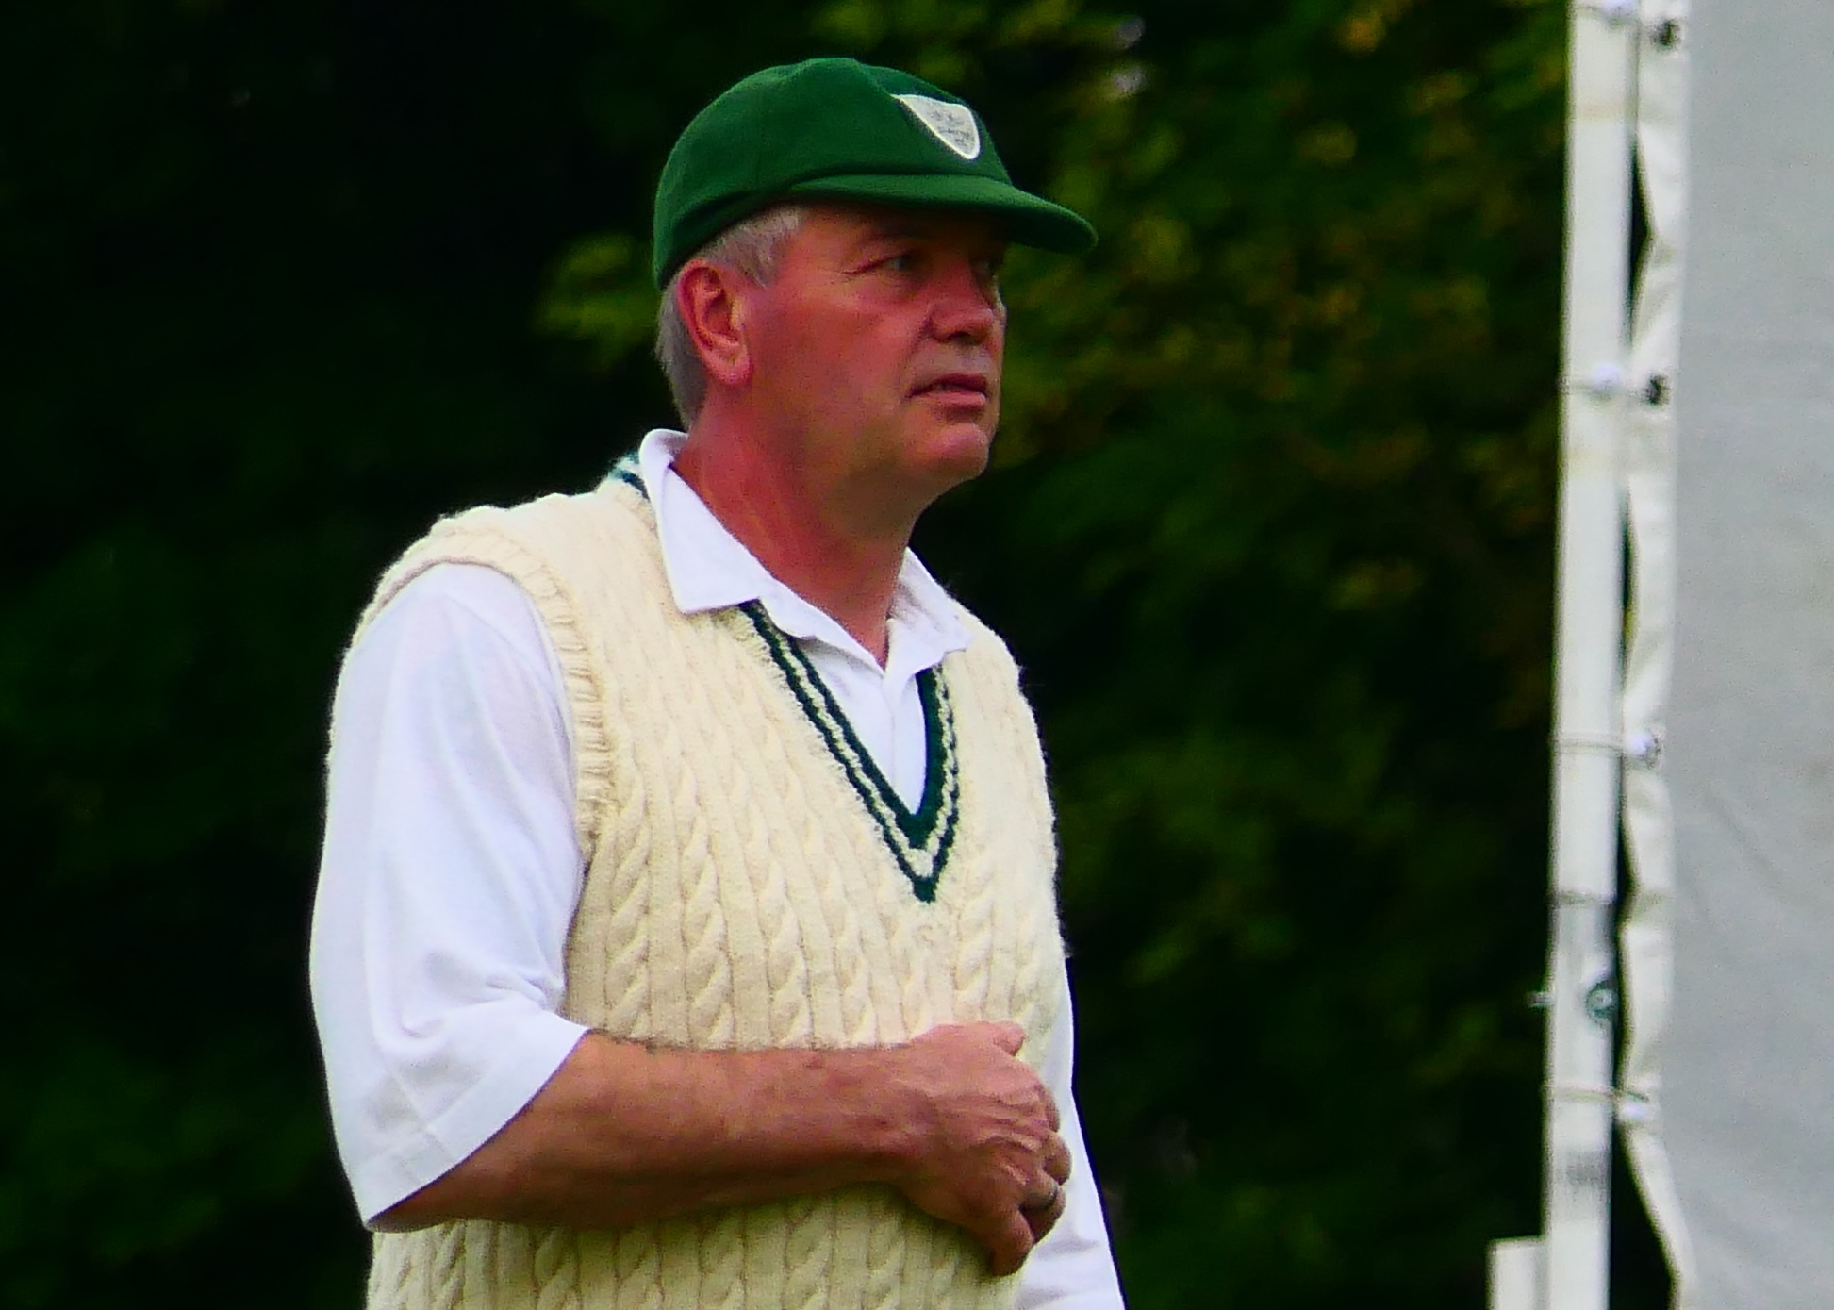
A thankful Steve King
The Brailsford innings ended tamely. Harry Jones coming on to bowl for the first time this season, took the final wicket with his first ball and looked disappointed.
Brailsford all out for 89 in 24.1 overs.

Taking the opportunity to use the fine weather before the impending rain shower, the Gargoyles had all but won the game in the 6 overs before tea. Will Siddons and Liam Duffy were in complete control, with Siddons in particularly punishing mood. Tea was taken on 47 without loss. With perfect timing, the rain passed and the sun shone again. Despite protestations that tea would break his concentration, Siddons just carried on, making a dominant, unbeaten 52 off only 33 balls, with 10 fours and 1 six. Duffy, happy to play second fiddle to the younger man, just enjoyed his time in the middle, making an unbeaten 22. After 15 overs the match was won and The George beckoned.
Sterner tests to come no doubt, but captain Andy Bray will be comforted in the knowledge he has much more to come from his talented squad.

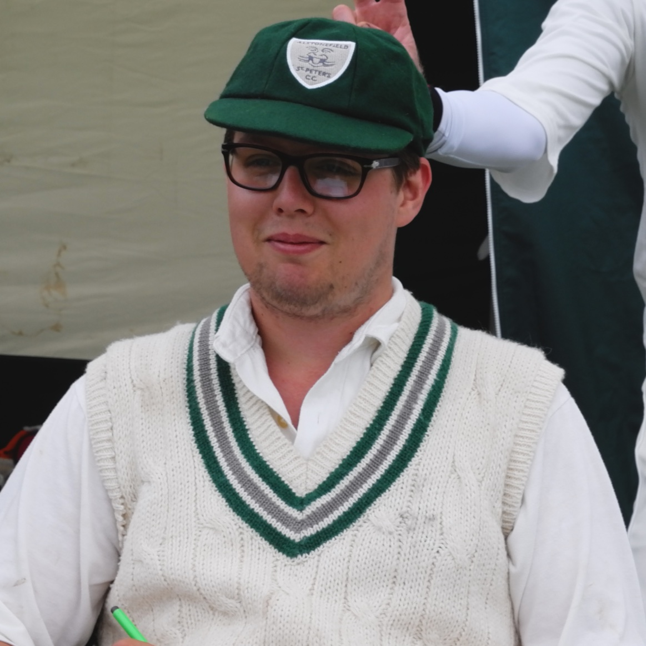

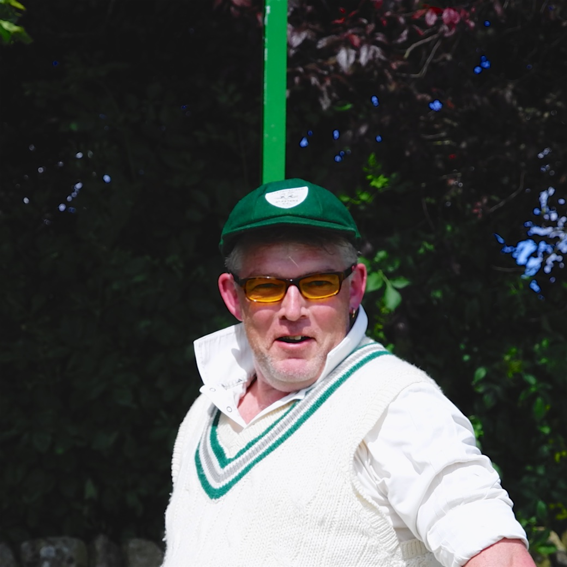
Batting together, Siddons and Duffy were in complete control…

ALSTONEFIELD CC 91 FOR 0 WICKETS BEAT BRAILSFORD CC 89 ALL OUT BY 10 WICKETS

