Alstonefield v Chatsworth
19th July 2020

Gargoyles go down to swashbuckling defeat

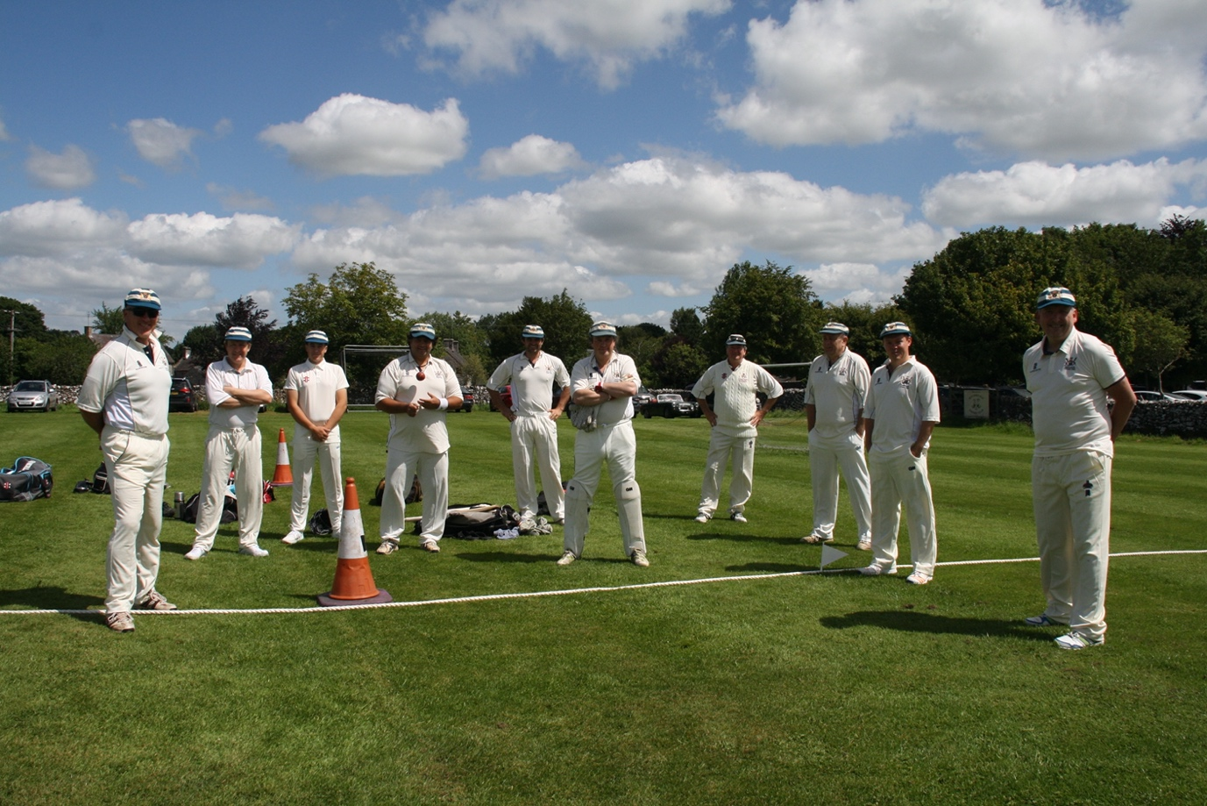

The Gargoyles hosted Chatsworth for the second match of the season, on another sunny Peak District Sunday. It was a rare pleasure to host Chatsworth, who rarely play away and this fixture came about through some friendly persuasion by our Chairman that our ground was equally picturesque - a feeling echoed by our guest photographer from the Cricketer magazine, Philip Wilcox - some of his photographs can be seen on his website, https://philipwilcoxphotography.weebly.com/cricket-grounds.html
Our own in house star photographer Brian Stack has provided the photographs for this report.

Steve King had produced another excellent wicket, which drew admiring comments from our opponents, and which batsmen from both sides took full advantage of. Gargoyles welcomed back Liam and Jordi Duffy, fresh from their Ashbourne CC exploits, and a new guest player Mick Jones, from Trent Valley CC, and fielded a stronger batting line up as a result. As our captain said after the defeat to Sheffield University staff, we fielded and bowled well, but our batting could be stronger. Well, it certainly was - with Andy Bray and John Curry forming a 27 run opening partnership, and Andy going on to score a well put together 36.

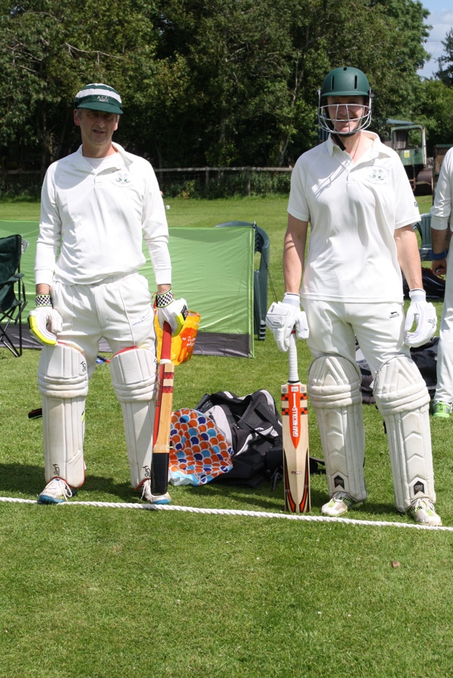

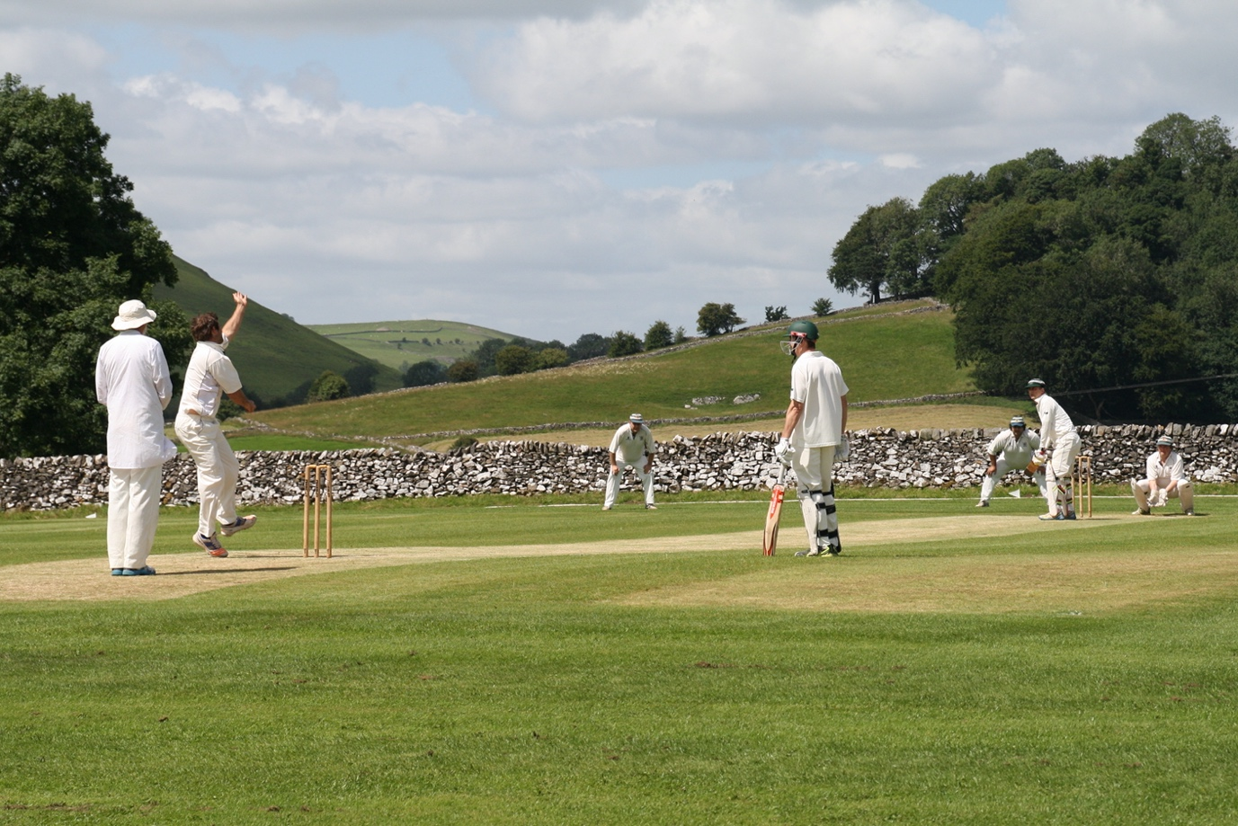

This brought Jordi and Liam Duffy together at the crease, and both scored excellent 50’s - 52 and 50 not out respectively.

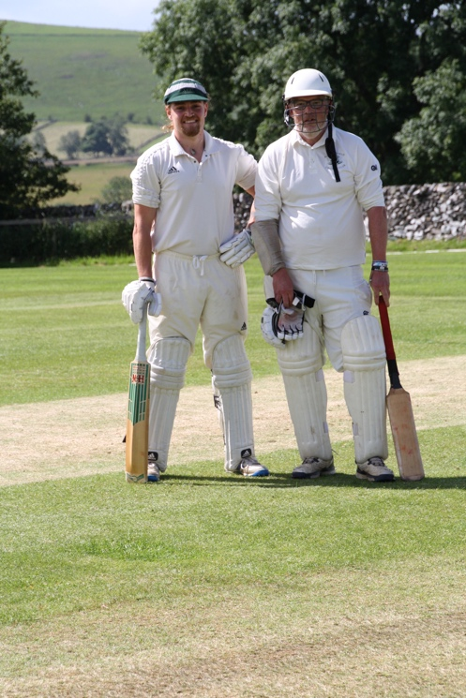

A quick rattle of wickets followed in attempt to score quickly in the last few overs, with Alstonefield ending on 179 for 4 – the much improved batting performance the captain had called for.

This looked a competitive total, but Chatsworth proved to have some star batting of their own, with Jackson and Gray both recording unbeaten 50’s - Andy Bray bowled the opener Everett for 10, with the only other success being Mick James taking his first wicket for the Gargoyles, bowling Drabble for 14. By then the score was 135 for 2, and Chatsworth successfully completed their run chase with 3 overs to spare. A few tough chances were dropped, but Chatsworth were just a bit too strong on this occasion.

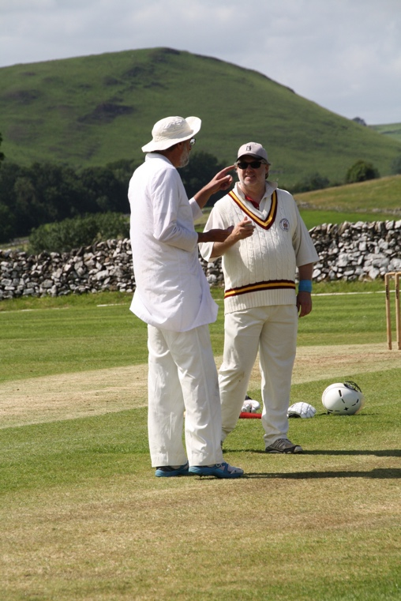

Our Chairman welcoming Mick James to the club with some friendly Umpires advice…….

