SCHOLARS GIVE GARGOYLES LESSON IN GOOD BEHAVIOUR

With an average age well into the 50s, there was always going to be a sense of trepidation for the Alstonefield CC team up against scholars from Uppingham School, all in their late teens, bar two members of staff tasked with keeping a semblance of control. Not only could they be daunting by their athleticism, but what about the much publicised antics of youth exploding onto the tranquil village sward?
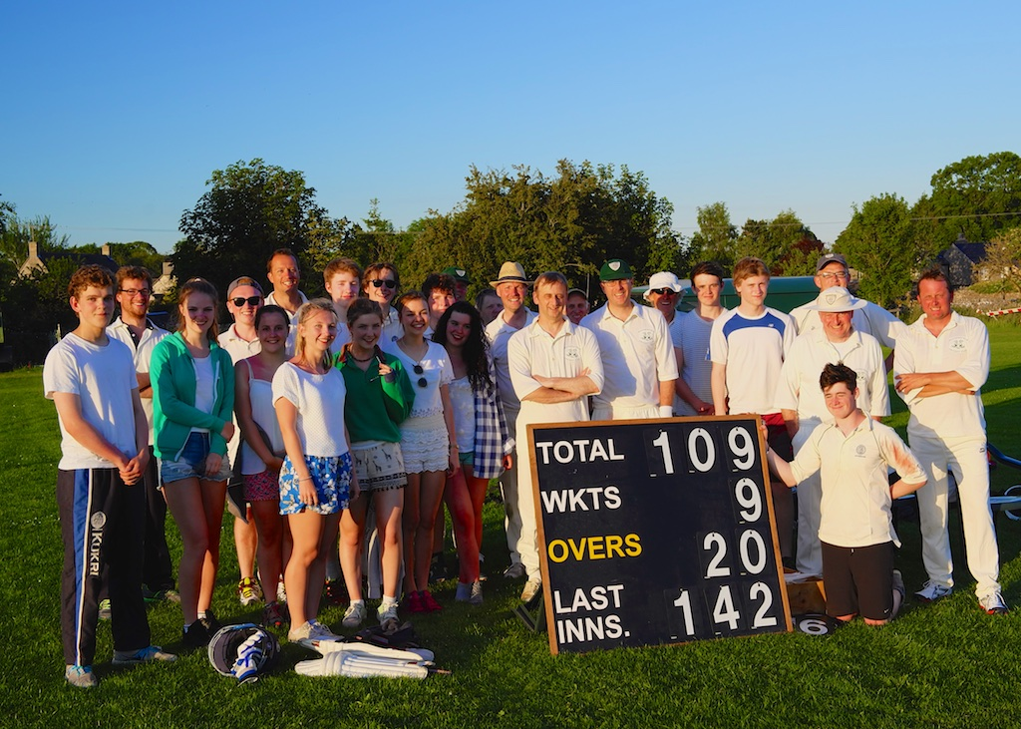
On a perfect summer’s evening, what transpired was a perfect example of how cricket should be played, in a competitive, yet fun atmosphere. The result was a 33 run win for the Gargoyles, but the overwhelming impression was left by the scholars’ exemplary behaviour and courtesy.
A most welcome addition to the fixture list.

