BAND OF GARGOYLES BACK FROM BRINK

Equalling their longest winning run, Alstonefield CC pulled off a remarkable victory at Wootton on Sunday. From scaling the batting heights at Sutton on the Hill a week earlier, the Gargoyles were reeling at 9 for 4 within 20 minutes of the start of play. To fashion a win from there against a talented Wootton side, says a lot about their self-belief and palpable team spirit. And it wasn’t the form players of the season so far who turned it round…
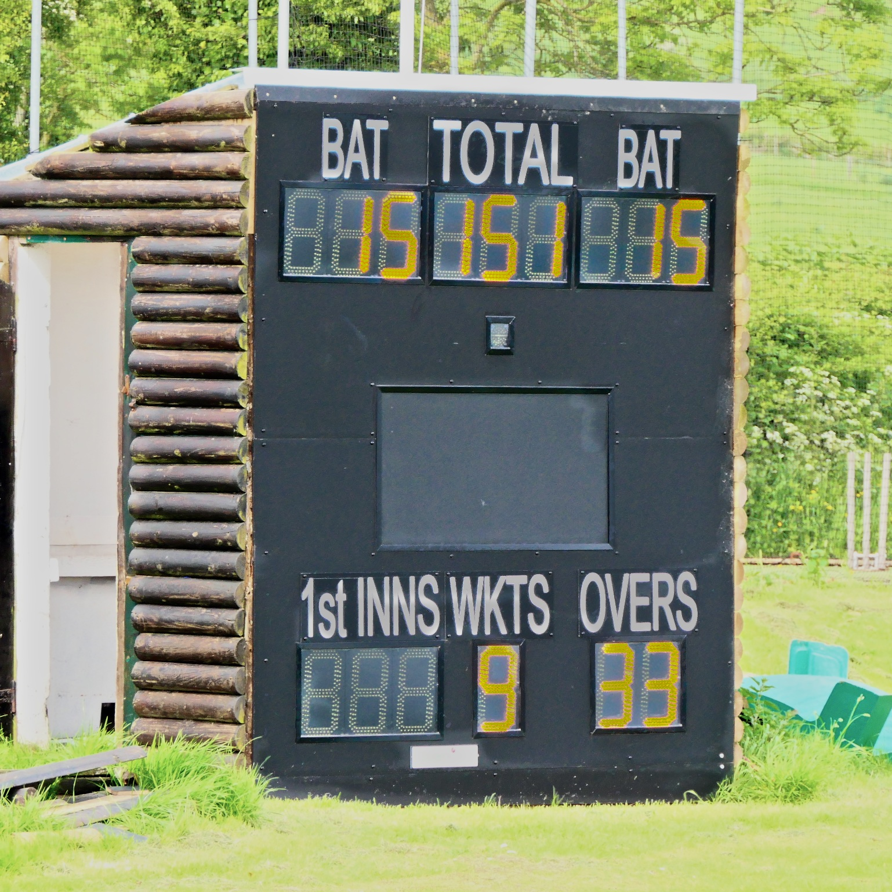
Alstonefield's ending score at Wootton on Sunday, setting up a remarkable win against talented opposition
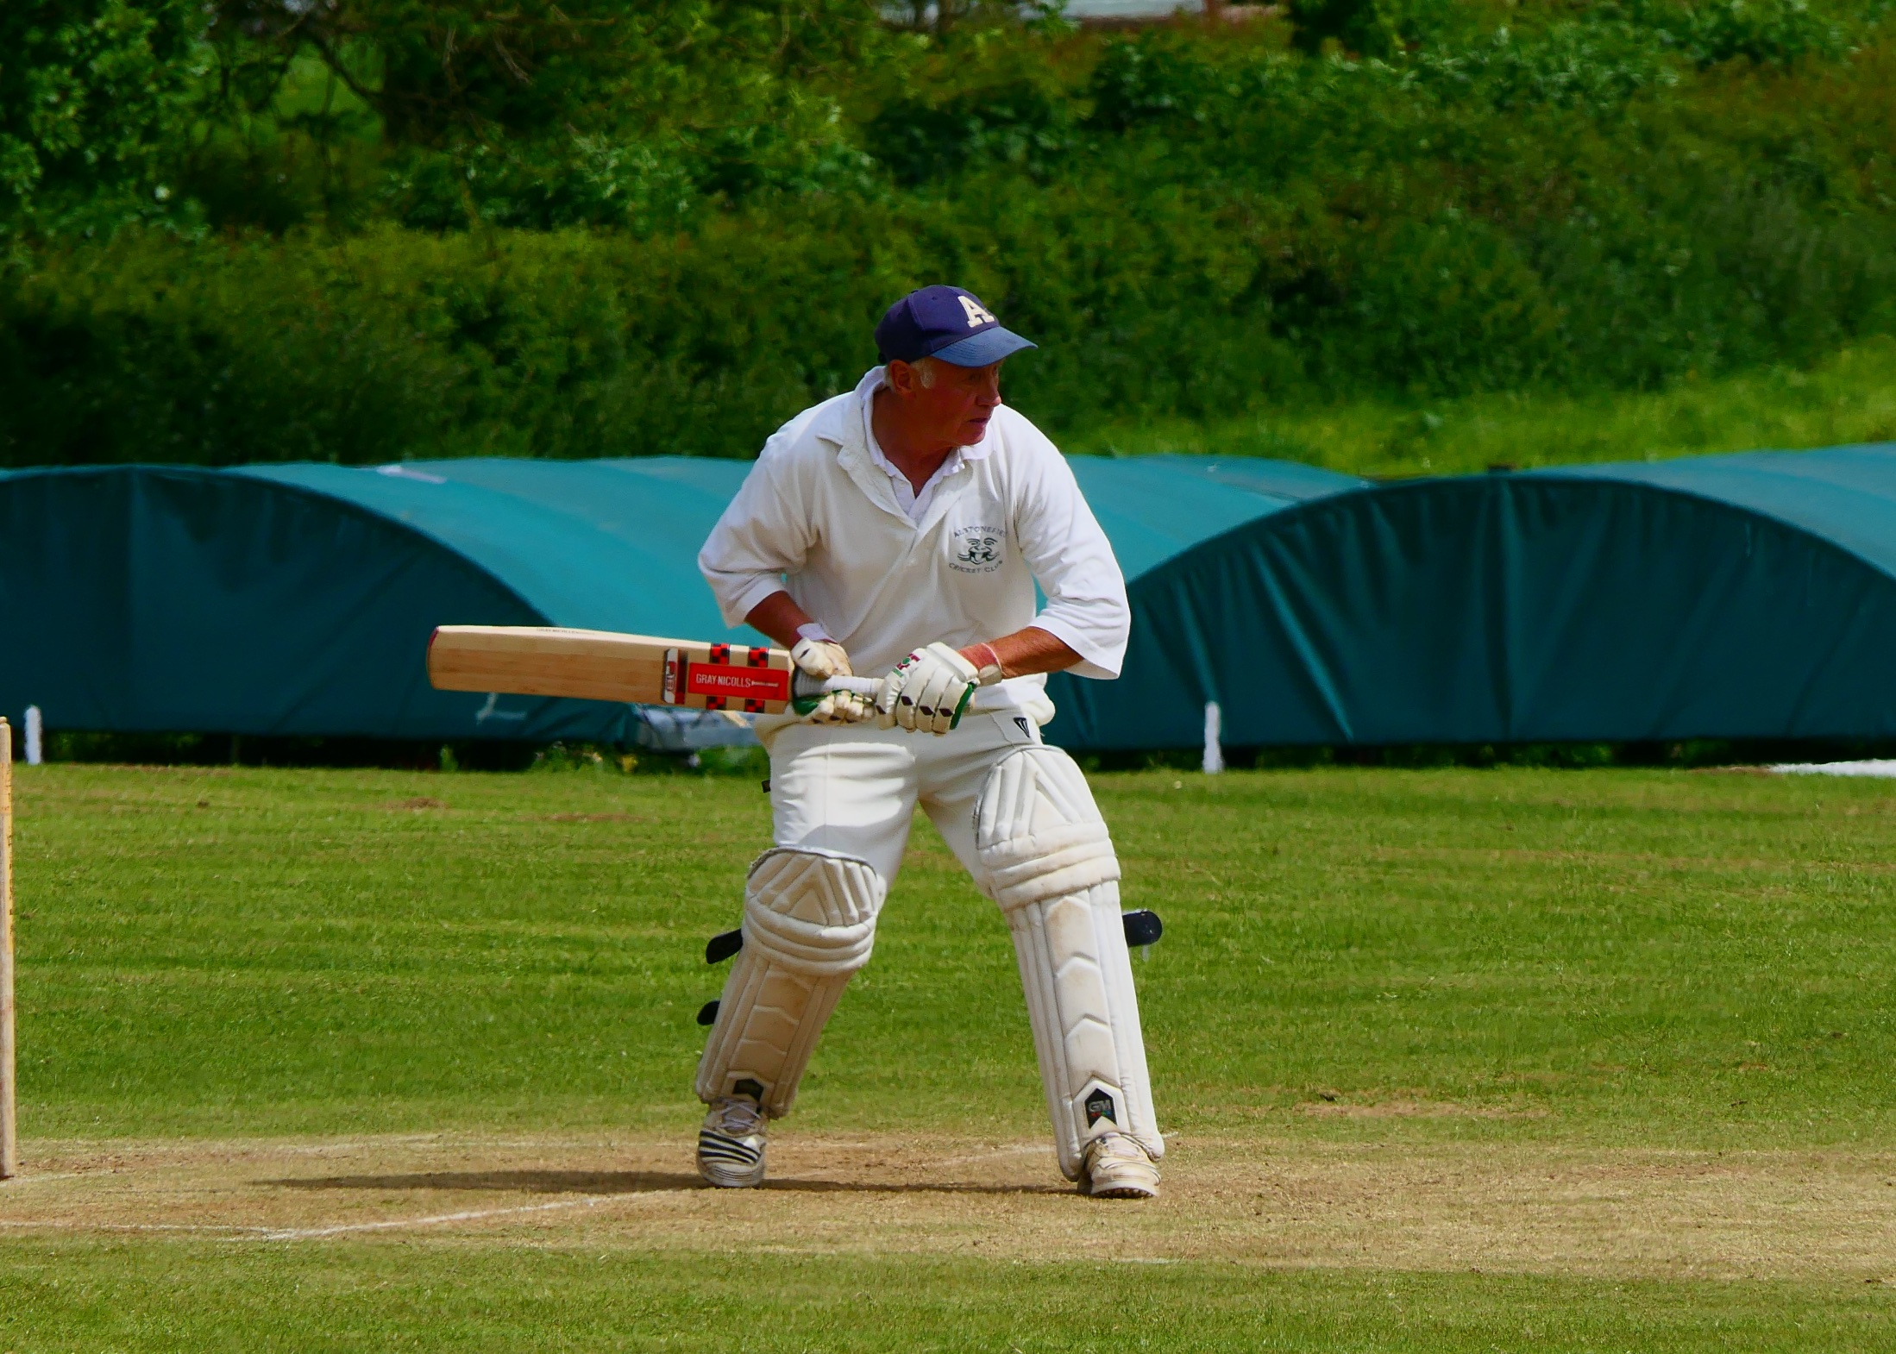
9 for 4 after 5 overs was a new experience for the Gargoyles this season. Jon Lane, run machine Will Siddons, captain Andy Bray and John Curry were all back in the shed, courtesy of some pacey and deadly accurate strike bowling from Wootton’s Tomkinson, who took 4 for 20 off his 7 overs. When the prolific Liam Duffy followed with the score at 28 for 5, it didn’t feel like a match destined to go the distance. Wise and cool heads were needed to make the most of the 23 overs remaining. They don’t come much wiser and cooler than Harry Jones. Batting down the order these days, Jones gave a masterclass in shot selection, deft touches and ruthless disposal of bad balls.
Harry Jones – a cool head in a critical situation

At its heart was a perfect demonstration of unhurried timing. Where others had struggled to exert any dominance over the bowler, Jones’s innings exuded calm authority. In the words of a seasoned spectator “ I’d pay money to watch batting like that.”

It was an innings that kept on giving because its aura transformed Neil Shotton’s batting at the other end. Gone were the pivots and static feet and in their place was Shotton at his careful best. When he was adjudged lbw for 30, he and Jones had taken the score to 73 for 6 after 23 overs. Still behind the game, but much improved.
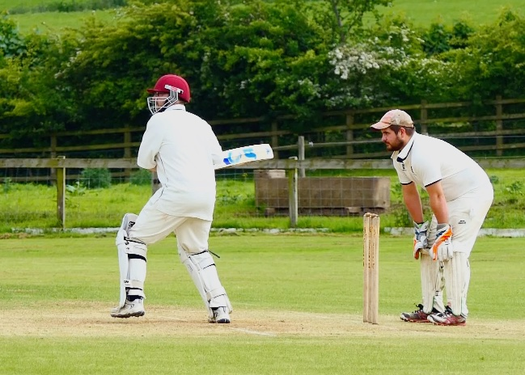
Neil Shotton - transformed and at his careful best…

If any one player represents the ethos of Gargoyles cricket, it is Andy Farmer. Still avidly absorbing the nuances and niceties of the game, he brings a refreshing lack of fear as well as his abundant natural flair to his batting. Exquisite shot after exquisite shot from Jones and Farmer propelled the score to 138 in the 31st over.
Farmer had made a personal best 29 off only 27 balls, just when his team needed them most, when he was bowled by the returning Tomkinson. Jones finished his impeccable innings on 58 not out and the Gargoyles had improbably notched up 151 when the last wicket fell. Something to bowl at, but a competitive total?
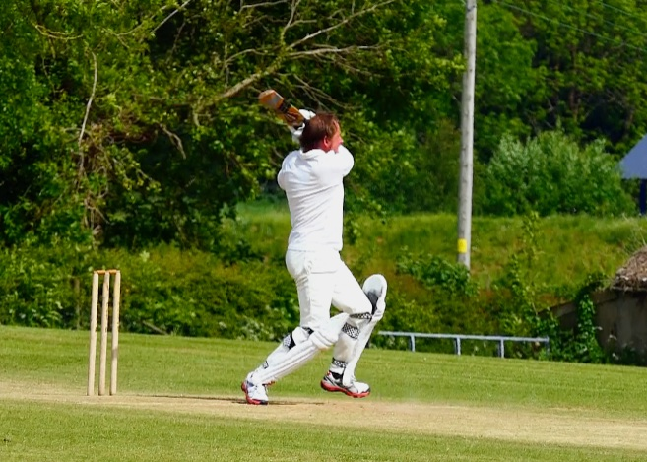
Andy Farmer - a personal best

It didn’t look like one after 5 overs with the score at 28 without loss. Then Liam Duffy found the perfect length and movement off the pitch to bowl the other Tomkinson. Wootton captain Clewes had reportedly been in the runs the day before, but was immediately deceived by Duffy, mistiming a push to Andy Bray in the covers. A glimmer perhaps?
12 overs later the score was 101 for 2. The other Clewes and the same Tomkinson who had wreaked the damage with the ball, had it appeared put their team in an unassailable position. Scoring at a consistent 6 per over, with Tomkinson in particular, combining fine strokeplay with youthful power, the Gargoyles needed to exert control. In the same way that Harry Jones had brought a wise head and calm authority to the batting, so it was that Ian McKay was able to quell the flow of runs. His 7 over spell of 1 for 14 put the batsmen under scoreboard pressure for the first time in the match. Back for his second spell, Will Siddons ramped the pressure up by bowling his final 4 overs for just 5 runs. In an amazing transformation and with the score at 126 for 6 after 30 overs, the
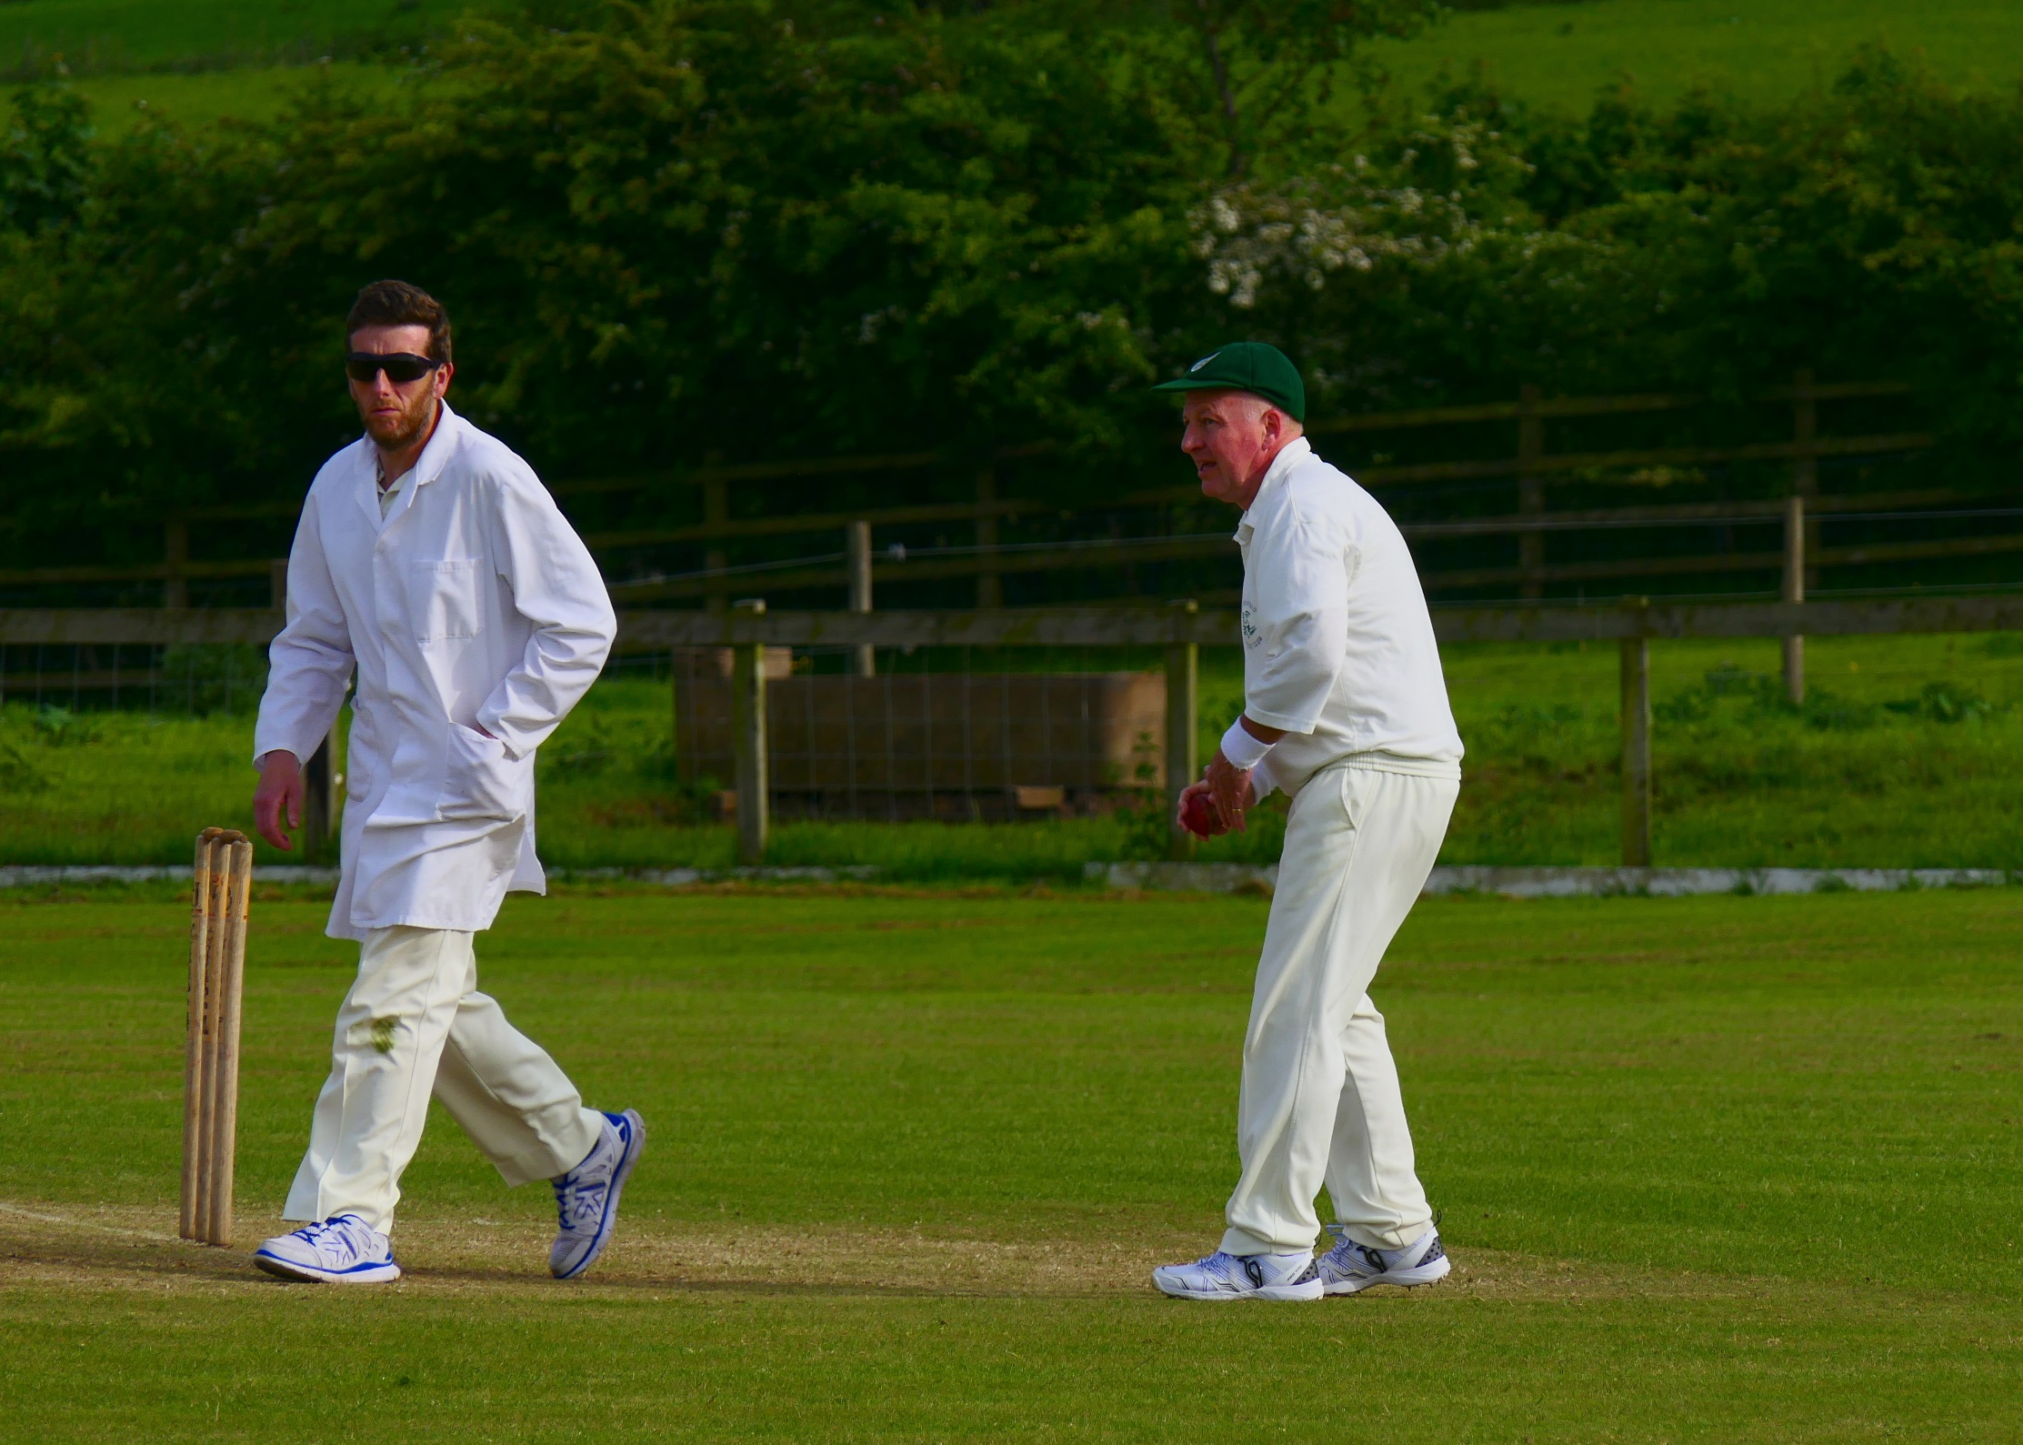
Ian McKay – quelling the runs alongside Will Siddons, who exerted pressure with a tight spell of bowling …
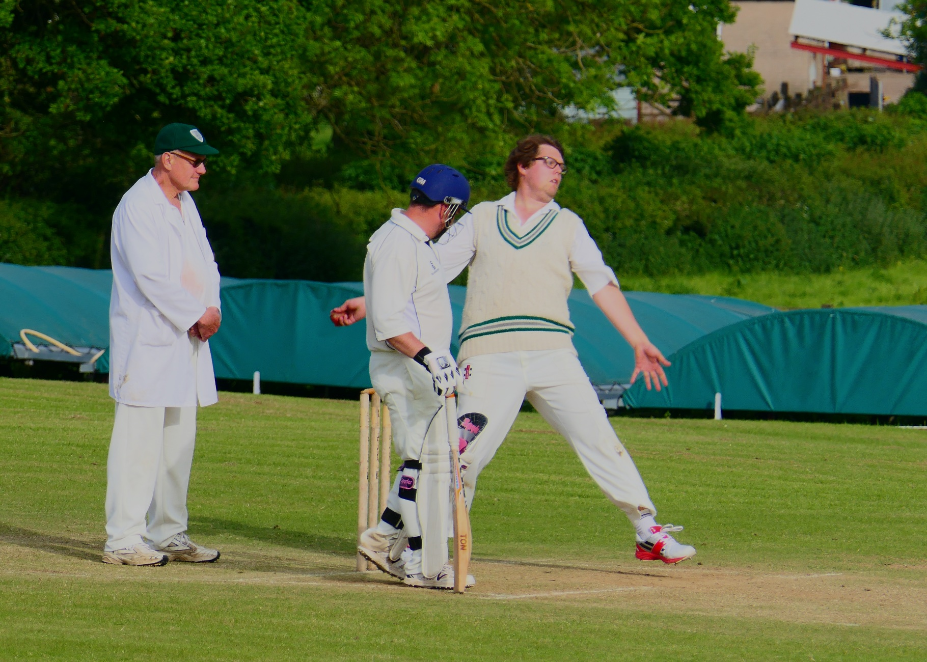
Will Siddons

Wootton batsmen were now having to take risks. The Gargoyles fielding sharpened visibly. Harry Jones gave another masterclass with the gloves, saving vital runs at vital junctures. Captain Andy
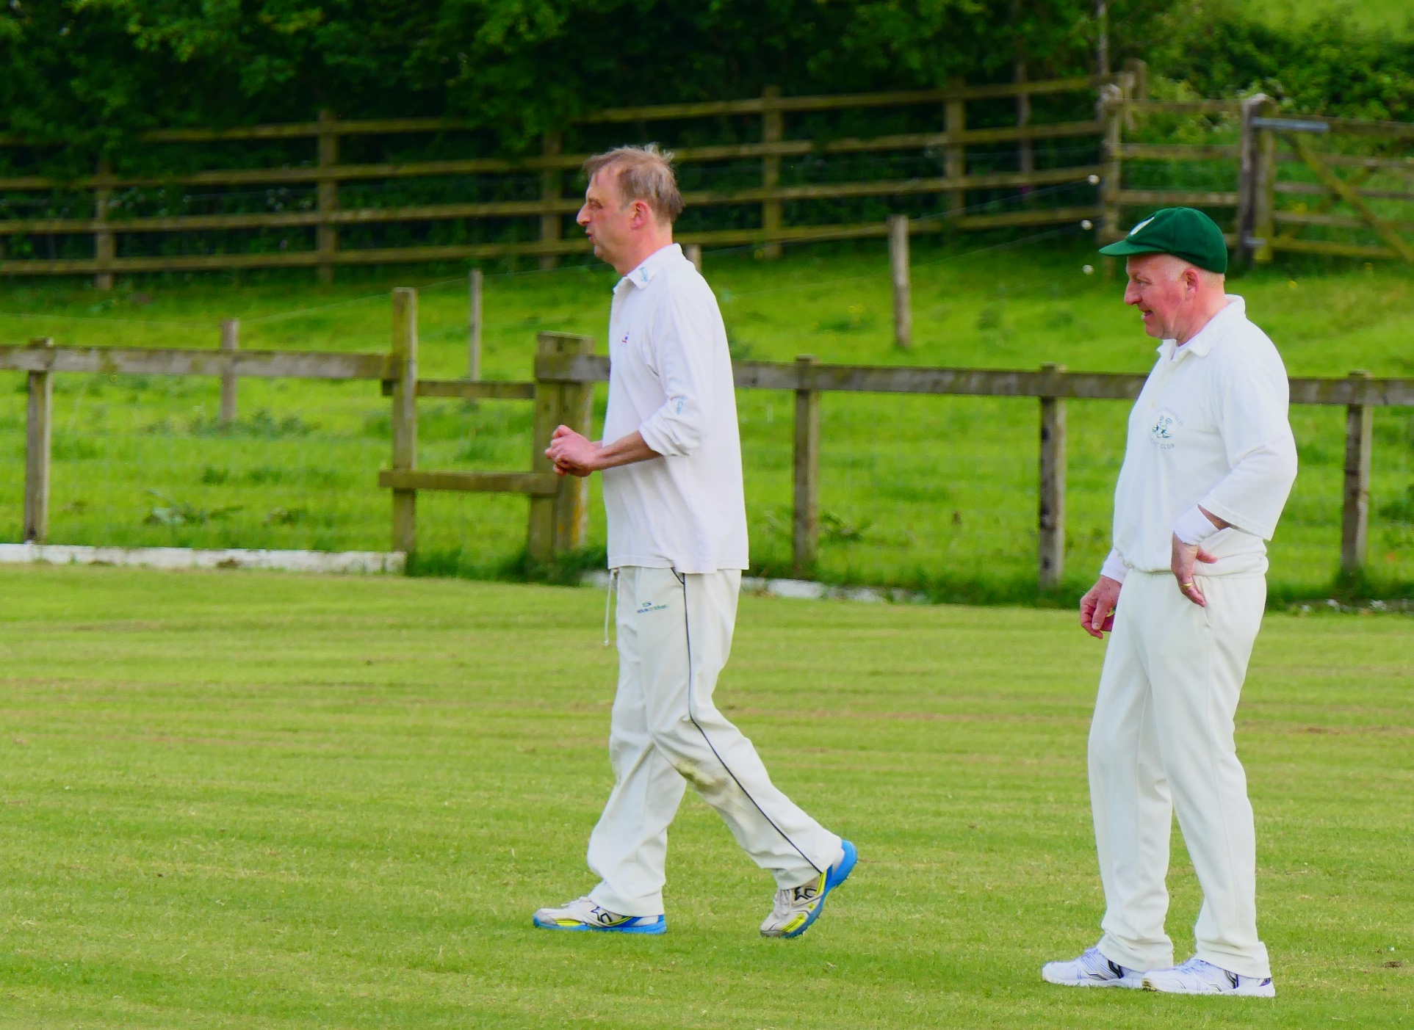
Bray, always leading from the front, took the responsibility to close out the innings with his looping spin. And a masterstroke it proved. He took the remaining 4 wickets in 3 overs for 12 runs. Flight and
Captain Andy Bray closed out the Wootton innings with his looping spinners
variations in pace did for young and old batsmen alike. The final wicket to fall and the precursor for scenes of joy, relief and disbelief in equal measure, tells the story of the match and its participants.
141 for 9, Bray’s looping tempter just outside off stump and Tomkinson on 60, eyed another chance to show his fine lofted drive over extra cover. The flight deceived him and the lofted drive became a lofted push too high on the bat. Nonetheless, the ball was travelling and straight towards Jon Lane at cover. This was only Jon’s second game for the club and his catching temperament is unknown.
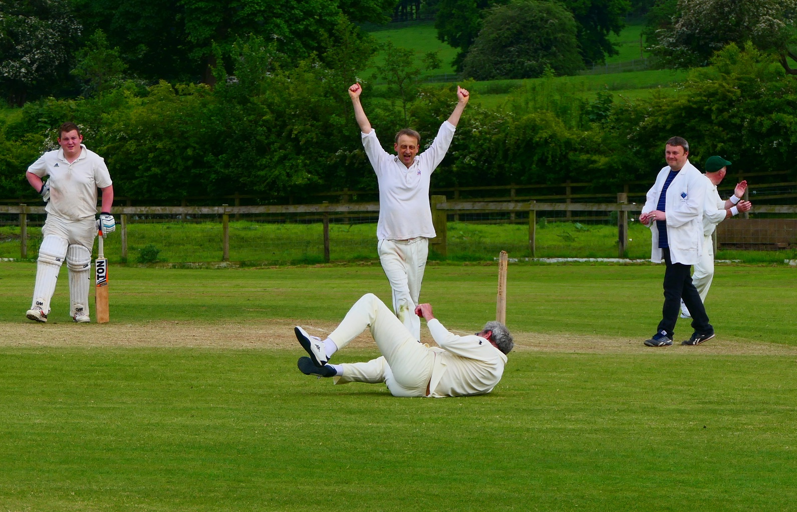
Jon Lane and that match winning catch !

To the ever helpful chorus of “catch it” he was in no doubt that this was perhaps the defining moment of the match. The ball appeared to bask in ultra-slow motion and took an interminable age to reach him, by which time Lane had had time to contemplate both hero and villain status with his new teammates. He preferred the former and calmly cupped his hands in front of his chest. The ball and the most unlikely victory was secured.
To win a game against a good side, after being behind for all but the final moments, proved to be the most satisfying of ways to spend a Sunday afternoon.

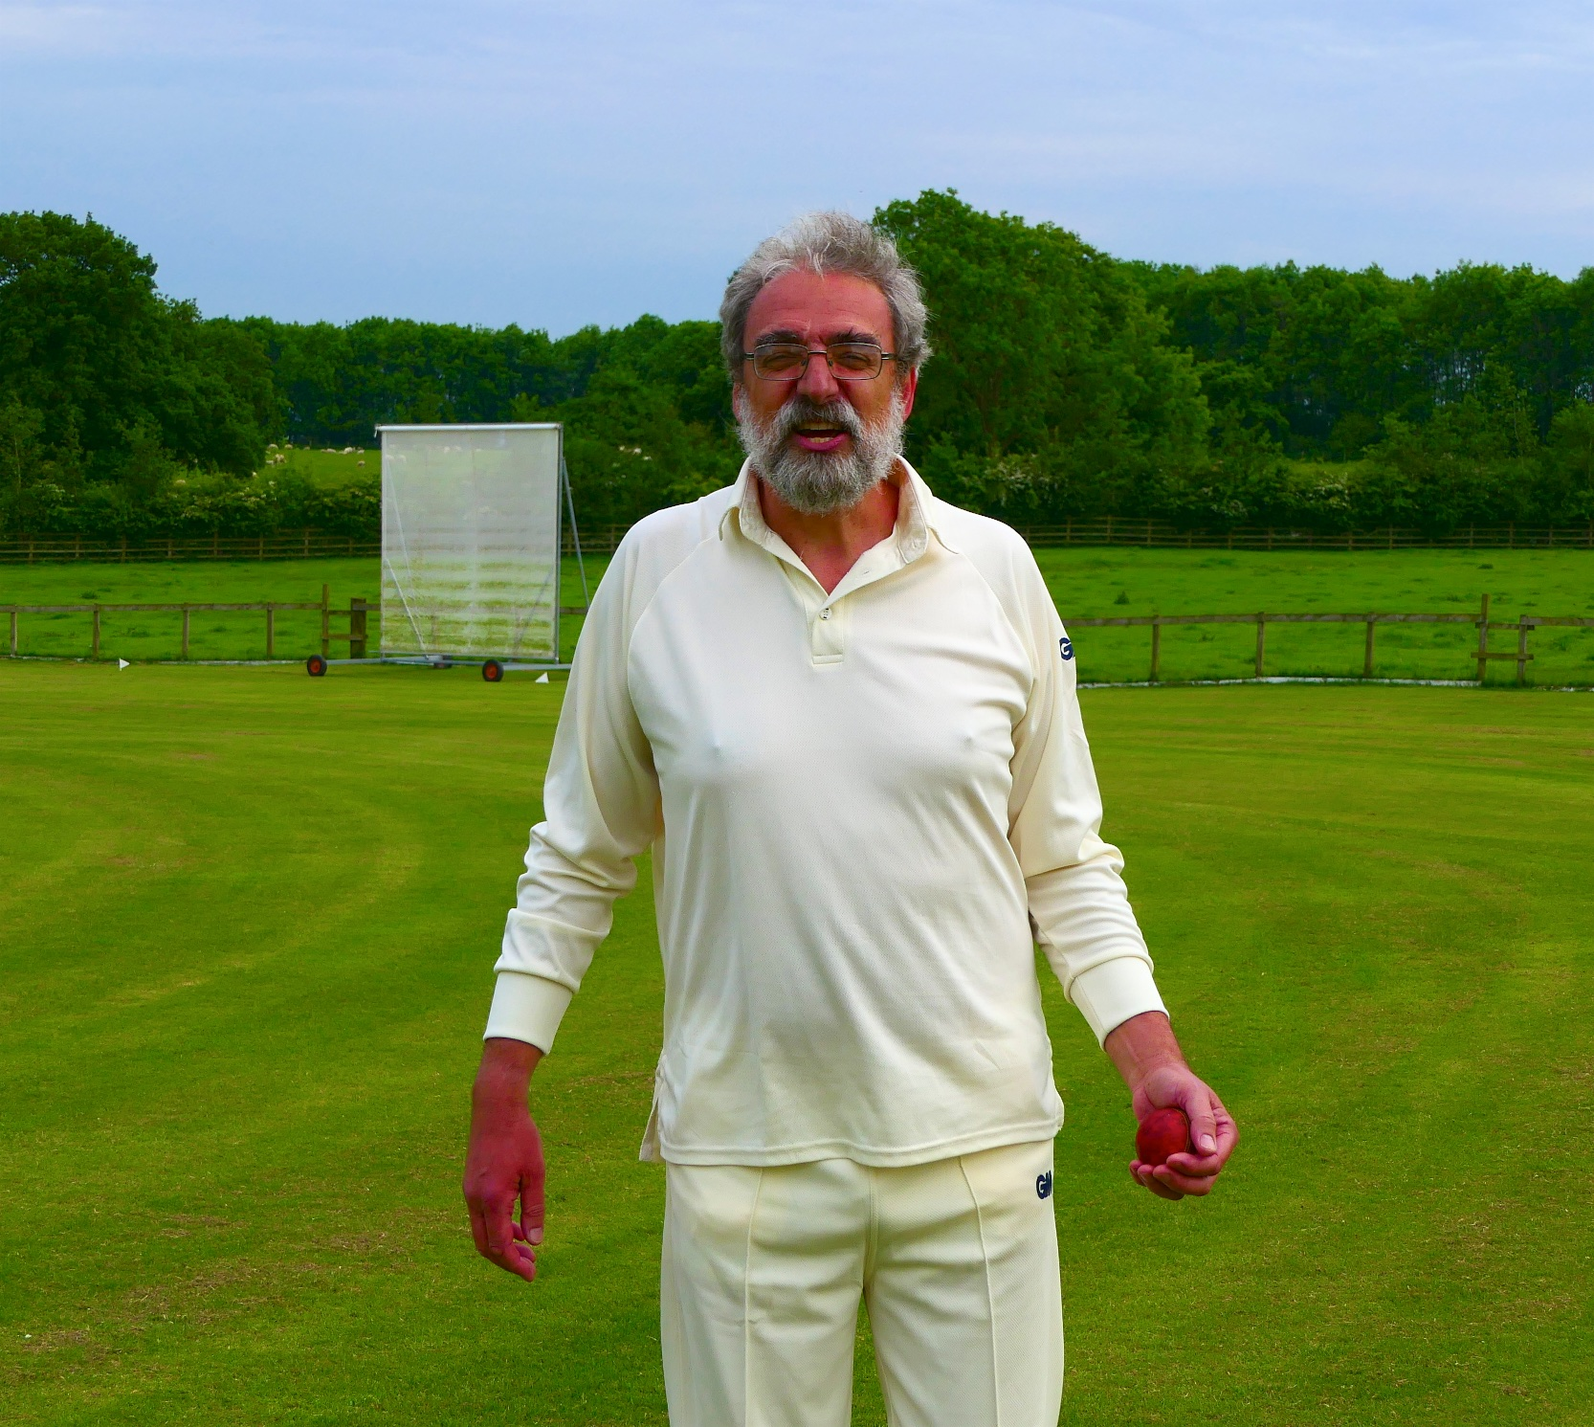
Jon Lane - still holding on to the ball after that catch !

ALSTONEFIELD CC 151 ALL OUT BEAT WOOTTON CC 141 ALL OUT BY 10 RUNS

