GARGOYLES SMASH RECORDS

Three convincing away wins, their highest ever score and a record winning margin; not a bad start to the 2017 season for Alstonefield CC.
The tranquil bucolic idyll that is Sutton on the Hill cricket ground on a perfect late Spring afternoon erupted in a frenzy of willow waving violence and then ferociously launched leather missiles on Sunday. But by 6:45 in the evening the blackbirds were piercing the stillness again and peace had returned. For the Gargoyles, and for vice-captain Shahid Ali in particular, this had been the perfect day.

A perfect day in a perfect setting for Shahid Ali

Put into bat the Gargoyles made a pulsating start. Sutton skipper Martindale opened his attack with an inexperienced pair, assuming early caution from openers Will Siddons and captain Andy Bray. He was wrong and 8 overs in, the score was 59 when Bray was out for 15. Siddons was once again in imperious form. Martindale had brought himself on and was impressive in pace and line. Runs became more difficult. Still it was a surprise when Siddons was undone by Martindale’s inswinger for a superb 60. John Curry had been resolute in his defence against the Sutton skipper, but was deceived by the flight of spinner Hardie at the other end. 96 for 3 after 18 overs.
With experienced spin at one end and Martindale’s hostility at the other, Liam Duffy was joined by Alan Hayes, who did exactly what was required in facing 18 balls and allowing Duffy to play himself in. When Hayes was bowled at 118 for 4 in the 24th over, the run rate needed an injection. Duffy was now building a lovely innings full of cultured caresses and sweet timing, giving Ali time to assess the bowling. When Duffy was bowled by the indefatigable Martindale for 41, the score was 181 for 5 in the 38th over. Eyeing a declaration just before tea, Ali knew he only had 4 or 5 overs to post an above par total, reckoned to be around 210. He was eventually stumped on 78, a score including 6 fours and 5 sixes. According to the locals in the pavilion, two of those strikes were the longest in living memory. Yet this was no heave-ho innings, rather a beautiful example of authentic strokes made to look effortless through exquisite timing and clean hitting.
232 for 7 declared at tea after 43 overs, beating by 1 run the previous club record set at Sunseekers in 2014.

Conversation over tea turned to Martindale’s marathon 18 over spell and the 182 he made in his previous innings. Not surprisingly, he opened the innings for Sutton. The intent and ability to score quickly were evident from the off and there was a sense of game on until Siddons bowled his ball of the season, an in-swinging Yorker, removing Martindale’s off stump. Fellow opener Harding immediately followed, deceived by Duffy’s variation in speed. 29 for 2 and a change of bowling. What followed was a force of nature, seemingly making the outcome of the whole match inevitable. 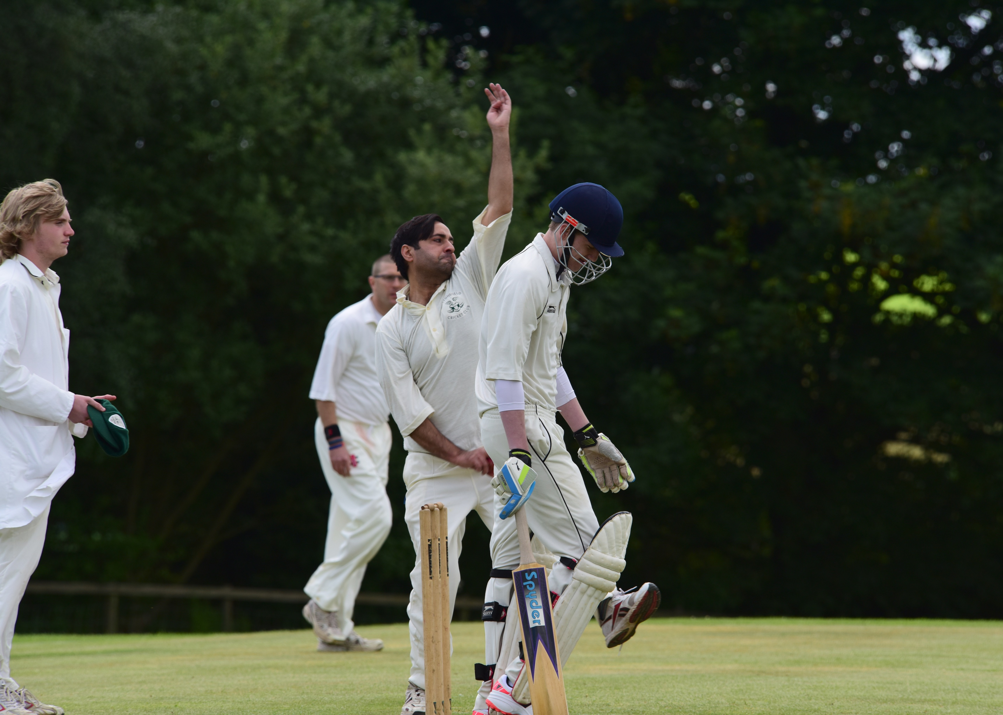
A force of nature : Shahid Ali at Sutton-on-the-Hill
I
n Shahid Ali’s first two overs, four batsmen had come and gone. 45 for 6. The beauty of the game at Sutton on the Hill, is that the old fashioned draw is a legitimate result. As early as 16th over, it was now the hosts’ only hope. Hardie and Prince dug in and frustrated all the bowlers tried by captain Bray, until he brought himself on and duly bamboozled Prince with flight and guile. That was the breakthrough and a refreshed Ali returned to the attack, to the same devastating effect. In his next four overs he cleaned up the tail to finish with the startling and club best figures of 9 overs, 4 maidens, 7 wickets for 12 runs. 5 dismissals were bowled as his vicious in-swinger, mesmeric slower ball and sharp off-cutters, all wreaked havoc. With only 4 overs remaining and the score on 94, it was fitting that the Sutton innings ended courtesy of a wonderful Ali caught and bowled, as if to emphasise his mastery of all the skills.

Cricket is a team game. The wonder of cricket is how the individual can take responsibility for the team’s destiny. This was a record winning margin performance by the whole team, with Shahid Ali’s enthusiasm and love of the game endearing him to opponents and teammates both.

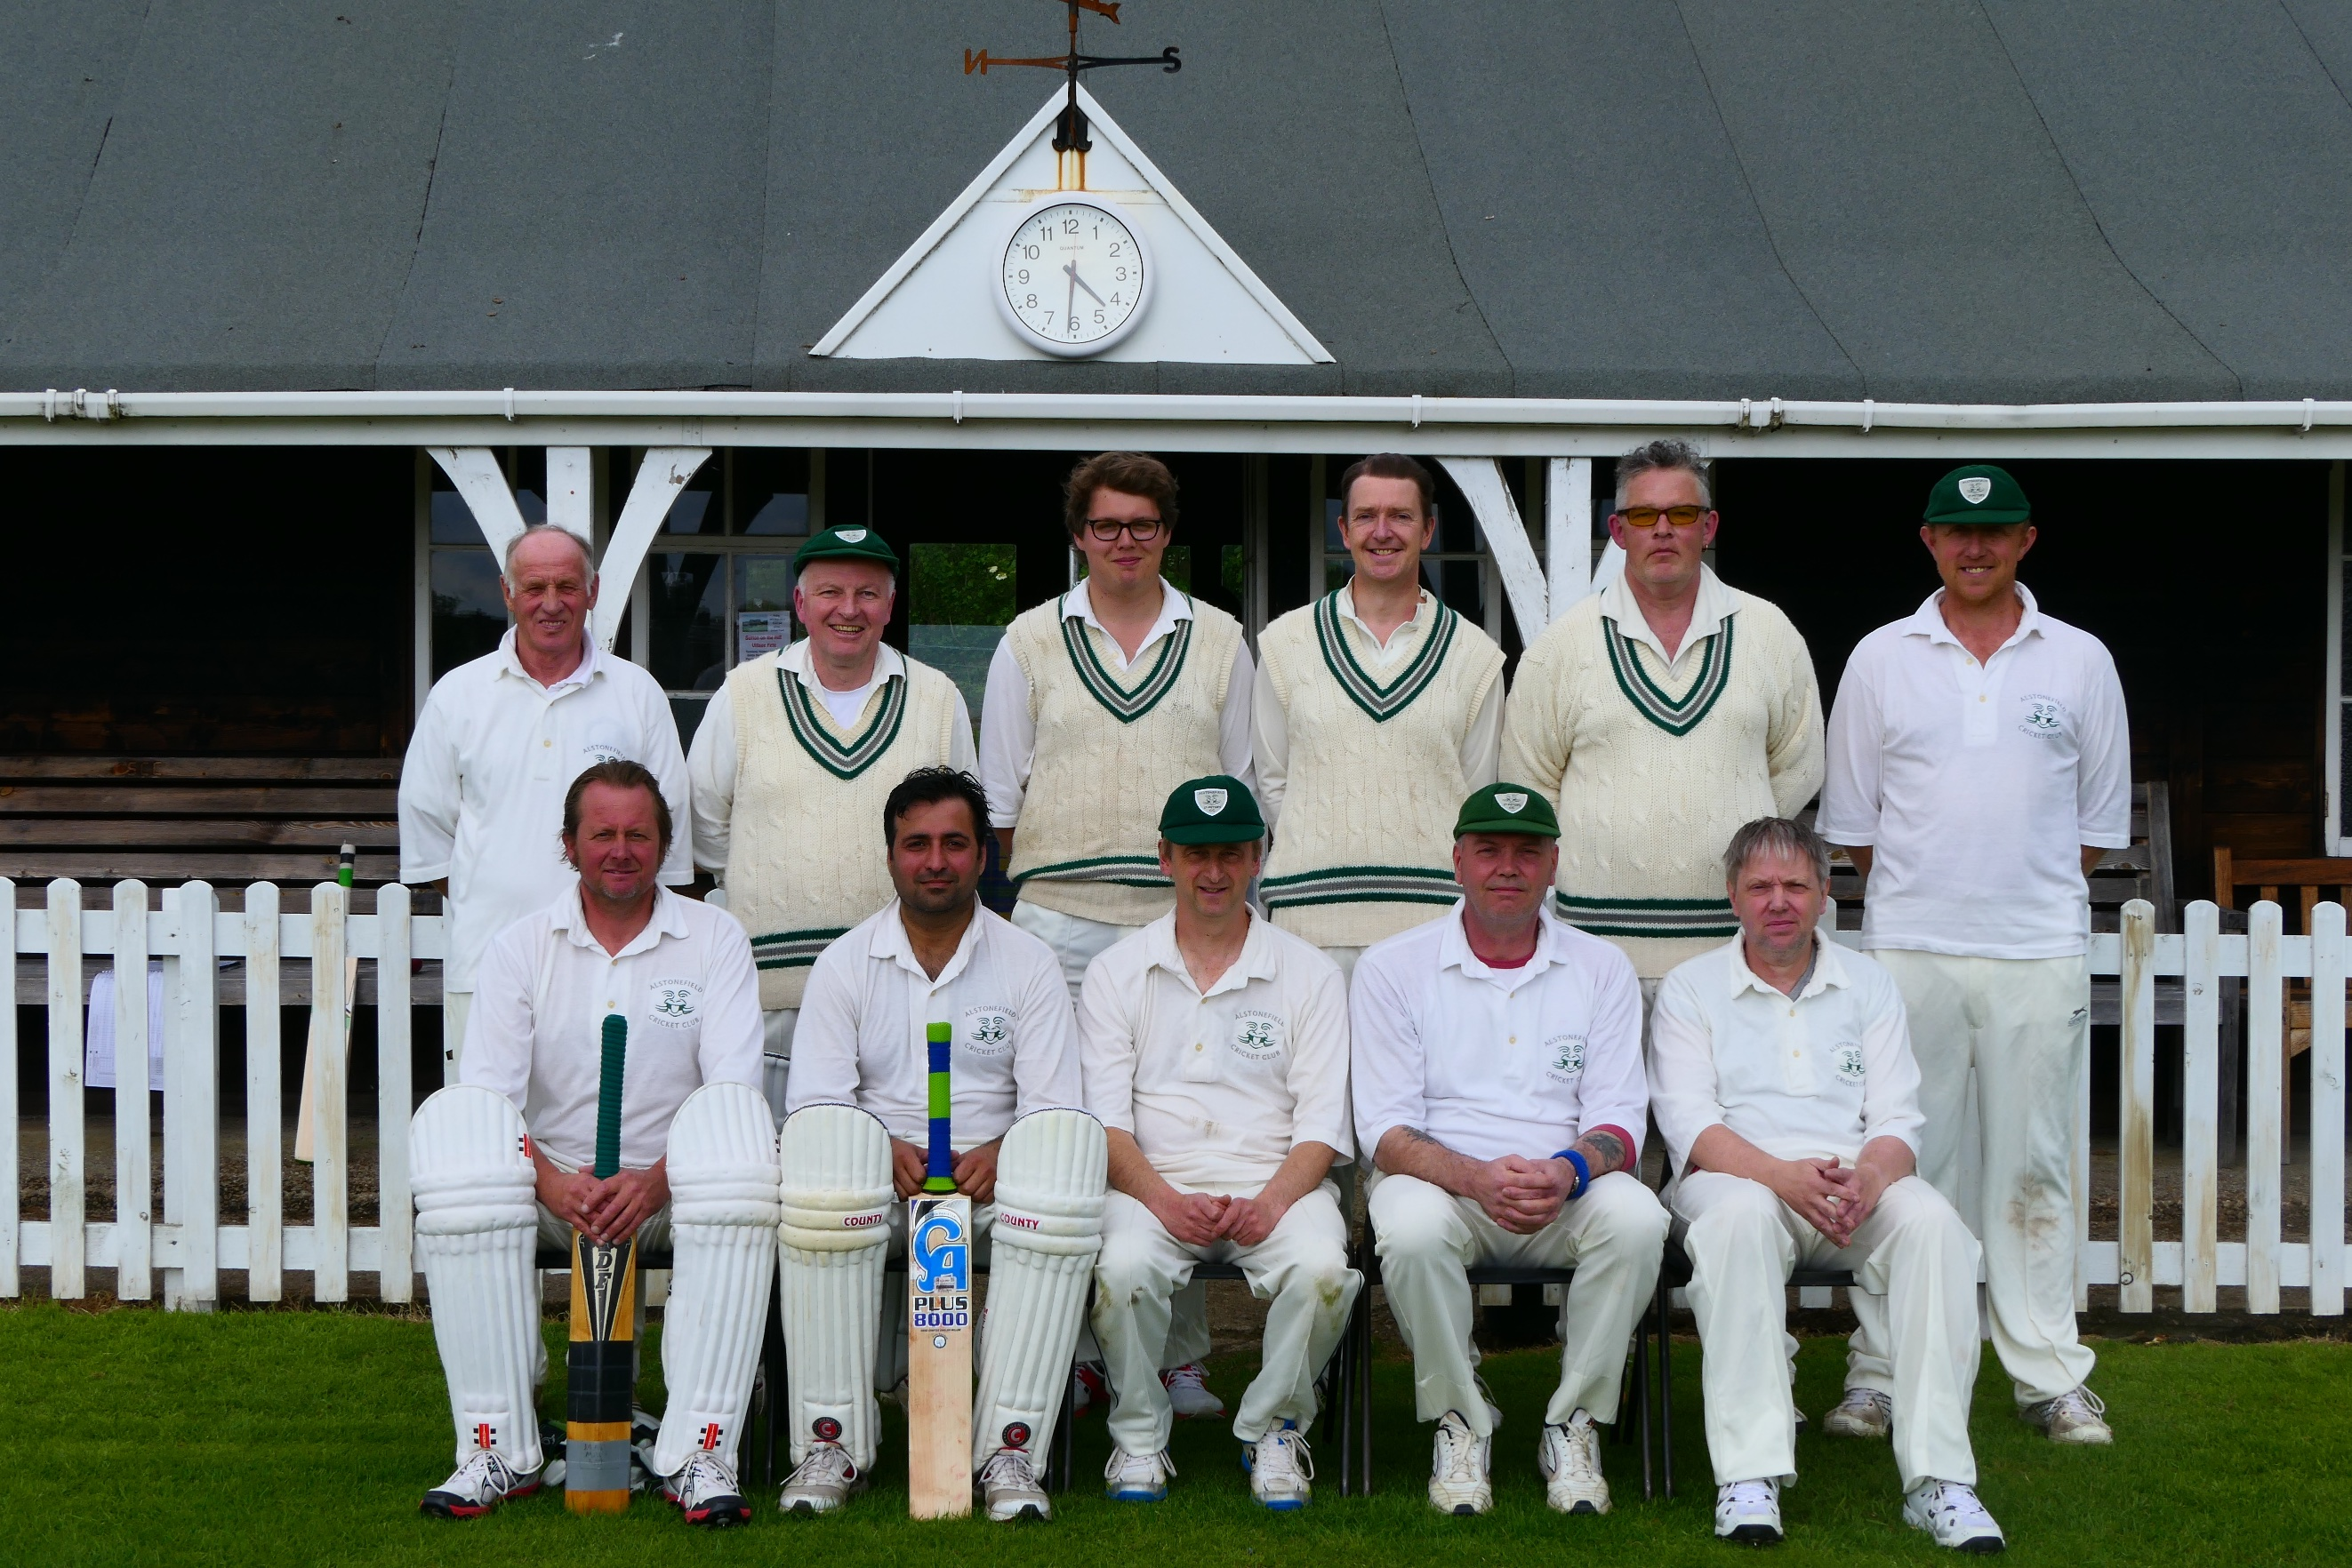

Alstonefield CC’s record breaking team against Sutton-on-the-Hill

ALSTONEFIELD CC 232 FOR 7 DECLARED, BEAT SUTTON on the HILL CC BY 138 RUNS.

