GARGOYLES PROSPER TO WIN NUMBER EIGHT

In many Asian cultures the number eight symbolises prosperity and good fortune. In western mysticism eight aligns with inner strength and determination. On the evidence of Sunday’s tense, but ultimately victorious, game against Duffield, Alstonefield Cricket Club is blessed with a global perspective. In a match that was always there for either team to win or lose, the Gargoyles made it eight wins out of eight because they were determined to and individuals relished taking responsibility in decisive moments.
As befits a club of their standing and resources, Duffield fielded a more experienced team than on their first visit to the hills and their calibration was spot on. Two perfectly balanced sides in a perfect setting on the perfect summer’s day…

For once it wasn’t Will Siddons who was going to launch the Gargoyles’ innings. Over exuberance and a perfectly straight ball accounted for his stumps in the second over. Jon Lane looking to nail the other opener slot offered the straightest of bats against the metronomically accurate Anderson, while Liam Duffy was also forced to be more circumspect than usual by the quality of the Duffield bowling. In the 11th over Lane, who had driven three handsome cover drives to the boundary, was bowled by Anderson for 14. As often happens, the next over brought the dismissal of Duffy for 12. Rob Handscombe and Simon Smith were now out in the middle, in only their first and second innings of the season respectively. Not ideal for the crucial period of the innings when runs were desperately needed and quickly.

The outstanding feature of this Gargoyles’ season has been how match shaping contributions have come from different individuals in each match. Never was that more true than with this partnership. Smith and Handscombe put on 77 runs in 15 overs, before Handscombe was dismissed for 15. Smith was visibly finding his form, timing and power with each ball, with 37 of his unbeaten 51 coming off his last 21 balls. Undoubtedly one of Smith’s finest innings and most valuable to the team cause.

Harry Jones played a Jones gem of an innings, immediately into his stride, disrupting bowlers’ lengths, finding gaps and the rope with panache in an 18 ball score of 27. 178 at the end of the 35 overs. With the wicket and outfield drying out, was 178 at a rate of spot- on 5 an over going to test Duffield?

Mixing youth and experience in their batting partnerships,Duffield started well. Clare and Etherington dealt in authentic shot boundaries from the off. 32 after 6 overs and game very much on.
Captain Andy Bray brought Will Siddons on to immediate effect with Clare popping one straight back to the bowler for the vital breakthrough. In the next over the returning Shahid Ali moved one away from Pope and first slip took a remarkable one handed catch just millimetres from the ground. These moments inspire the fielding team, while three tight overs and scoreboard pressure make batsmen take risks. Etherington, hitherto untroubled on 20, didn’t spot Ali’s ever so slightly slower ball and skied his straight drive high into the azure canopy. Simon Smith calmly steadied himself and made no mistake. 62 for 3 became 63 for 4 when Smith, bowling his most impressive spell of leg breaks ever, trapped Blenkinsopp lbw for 17 with his first ball. The Smith tour de force continued with wickets in his next two overs. 97 for 6 after 21 overs was up with the run rate, but a couple of wickets too many perhaps. The vastly experienced Dave Watson joined his talented son Niall in the middle and these two skilfully moved the needle back in Duffield’s favour. When Watson senior was adjudged lbw to Duffy for 33, the score had reached 158 in the 31st over. Exactly 5 runs an over required from 4 overs with 3 wickets remaining. Ali back into the attack and he bowls Blenkinsopp senior first ball! With the boundaries being protected, singles were aplenty. 161 after 32; 163 after 33 and 168 after 34 overs was how the tension built. Watson junior had constructed a superb innings of skill and maturity in his role as Duffield’s anchor. With his unbeaten 53 he had manoeuvred his side to within 11 runs of victory. Just the final over to be bowled by Will Siddons remained. Siddons was straight on the money. Just 3 runs from the first 3 balls, a single from the 4th. All results still possible. A loud appeal on the 5th and Pope was out lbw.
Game over.
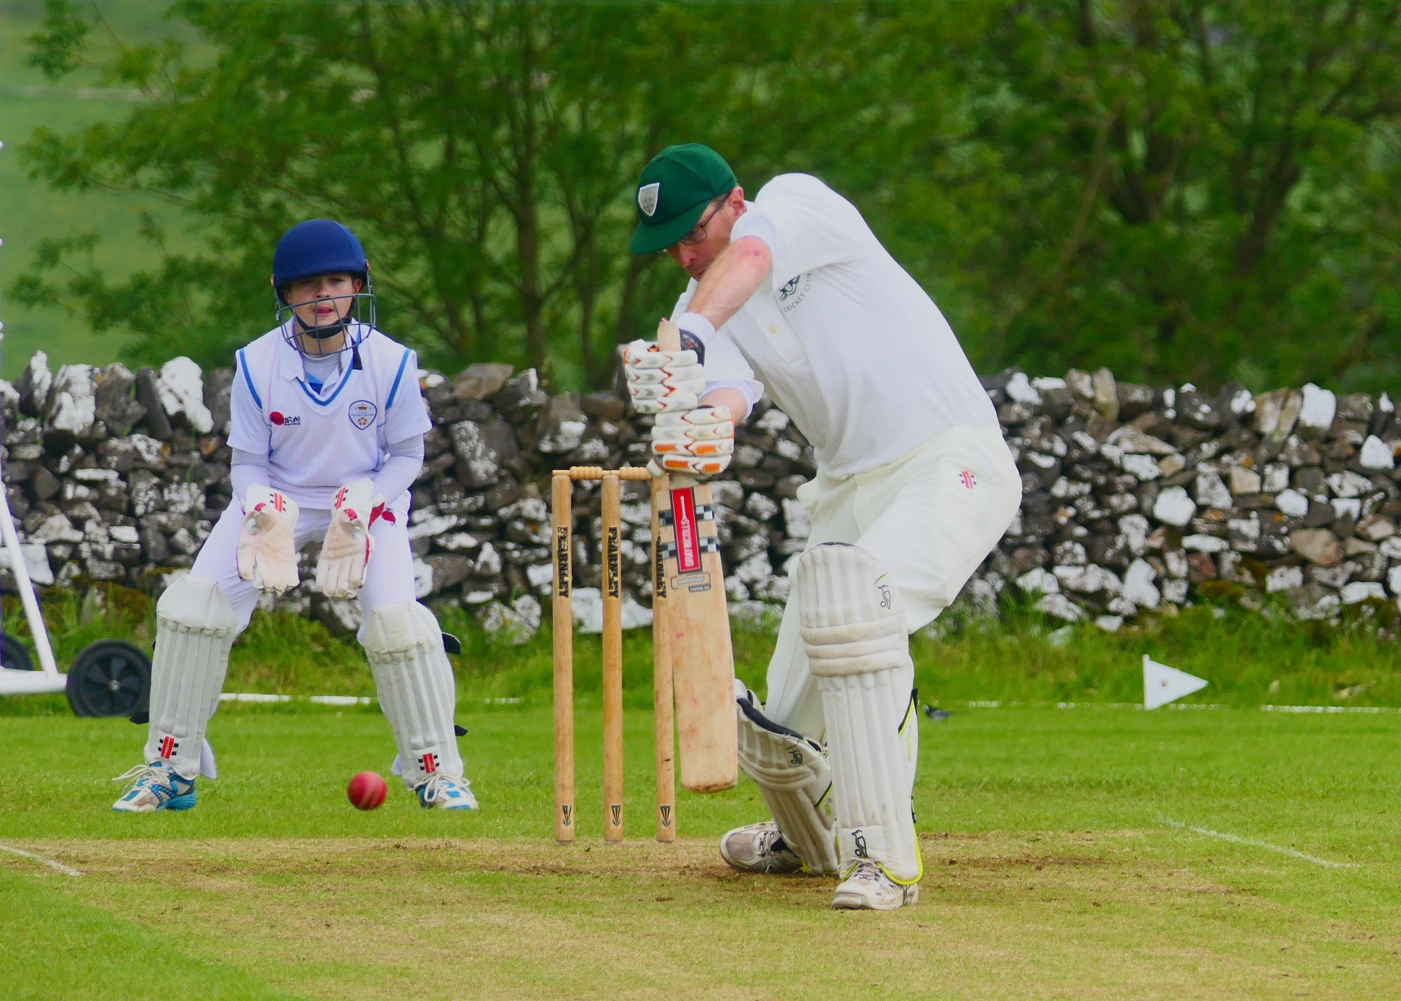
Simon Smith - a superb all-round performance to make him Man of the Match
Without doubt, the stand out all round performance of man of the match Simon Smith proved crucial, yet the overriding and palpable emotion in those final 5 dramatic overs was of a team willing each other to succeed. Successfully as it turned out, for the eighth time this season. Of course, good fortune along with bad luck, will always play a part in sport, but inner strength and determination will always make good fortune.

ALSTONEFIELD CC 178 ALL OUT BEAT DUFFIELD CC 172 FOR 9 BY 6 RUNS

