GARGOYLES IN SEVENTH HEAVEN

How long can the run continue? A potentially tricky visit to the big town club went the same way as the previous six matches. In the end a comfortable win by five wickets with over five overs to spare, but not without the ebbs and flows of a competitive match. Ashbourne fielded a nice balance of seasoned league experience and promising youth development players, while the Gargoyles’ average age was reduced by the inclusion of David Joyce.

Ashbourne batted first and looked threatening. Thomas and Weir punished anything short and they were scoring freely at over 5 an over until Will Siddons found his length and trapped Weir lbw with the score on 55 in the 11th over. Thomas continued his accomplished innings, making an unbeaten 45, while at the other end wickets were falling. Chief wicket taker was King. S not B. Somehow, he managed to entice two batsmen in consecutive balls to nudge the ball ever so slowly on to their stumps, so joining an illustrious band of Gargoyles on a potential hat trick.

As is customary on these occasions, all ten fielders were crowded around the new batsman in search of the edge and the King’s passage to the pantheon of bowling greats. The mark of true greatness is, of course, to eschew dependency on others, trusting the power of self-realisation. The hat trick ball is bowled to the most callow of the youth contingent, the tamest of lollipop dollies is apologetically spooned back to the bowler, giving time to read the maker’s name, caress it into his hand knitted sweater and consider life as a legend. So far so exceedingly good, but the tale was about to unravel. In a flurry of arms, legs and fully prone dust rolling, it became apparent that the King was trying to locate the piece of red leather about his person before it bit the aforementioned dust. The unseasonal chorus of “it’s behind you” and “oh no it isn’t” was all to no avail, the youth was spared and this King remained mortal.
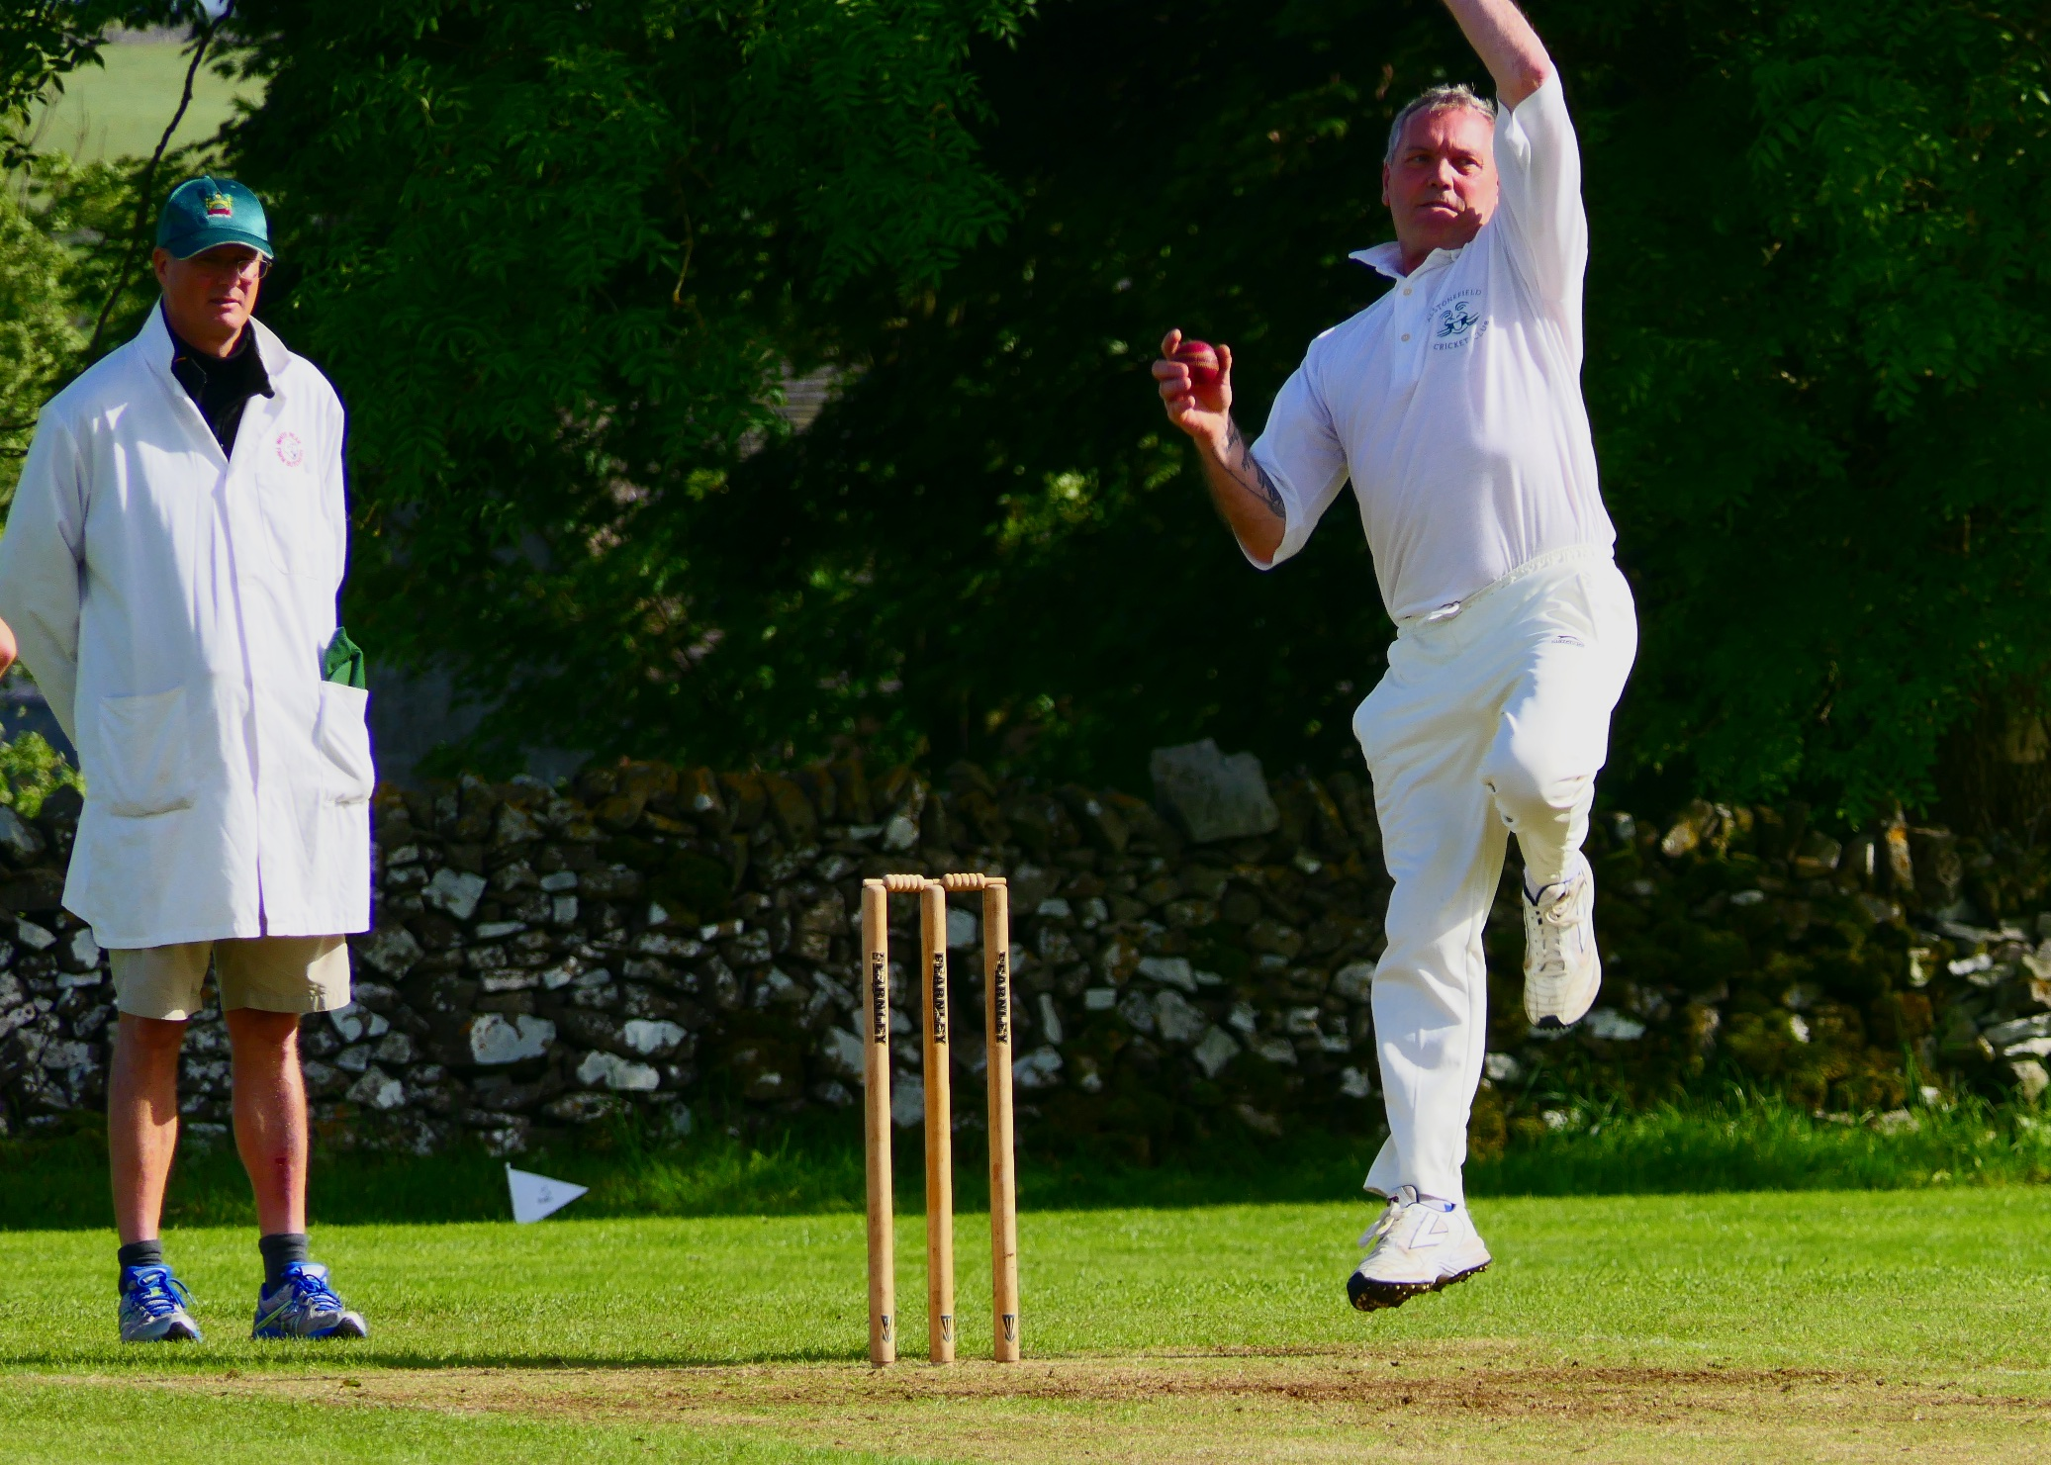
Steve King - denied immortality

At 93 for 6, Andy Hill came in at number 7 for Ashbourne, processing to the middle as a gladiator would, knowing that with 13 overs to go, he could give his team the ascendancy. Though he batted in typical Hill style, confronting the bowlers with explosive striking of the ball, Alstonefield’s nerve and discipline was maintained and pressure exerted, such that in spite of Hill’s 44 not out, the Ashbourne innings ended on 144 for 6 after 35 overs, a run rate of 4.1 per over.

The Gargoyles’ innings was nearly, but not quite, all about how Will Siddons imposed himself on the Ashbourne attack from the first ball. Perfectly timed front and back foot drives and an eye for singles in gaps, featured in an innings that made defeat unlikely. When Siddons retired on 40 not out from only 35 balls, the score was 51 in the 9th over.
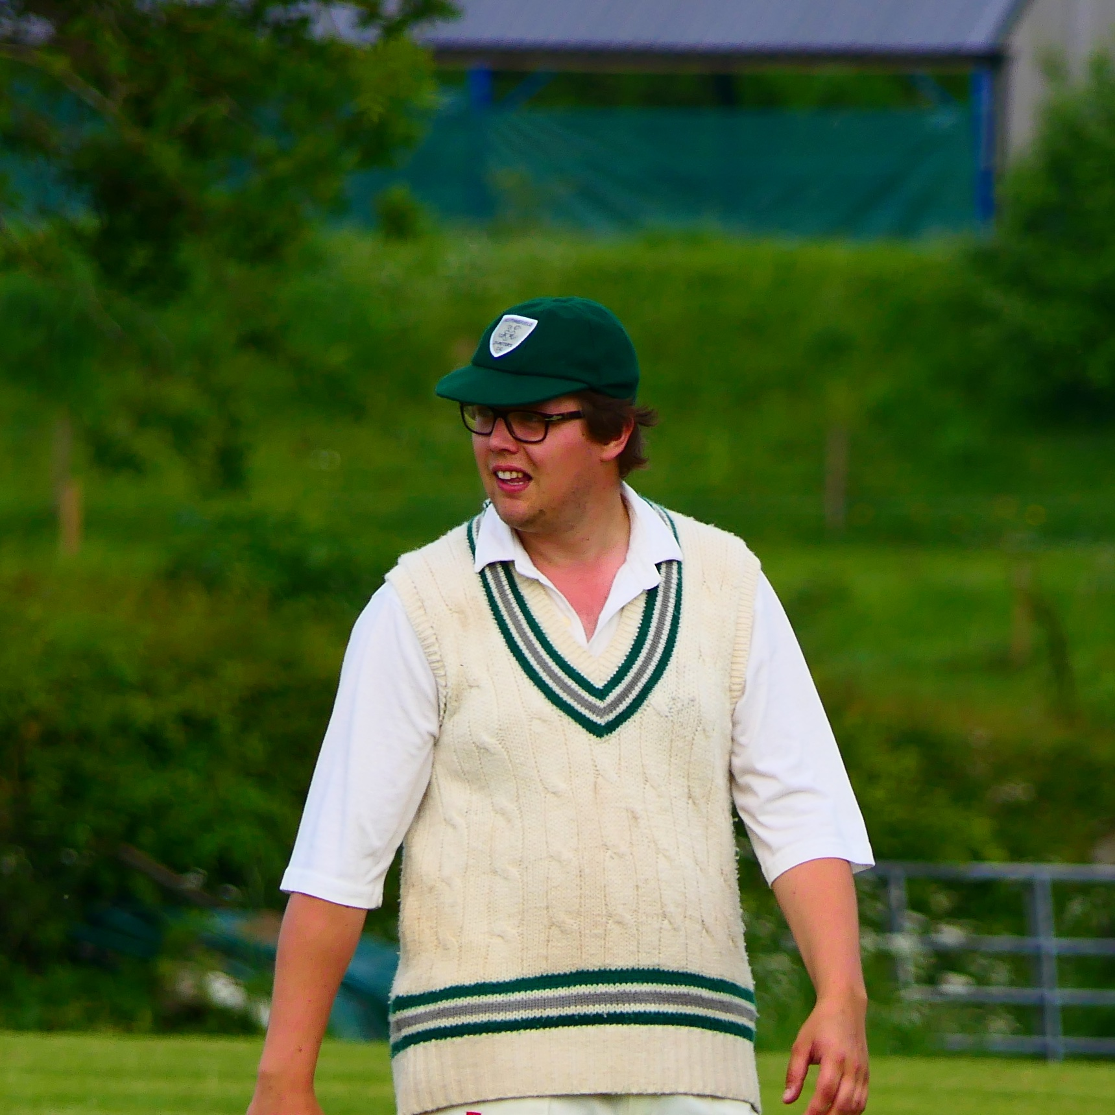
Will Sidons - imposed himself on the Ashbourne attack

Captain Andy Bray had been content to let Siddons do the scoring, but now began to free his shoulders, moving to 24 before being yorked by a brute from Andy Hill. The in-form John Curry joined Neil Shotton and batting suddenly looked far more difficult. Shotton’s 31 ball vigil for 8 runs ended with the score on 83 for 2, in the 20th over. By the 23rd over Curry and David Joyce had joined him back in the pavilion. 89 for 4 and only 12 overs remaining. If Will Siddons provided the start, Tony Guest delivered the finish. With “the Goose” swooshing, Guest calmed any jitters, striking 20 out of his 26 in boundaries, in only 16 balls. He and Harry Jones had put on 44 runs for the fifth wicket in only 5 overs, when Guest was adjudged lbw, with 11 runs needed for victory.
Ben King joined Jones and these two calmly knocked them off in 2 overs.

Another win, and by a decent margin with 5 overs to spare, but for periods of this match, not a foregone conclusion, which is how the Gods like to play with mere mortals in whites.

ALSTONEFIELD CC 147 FOR 5 BEAT ASHBOURNE CC 144 FOR 6 BY 5 WICKETS.

