GARGOYLES HAVE DEPTH
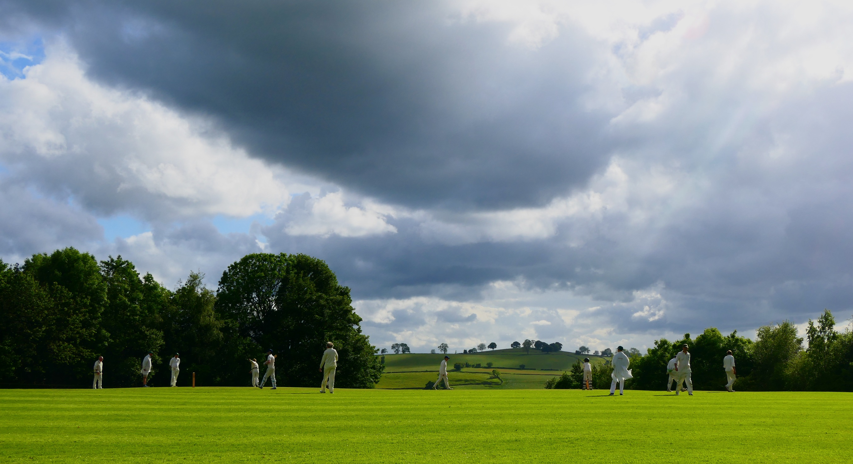

Thirty minutes into this absorbing match, the thought of unbeaten runs looked as distant a memory as Dave Singleton in whites. Indeed, any sort of run would have been welcome. 17 for 4, nearly 10 overs gone and one of the best bowlers ever to do damage in Alstonefield, still had 3 overs up his sleeve. On a glorious afternoon, Abbots Bromley had come to make a day of it and winning was clearly going to be at the heart of their fun. No youth development players for this one, they fielded a side full of current Derbyshire league experience, including a wicket keeper who stands up to a genuinely fast bowler and takes every ball cleanly. It doesn’t take long to spot the signs of a tough match to come.

And yet something quite strange has manifestly occurred in the Gargoyles’ psyche. In seasons past, to lose Will Siddons, Andy Bray and Liam Duffy cheaply and quickly, would have given rise to mutterings of “well it’s only a game after all and win some lose some.” No longer. Once Akram (no relation, but equally devastating) had finished his opening 4 over spell with 3 wickets for 0 runs, there was a calm purpose to the Gargoyles’ batting against an accurate, steady rather than threatening, Abbots Bromley attack. It was Shahid Ali who led from the front. It was he who rebuilt the innings, slowly at first and then, taking a particular liking to the bowling of Freeman, excitingly showing his full repertoire of free flowing, boundary finding shots. Ali was there at the end on 64 not out, including a straight six off Akram’s final over, which dented his figures somewhat, ending with 7 overs, 5 wickets for 7 runs.
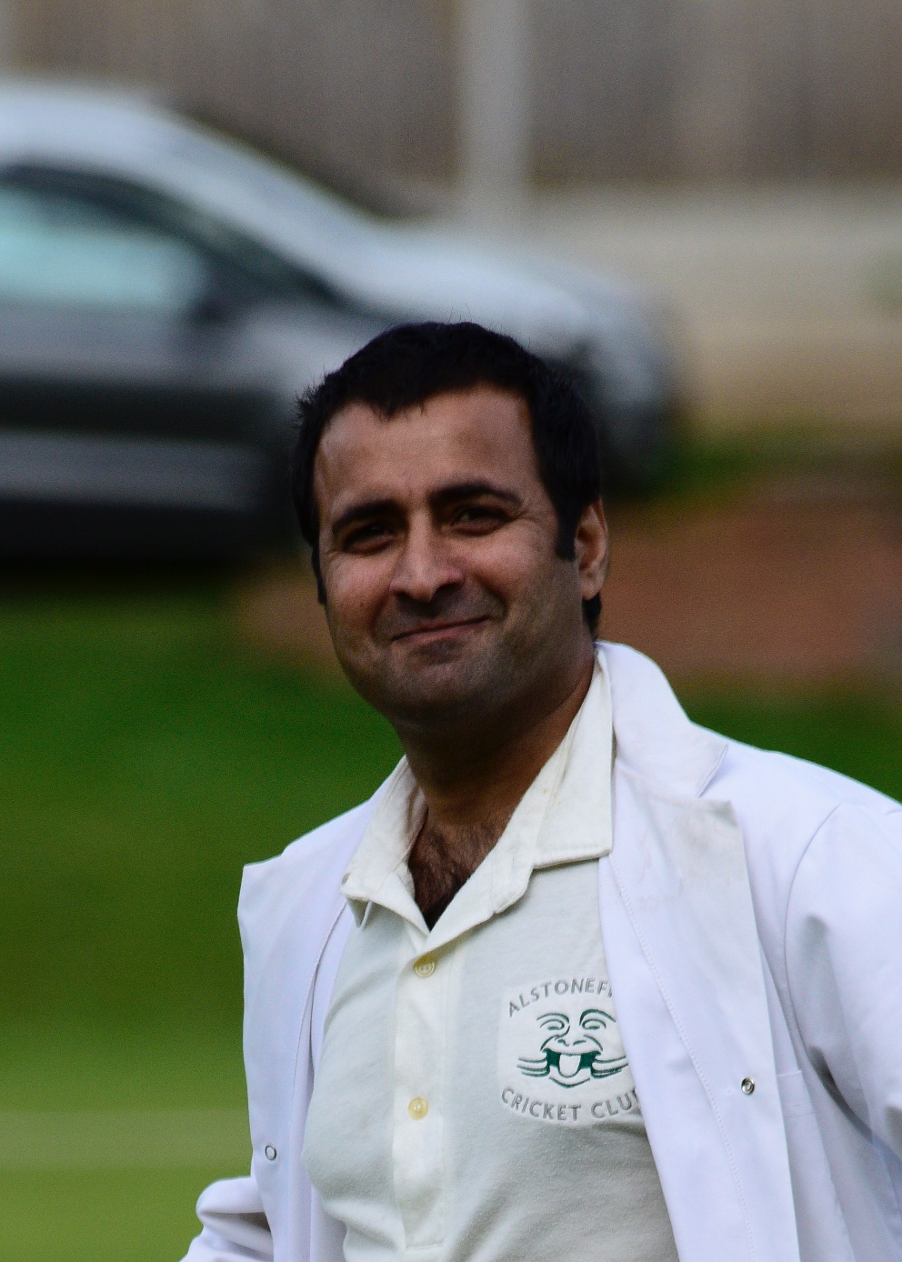
Shahid Ali - rebuilt Alstonefield’s innings
The true value of Ali’s innings was the confidence it gave to his teammates. The top four were dispatched for a combined 9 runs. The next five batsmen contributed 134 and at a fair lick of 6 runs an over. John Curry, Harry Jones, Tony Guest and Ian McKay all made sure Ali had someone at the other end contributing runs.

To reach 160 for 9 from 17 for 4 was a feat of application,
resilience and batting ability. The question over tea of course, was whether Abbots Bromley had a batting Akram?

If they did, he was coming in down the order, because the first 4
wickets fell for just 27 runs in 8 overs. Tony Guest, bowling his best spell of the season, made the early breakthroughs, bowling both openers.
Tony Guest – best spell of the season
Will Siddons repeated the medicine to a startled number 3 and a sharp piece of glovework by Harry Jones completed an impressive run out for the fourth wicket. The game then moved into its formative phase. The depth of bowling talent at Andy Bray’s disposal means scoreboard pressure is applied throughout the innings. Shahid Ali, Liam Duffy and Ian McKay bowled the next 15 overs for only 41 runs and shared 4 wickets. 68 for 8 and Akram in at number 10 with 93 needed off 12 overs.
Was this just a ploy? Could he bat as well as he bowls? Fortunately, unlike his bowling, classic technique there was not. Sheer confidence however was in abundance. Akram’s ability to play swatting drives off his stumps, changed the tone of the game. With number 9 Richards showing he could hold one end, these two made a fist of the chase, adding 45 in 10 overs before Richards holed out to Will Stupples at deep mid-on for 18.

111 for 9 had moved to 118 for 9, when Akram, on 24, faced Shahid Ali in the 31st over.
No straight sixes here, just a cartwheeling off stump.

Abbots Bromley all out for 118.

Another victory and against a team well capable of winning. The secret? It may just be down to having a stronger XI…

ALSTONEFIELD CC 160 FOR 9 BEAT ABBOTS BROMLEY CC 118 ALL OUT BY 42 RUNS

